

**VIVEKANANDA INSTITUTE OF PROFESSIONAL STUDIES - TECHNICAL CAMPUS**

**Grade A++ Accredited Institution by NAAC**

NBA Accredited for MCA Programme; Recognized under Section 2(f) by UGC;

Affiliated to GGSIP University, Delhi; Recognized by Bar Council of India and AICTE

An ISO 9001:2015 Certified Institution

**SCHOOL OF ENGINEERING & TECHNOLOGY**

**B. Tech Programme: B. Tech AI-ML (A)**

**Course Title: Web Programming Lab**

**Course Code: AIML - 259**

**Submitted To: Submitted By:**

**Ms. Anshula Gupta Name: Kunsh Sabharwal**

**Assistant Professor Enrolment No: 01117711623**

**VIVEKANANDA INSTITUTE OF PROFESSIONAL STUDIES - TECHNICAL CAMPUS**

**Grade A++ Accredited Institution by NAAC**

NBA Accredited for MCA Programme; Recognized under Section 2(f) by UGC;

Affiliated to GGSIP University, Delhi; Recognized by Bar Council of India and AICTE

An ISO 9001:2015 Certified Institution

**SCHOOL OF ENGINEERING & TECHNOLOGY**

**VISION OF INSTITUTE**

To be an educational institute that empowers the field of engineering to build a sustainable future by providing quality education with innovative practices that supports people, planet and profit.

**MISSION OF INSTITUTE**

To groom the future engineers by providing value-based education and awakening students' curiosity, nurturing creativity and building capabilities to enable them to make significant contributions to the world.

**VIVEKANANDA INSTITUTE OF PROFESSIONAL STUDIES - TECHNICAL CAMPUS**

**Grade A++ Accredited Institution by NAAC**

NBA Accredited for MCA Programme; Recognized under Section 2(f) by UGC;

Affiliated to GGSIP University, Delhi; Recognized by Bar Council of India and AICTE

An ISO 9001:2015 Certified Institution

**SCHOOL OF ENGINEERING & TECHNOLOGY**

**VIVEKANANDA INSTITUTE OF PROFESSIONAL STUDIES - TECHNICAL CAMPUS**

**Grade A++ Accredited Institution by NAAC**

NBA Accredited for MCA Programme; Recognized under Section 2(f) by UGC;

Affiliated to GGSIP University, Delhi; Recognized by Bar Council of India and AICTE

An ISO 9001:2015 Certified Institution

**SCHOOL OF ENGINEERING & TECHNOLOGY**

**VIVEKANANDA INSTITUTE OF PROFESSIONAL STUDIES - TECHNICAL CAMPUS**

**Grade A++ Accredited Institution by NAAC**

NBA Accredited for MCA Programme; Recognized under Section 2(f) by UGC;

Affiliated to GGSIP University, Delhi; Recognized by Bar Council of India and AICTE

An ISO 9001:2015 Certified Institution

**SCHOOL OF ENGINEERING & TECHNOLOGY**

**VIVEKANANDA INSTITUTE OF PROFESSIONAL STUDIES - TECHNICAL CAMPUS**

**Grade A++ Accredited Institution by NAAC**

NBA Accredited for MCA Programme; Recognized under Section 2(f) by UGC;

Affiliated to GGSIP University, Delhi; Recognized by Bar Council of India and AICTE

An ISO 9001:2015 Certified Institution

**SCHOOL OF ENGINEERING & TECHNOLOGY**

**INDEX**

|  |  |  |  |  |  |  |  |  |
| --- | --- | --- | --- | --- | --- | --- | --- | --- |
| S.No. | Experiment | D.O.A /  D.O.S | Marks | | | Remarks | Updated Marks | Faculty Signature |
| Laboratory Assessment (15 Marks) | Class Participation (5 Marks) | Viva (5 Marks) |  |  |  |
| 1. |  |  |  |  |  |  |  |  |
| 2. |  |  |  |  |  |  |  |  |

**VIVEKANANDA INSTITUTE OF PROFESSIONAL STUDIES - TECHNICAL CAMPUS**

**Grade A++ Accredited Institution by NAAC**

NBA Accredited for MCA Programme; Recognized under Section 2(f) by UGC;

Affiliated to GGSIP University, Delhi; Recognized by Bar Council of India and AICTE

An ISO 9001:2015 Certified Institution

|  |  |  |  |  |  |  |  |  |
| --- | --- | --- | --- | --- | --- | --- | --- | --- |
| S.No. | Experiment | D.O.A / D.O.S | Marks | | | Remarks | Updated Marks | Faculty Signature |
| Laboratory Assessment (15 Marks) | Class Participation (5 Marks) | Viva (5 Marks) |  |  |  |
| 3. |  |  |  |  |  |  |  |  |
| 4. |  |  |  |  |  |  |  |  |

**SCHOOL OF ENGINEERING & TECHNOLOGY**

**VIVEKANANDA INSTITUTE OF PROFESSIONAL STUDIES - TECHNICAL CAMPUS**

**Grade A++ Accredited Institution by NAAC**

NBA Accredited for MCA Programme; Recognized under Section 2(f) by UGC;

Affiliated to GGSIP University, Delhi; Recognized by Bar Council of India and AICTE

An ISO 9001:2015 Certified Institution

|  |  |  |  |  |  |  |  |  |
| --- | --- | --- | --- | --- | --- | --- | --- | --- |
| S.No. | Experiment | D.O.A / D.O.S | Marks | | | Remarks | Updated Marks | Faculty Signature |
| Laboratory Assessment (15 Marks) | Class Participation (5 Marks) | Viva (5 Marks) |  |  |  |
| 5. |  |  |  |  |  |  |  |  |
| 6. |  |  |  |  |  |  |  |  |

**SCHOOL OF ENGINEERING & TECHNOLOGY**

**VIVEKANANDA INSTITUTE OF PROFESSIONAL STUDIES - TECHNICAL CAMPUS**

**Grade A++ Accredited Institution by NAAC**

NBA Accredited for MCA Programme; Recognized under Section 2(f) by UGC;

Affiliated to GGSIP University, Delhi; Recognized by Bar Council of India and AICTE

An ISO 9001:2015 Certified Institution

**SCHOOL OF ENGINEERING & TECHNOLOGY**

|  |  |  |  |  |  |  |  |  |
| --- | --- | --- | --- | --- | --- | --- | --- | --- |
| S.No. | Experiment | D.O.A / D.O.S | Marks | | | Remarks | Updated Marks | Faculty Signature |
| Laboratory Assessment (15 Marks) | Class Participation (5 Marks) | Viva (5 Marks) |  |  |  |
| 7. |  |  |  |  |  |  |  |  |
| 8. |  |  |  |  |  |  |  |  |

**VIVEKANANDA INSTITUTE OF PROFESSIONAL STUDIES - TECHNICAL CAMPUS**

**Grade A++ Accredited Institution by NAAC**

NBA Accredited for MCA Programme; Recognized under Section 2(f) by UGC;

Affiliated to GGSIP University, Delhi; Recognized by Bar Council of India and AICTE

An ISO 9001:2015 Certified Institution

**SCHOOL OF ENGINEERING & TECHNOLOGY**

|  |  |  |  |  |  |  |  |  |
| --- | --- | --- | --- | --- | --- | --- | --- | --- |
| S.No. | Experiment | D.O.A / D.O.S | Marks | | | Remarks | Updated Marks | Faculty Signature |
| Laboratory Assessment (15 Marks) | Class Participation (5 Marks) | Viva (5 Marks) |  |  |  |
| 9. |  |  |  |  |  |  |  |  |
| 10. |  |  |  |  |  |  |  |  |

**VIVEKANANDA INSTITUTE OF PROFESSIONAL STUDIES - TECHNICAL CAMPUS**

**Grade A++ Accredited Institution by NAAC**

NBA Accredited for MCA Programme; Recognized under Section 2(f) by UGC;

Affiliated to GGSIP University, Delhi; Recognized by Bar Council of India and AICTE

An ISO 9001:2015 Certified Institution

**SCHOOL OF ENGINEERING & TECHNOLOGY**

|  |  |  |  |  |  |  |  |  |
| --- | --- | --- | --- | --- | --- | --- | --- | --- |
| S.No. | Experiment | D.O.A / D.O.S | Marks | | | Remarks | Updated Marks | Faculty Signature |
| Laboratory Assessment (15 Marks) | Class Participation (5 Marks) | Viva (5 Marks) |  |  |  |
| 11.  Project |  |  |  |  |  |  |  |  |

**EXPERIMENT 1**

**Problem statement:** Create a web page that covers your CV using various HTML tags (UL, OL, Table etc.)

**Theory:**

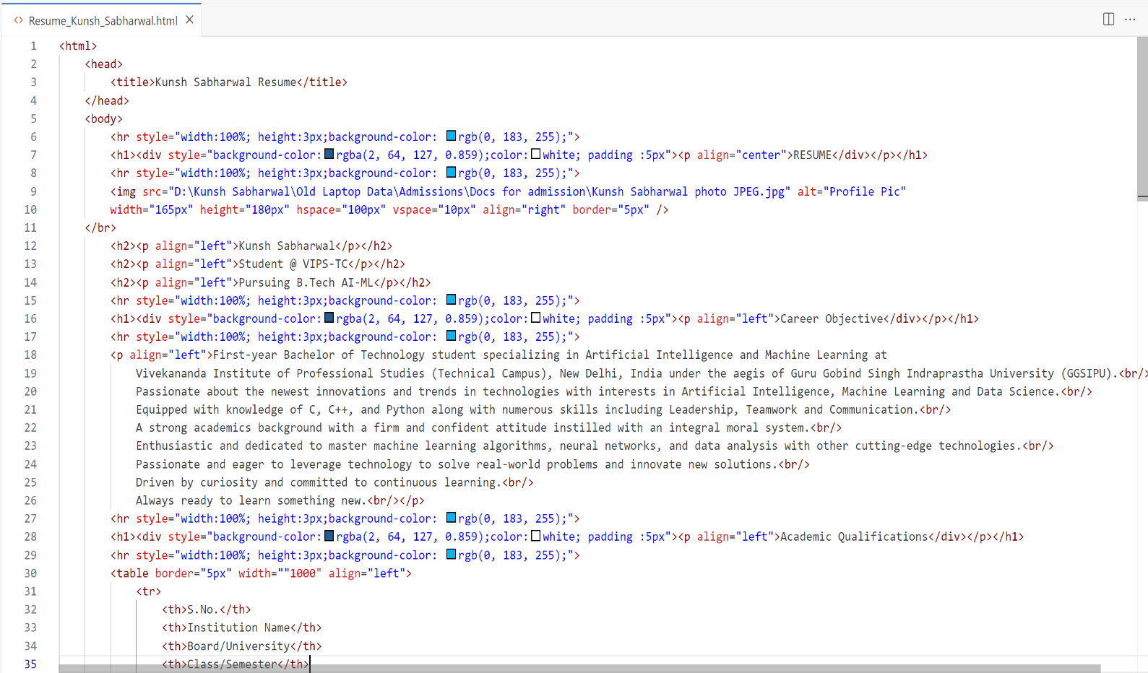**Source Code:**

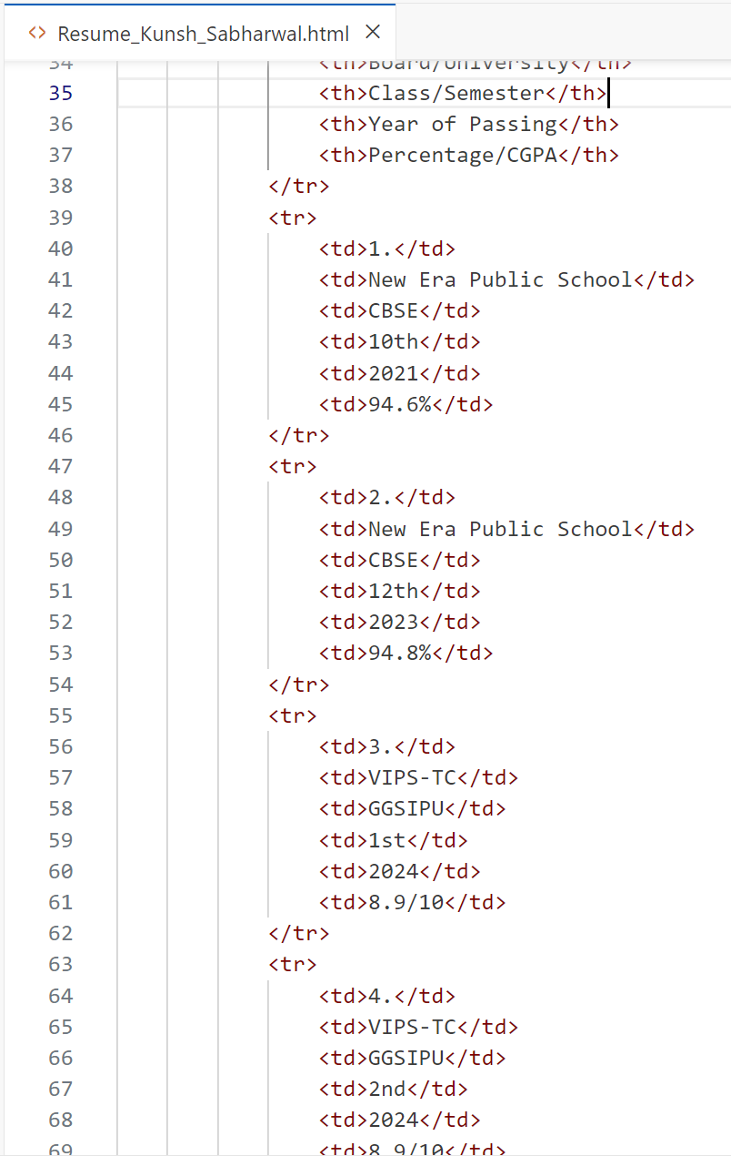

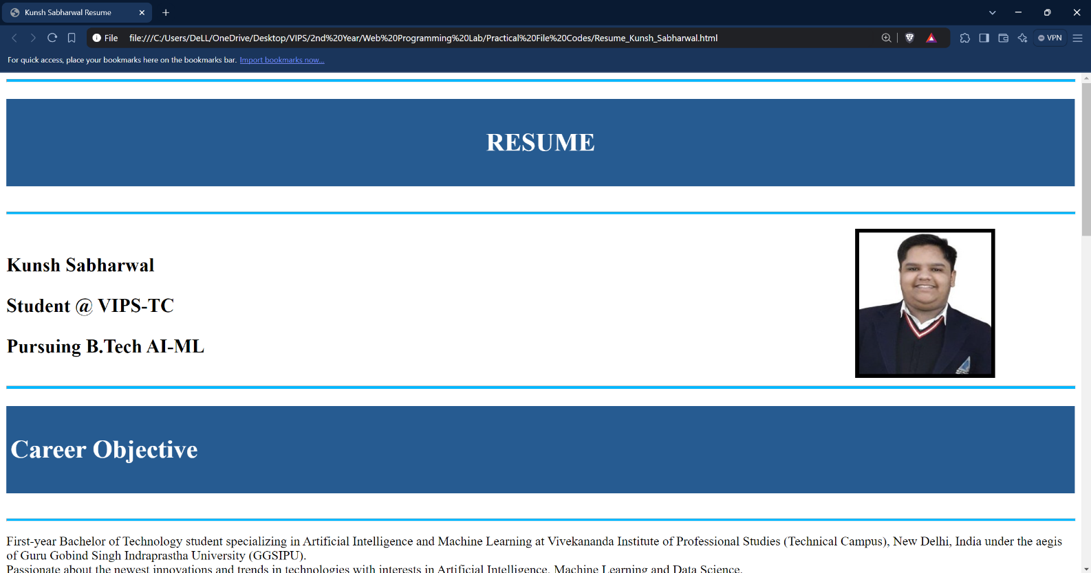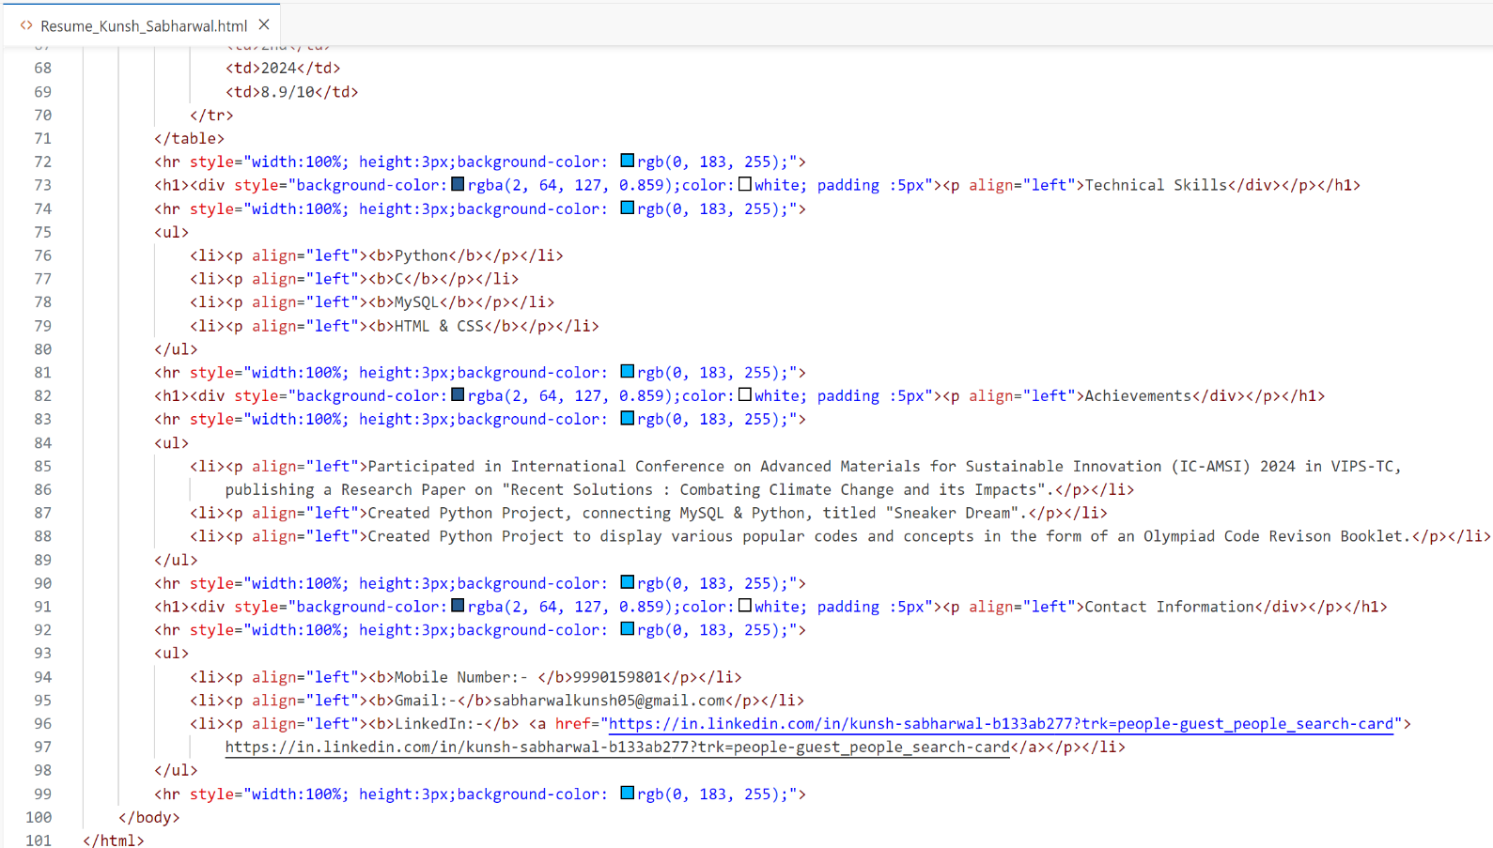**Output:**

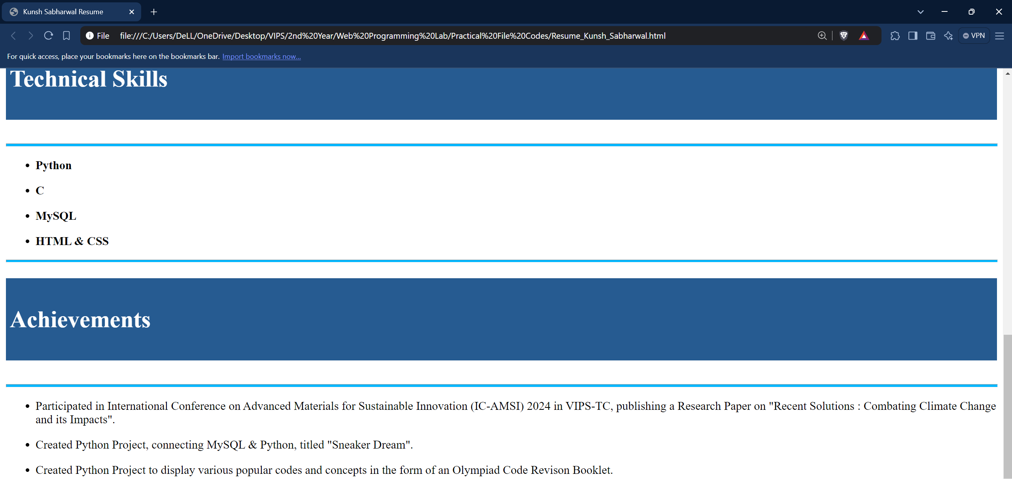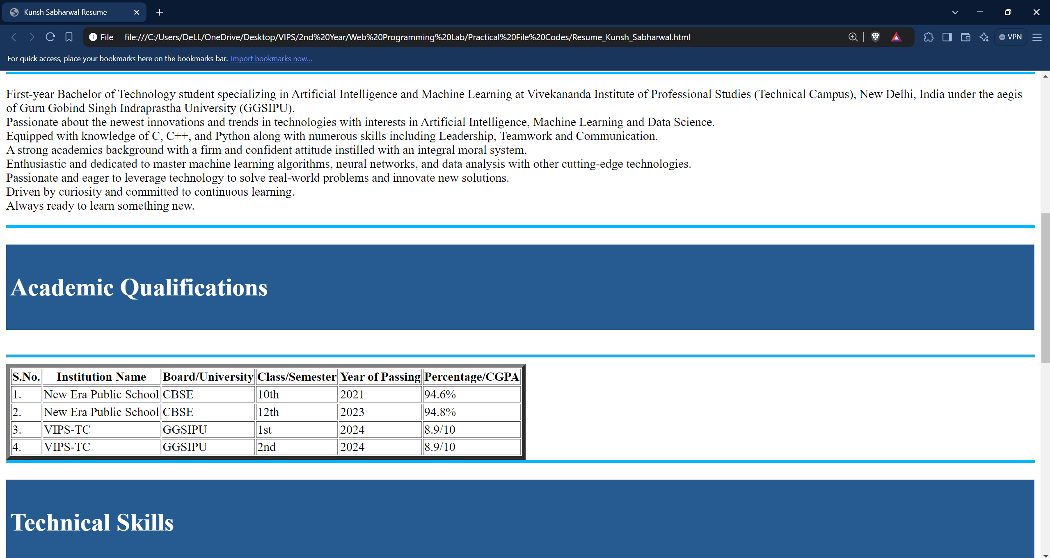

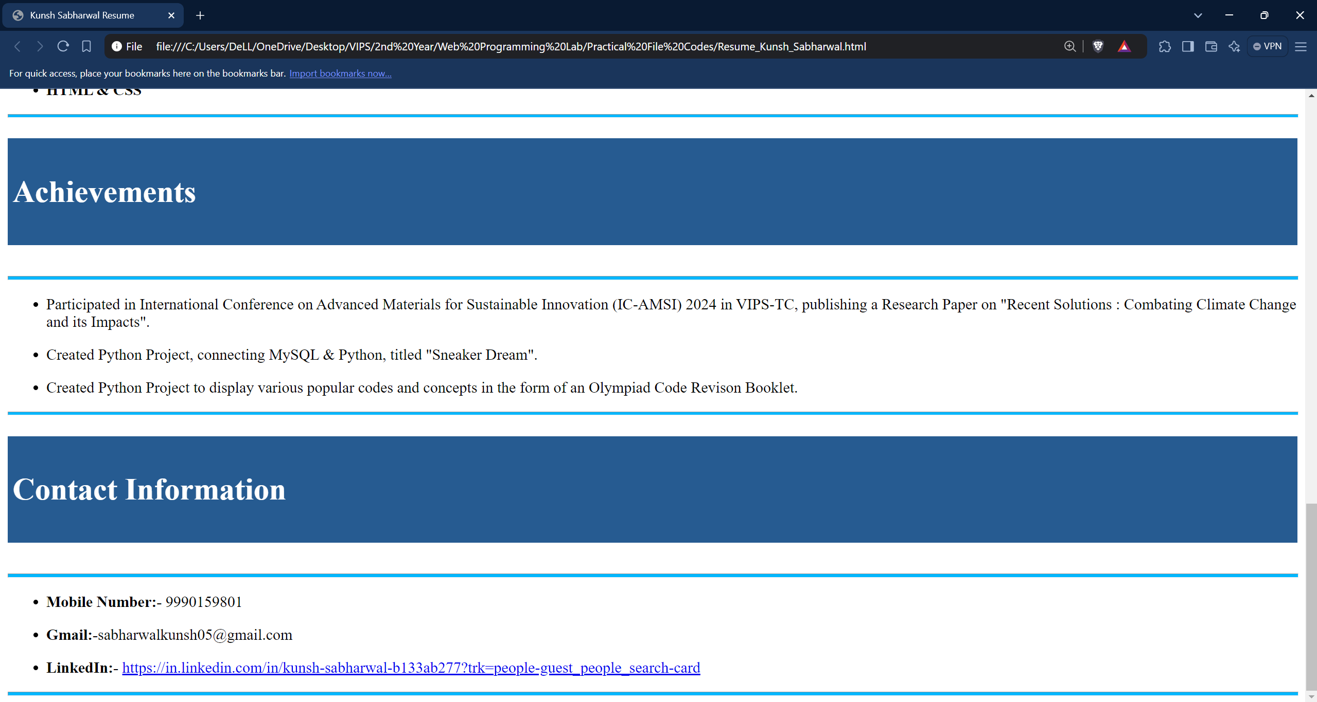**Learning Outcome:**

**EXPERIMENT 2**

**Problem statement:** Create a webpage that displays brief details of various programming language using various types of CSS.

**Theory:**

**Source Code:**

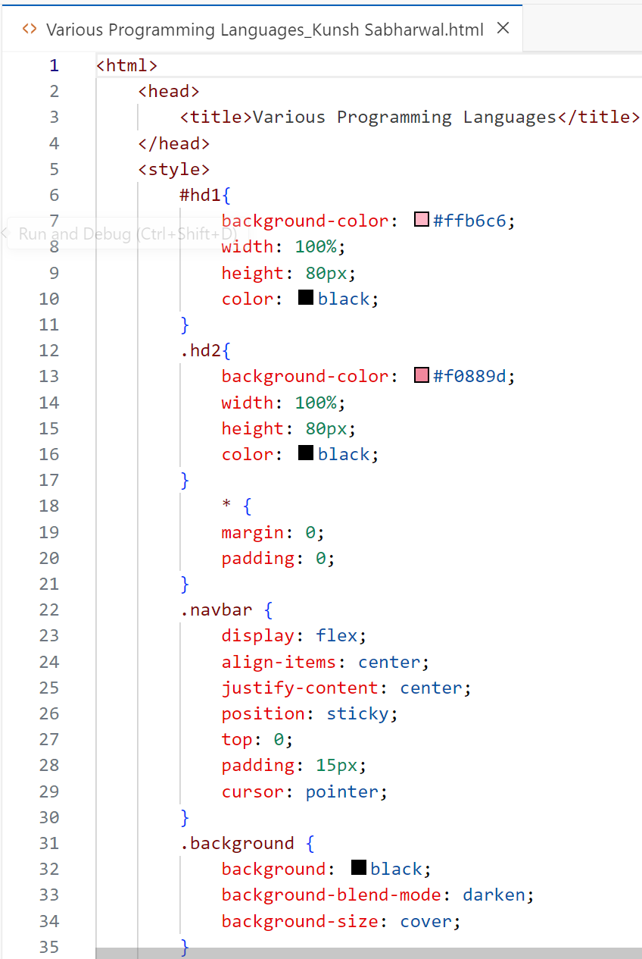

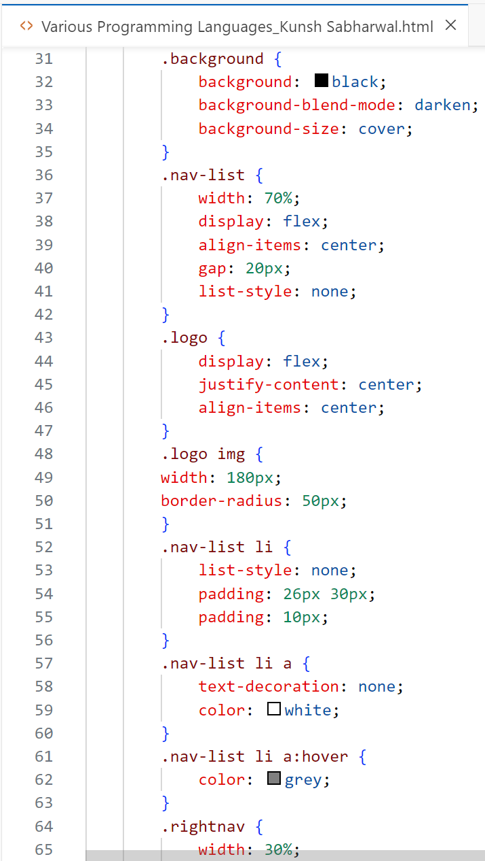

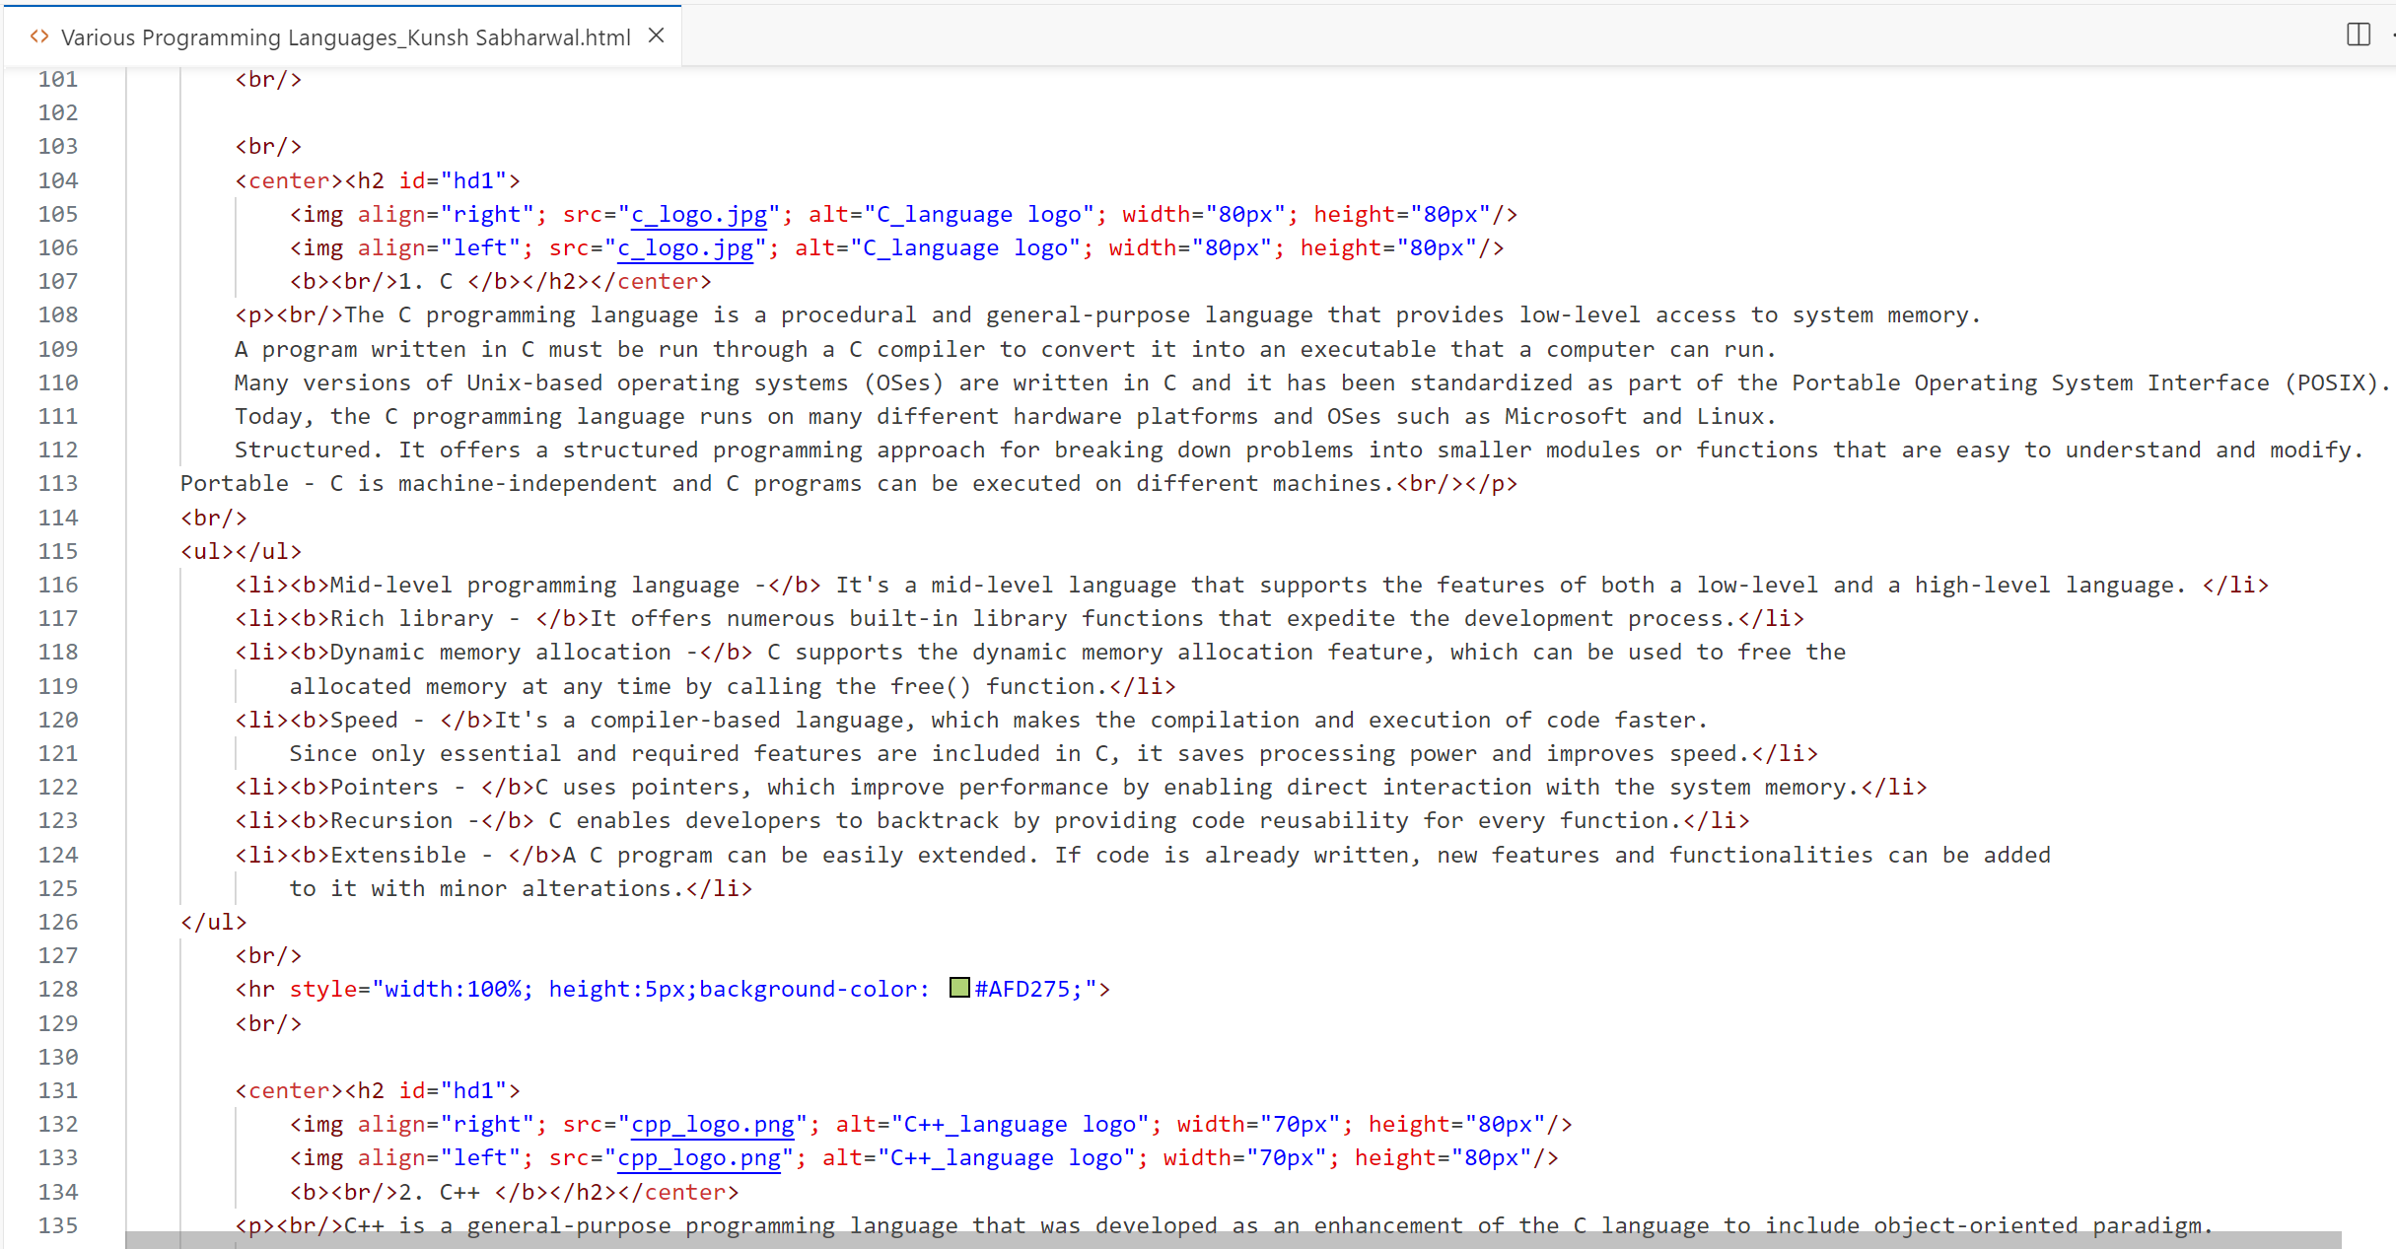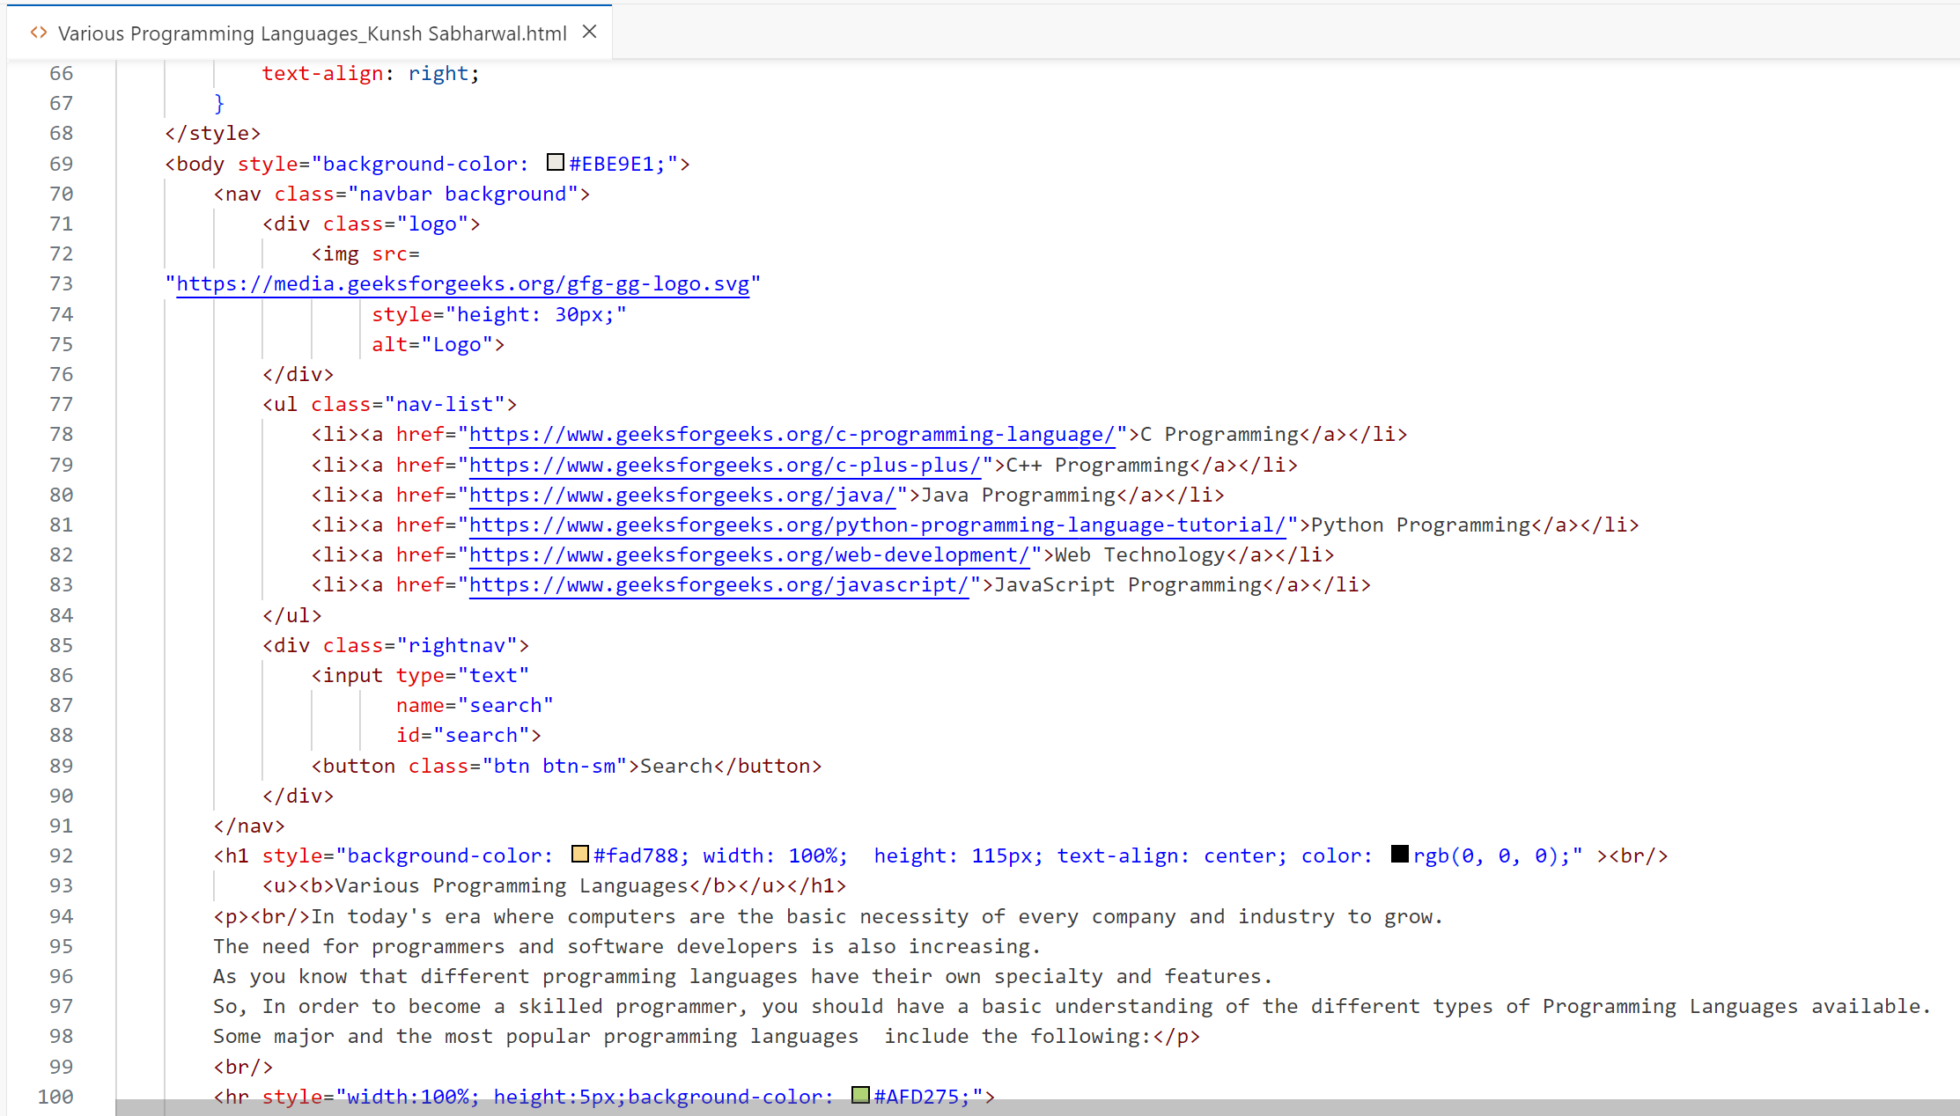

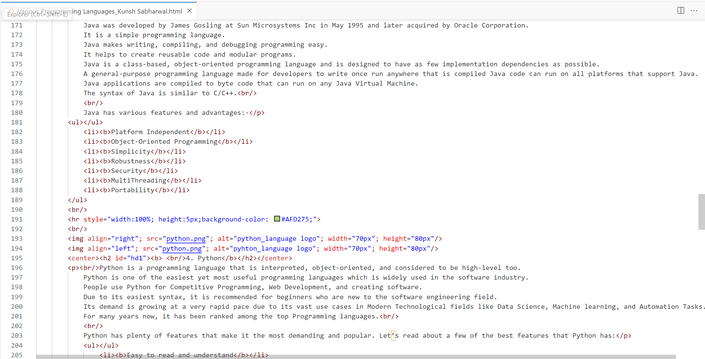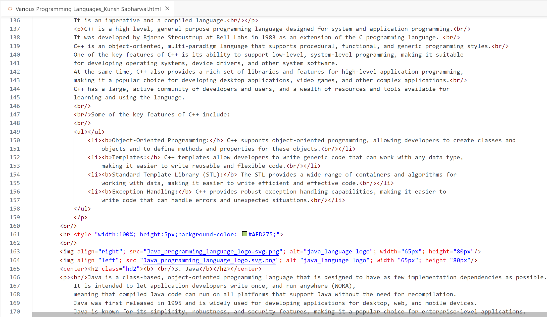

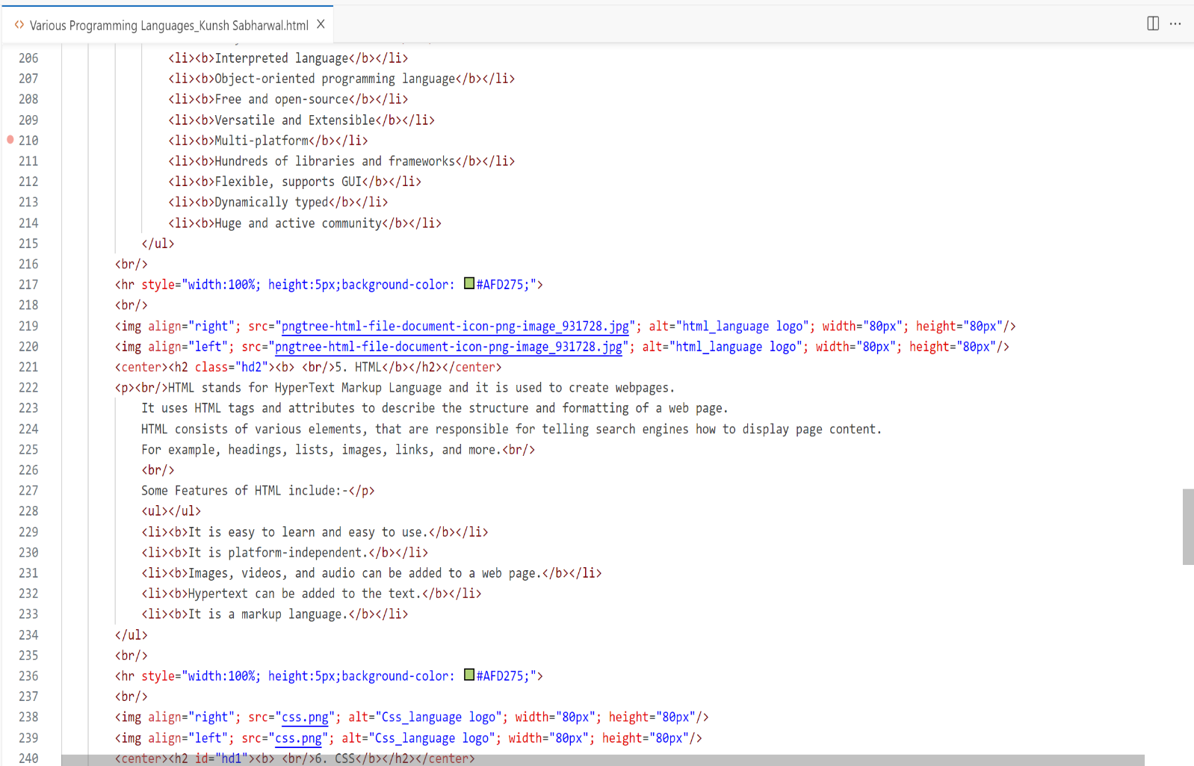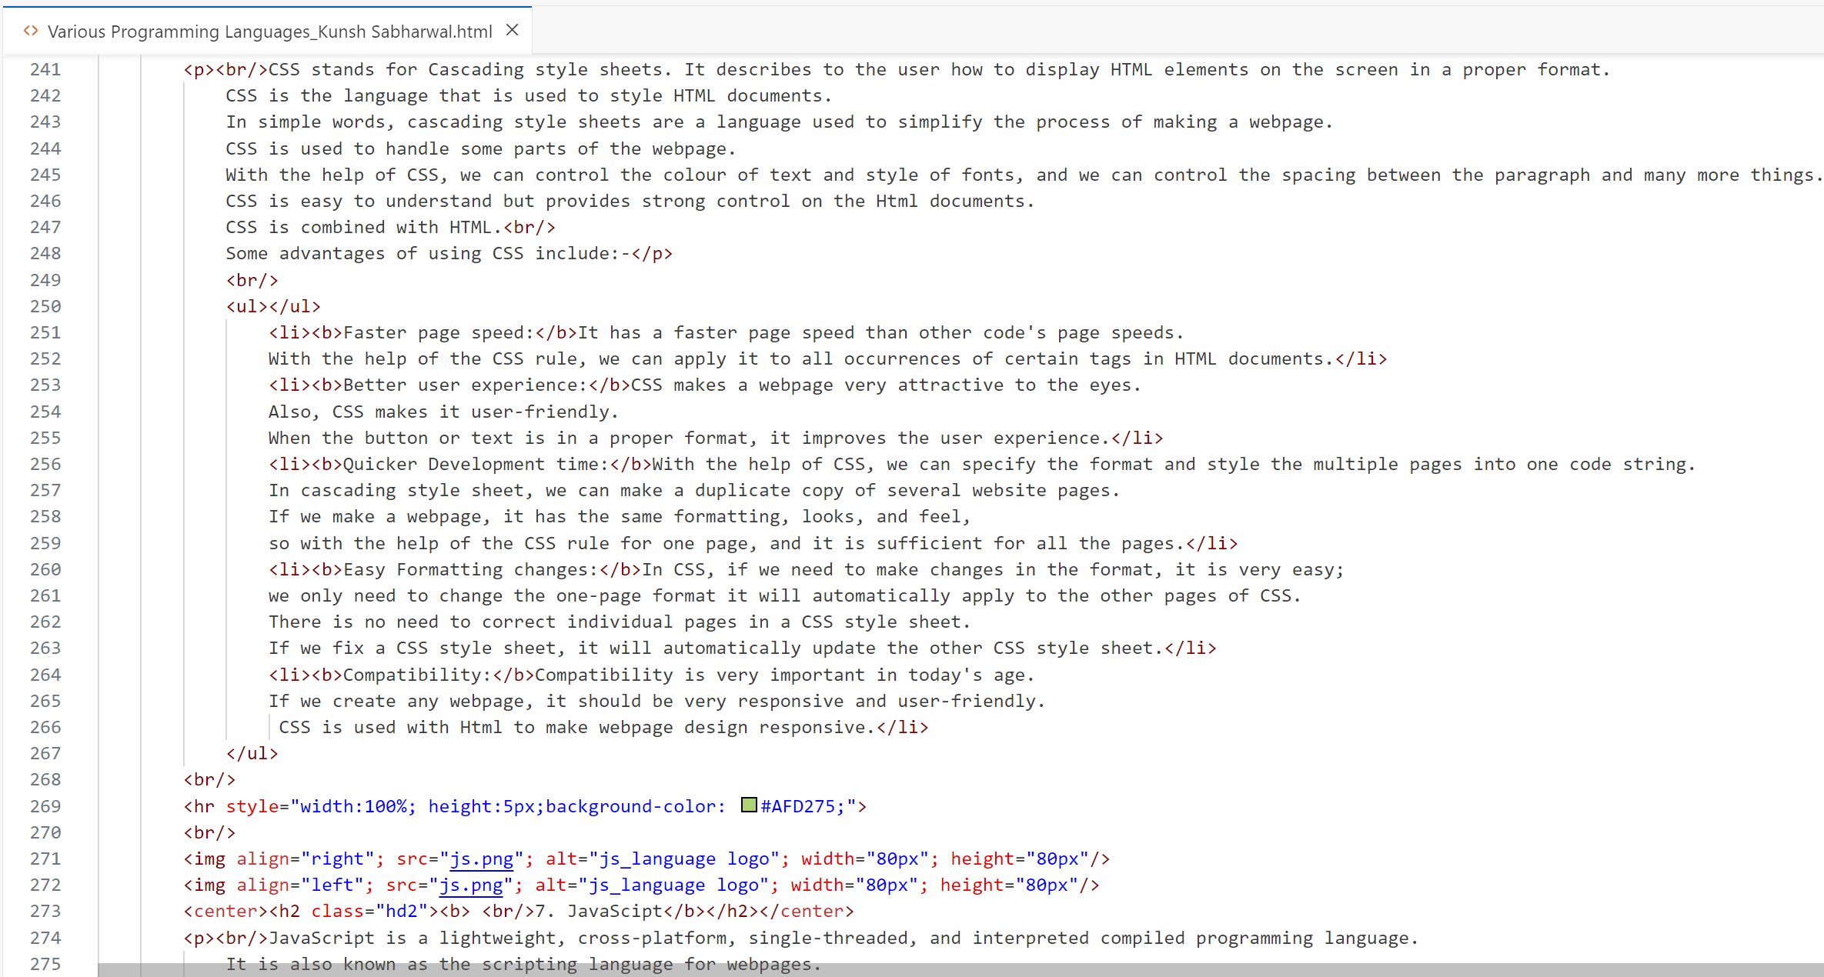

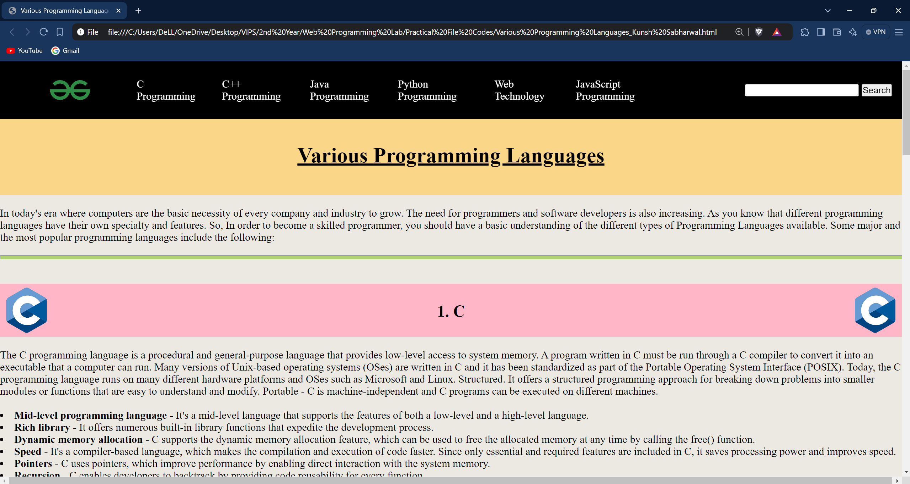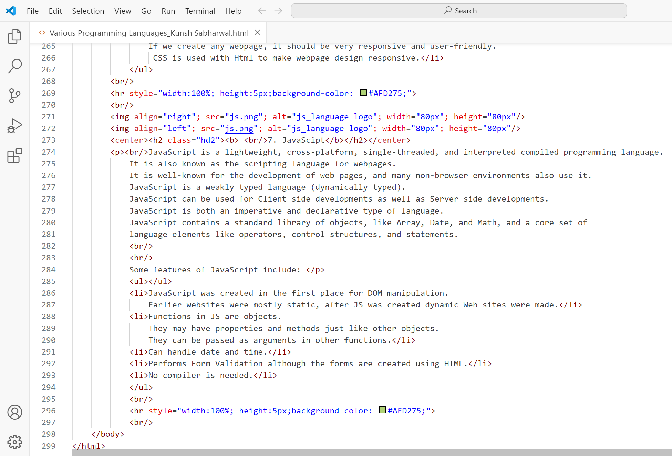**Output:**

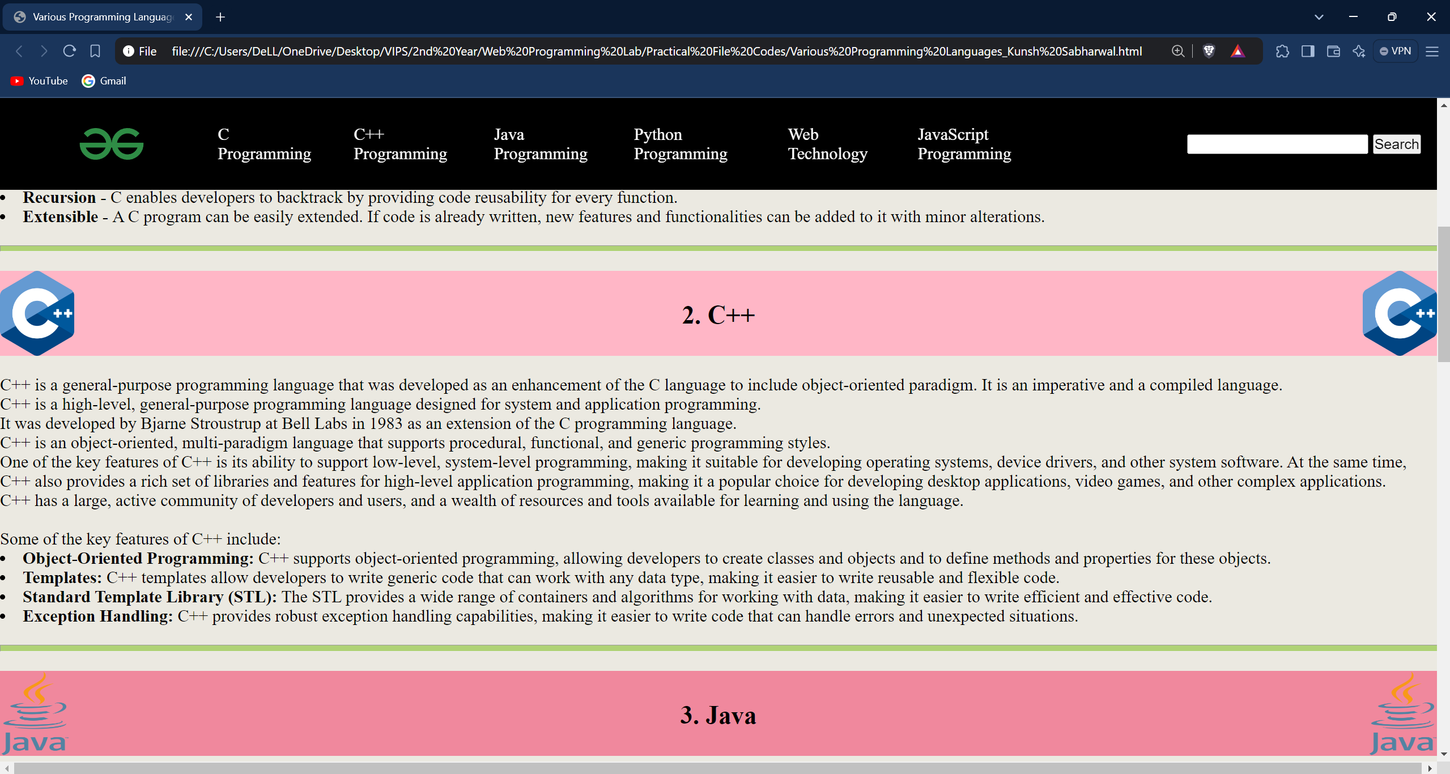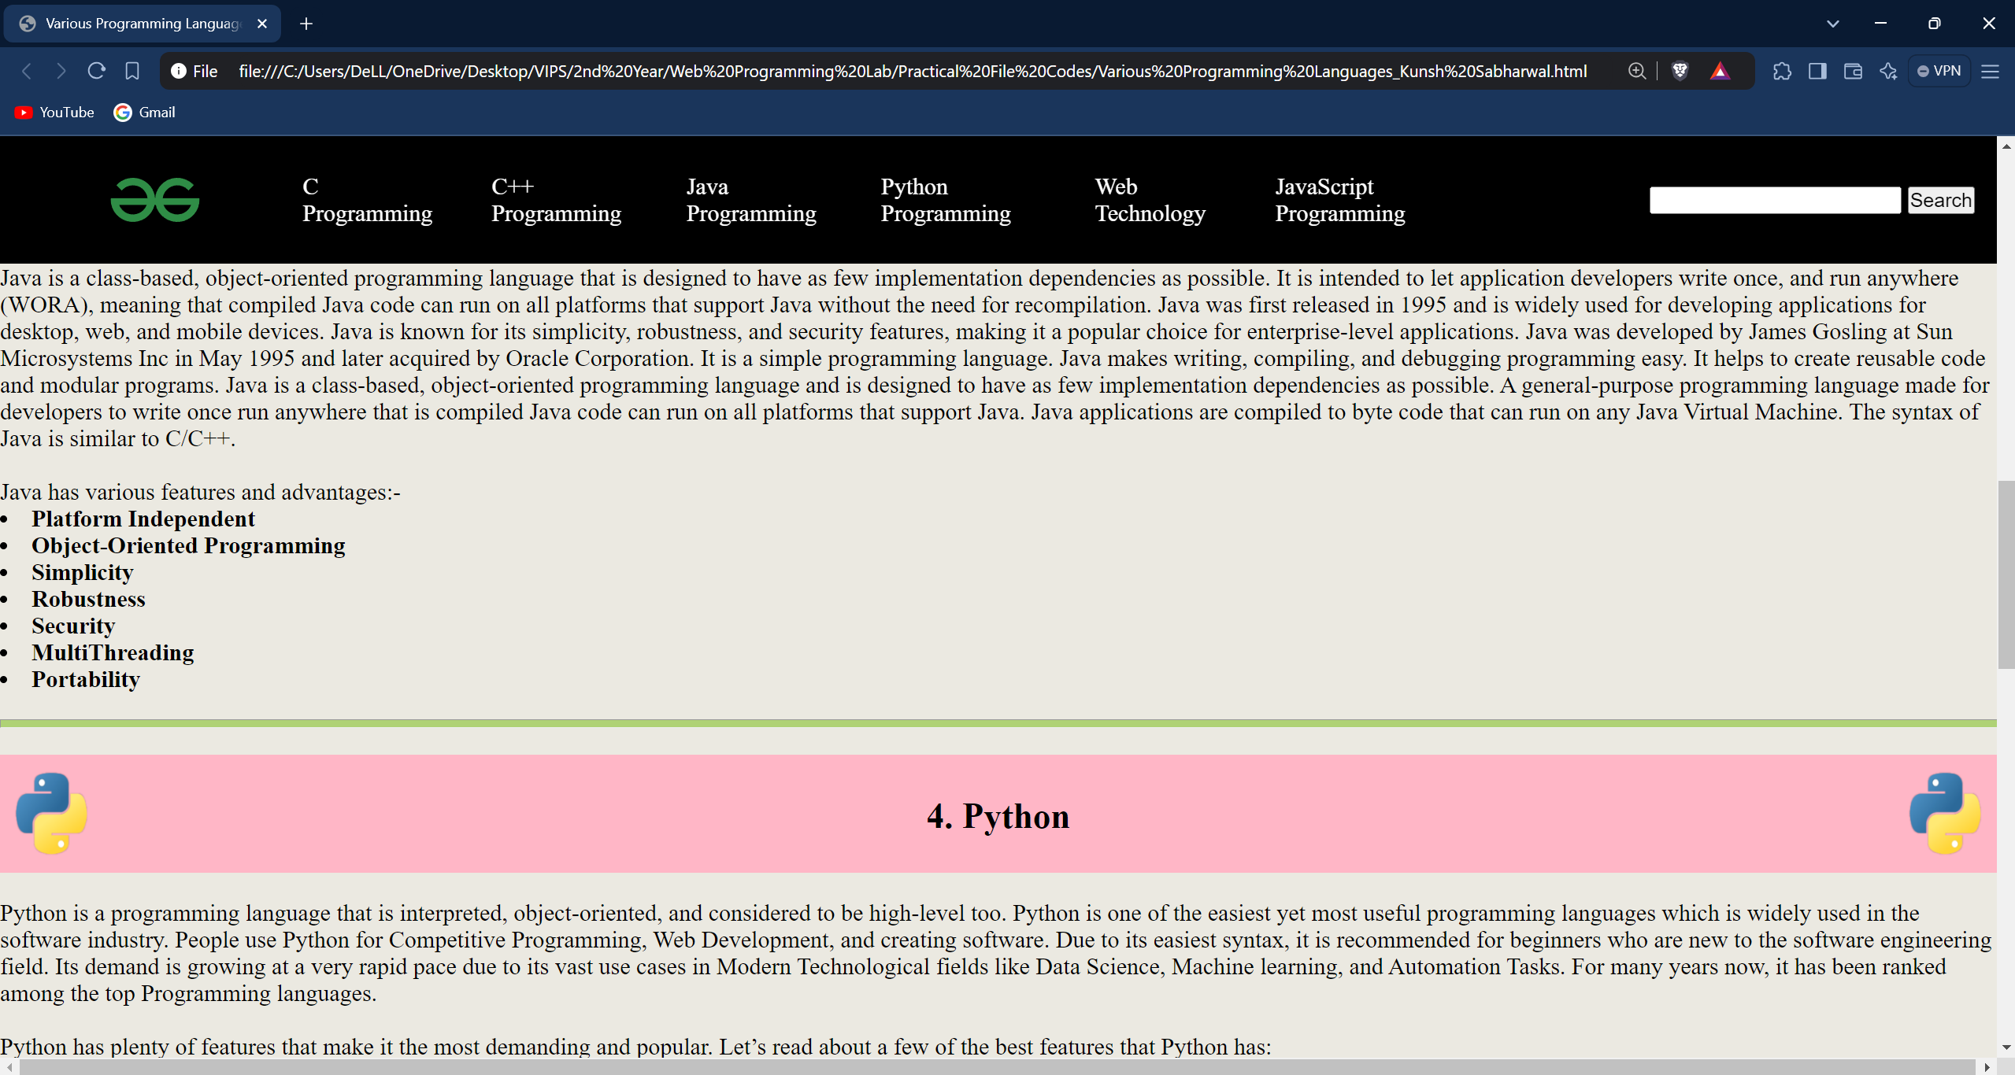

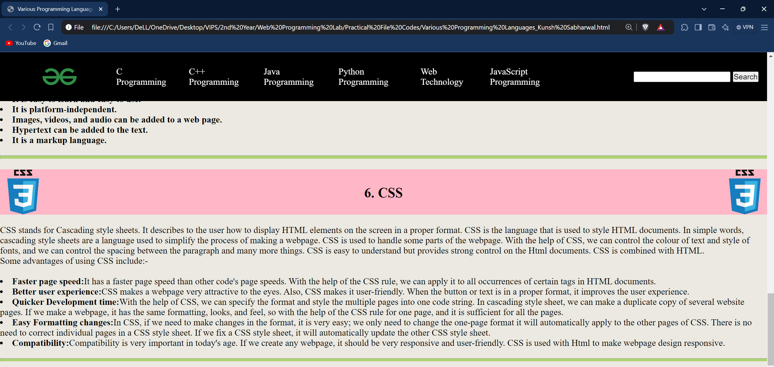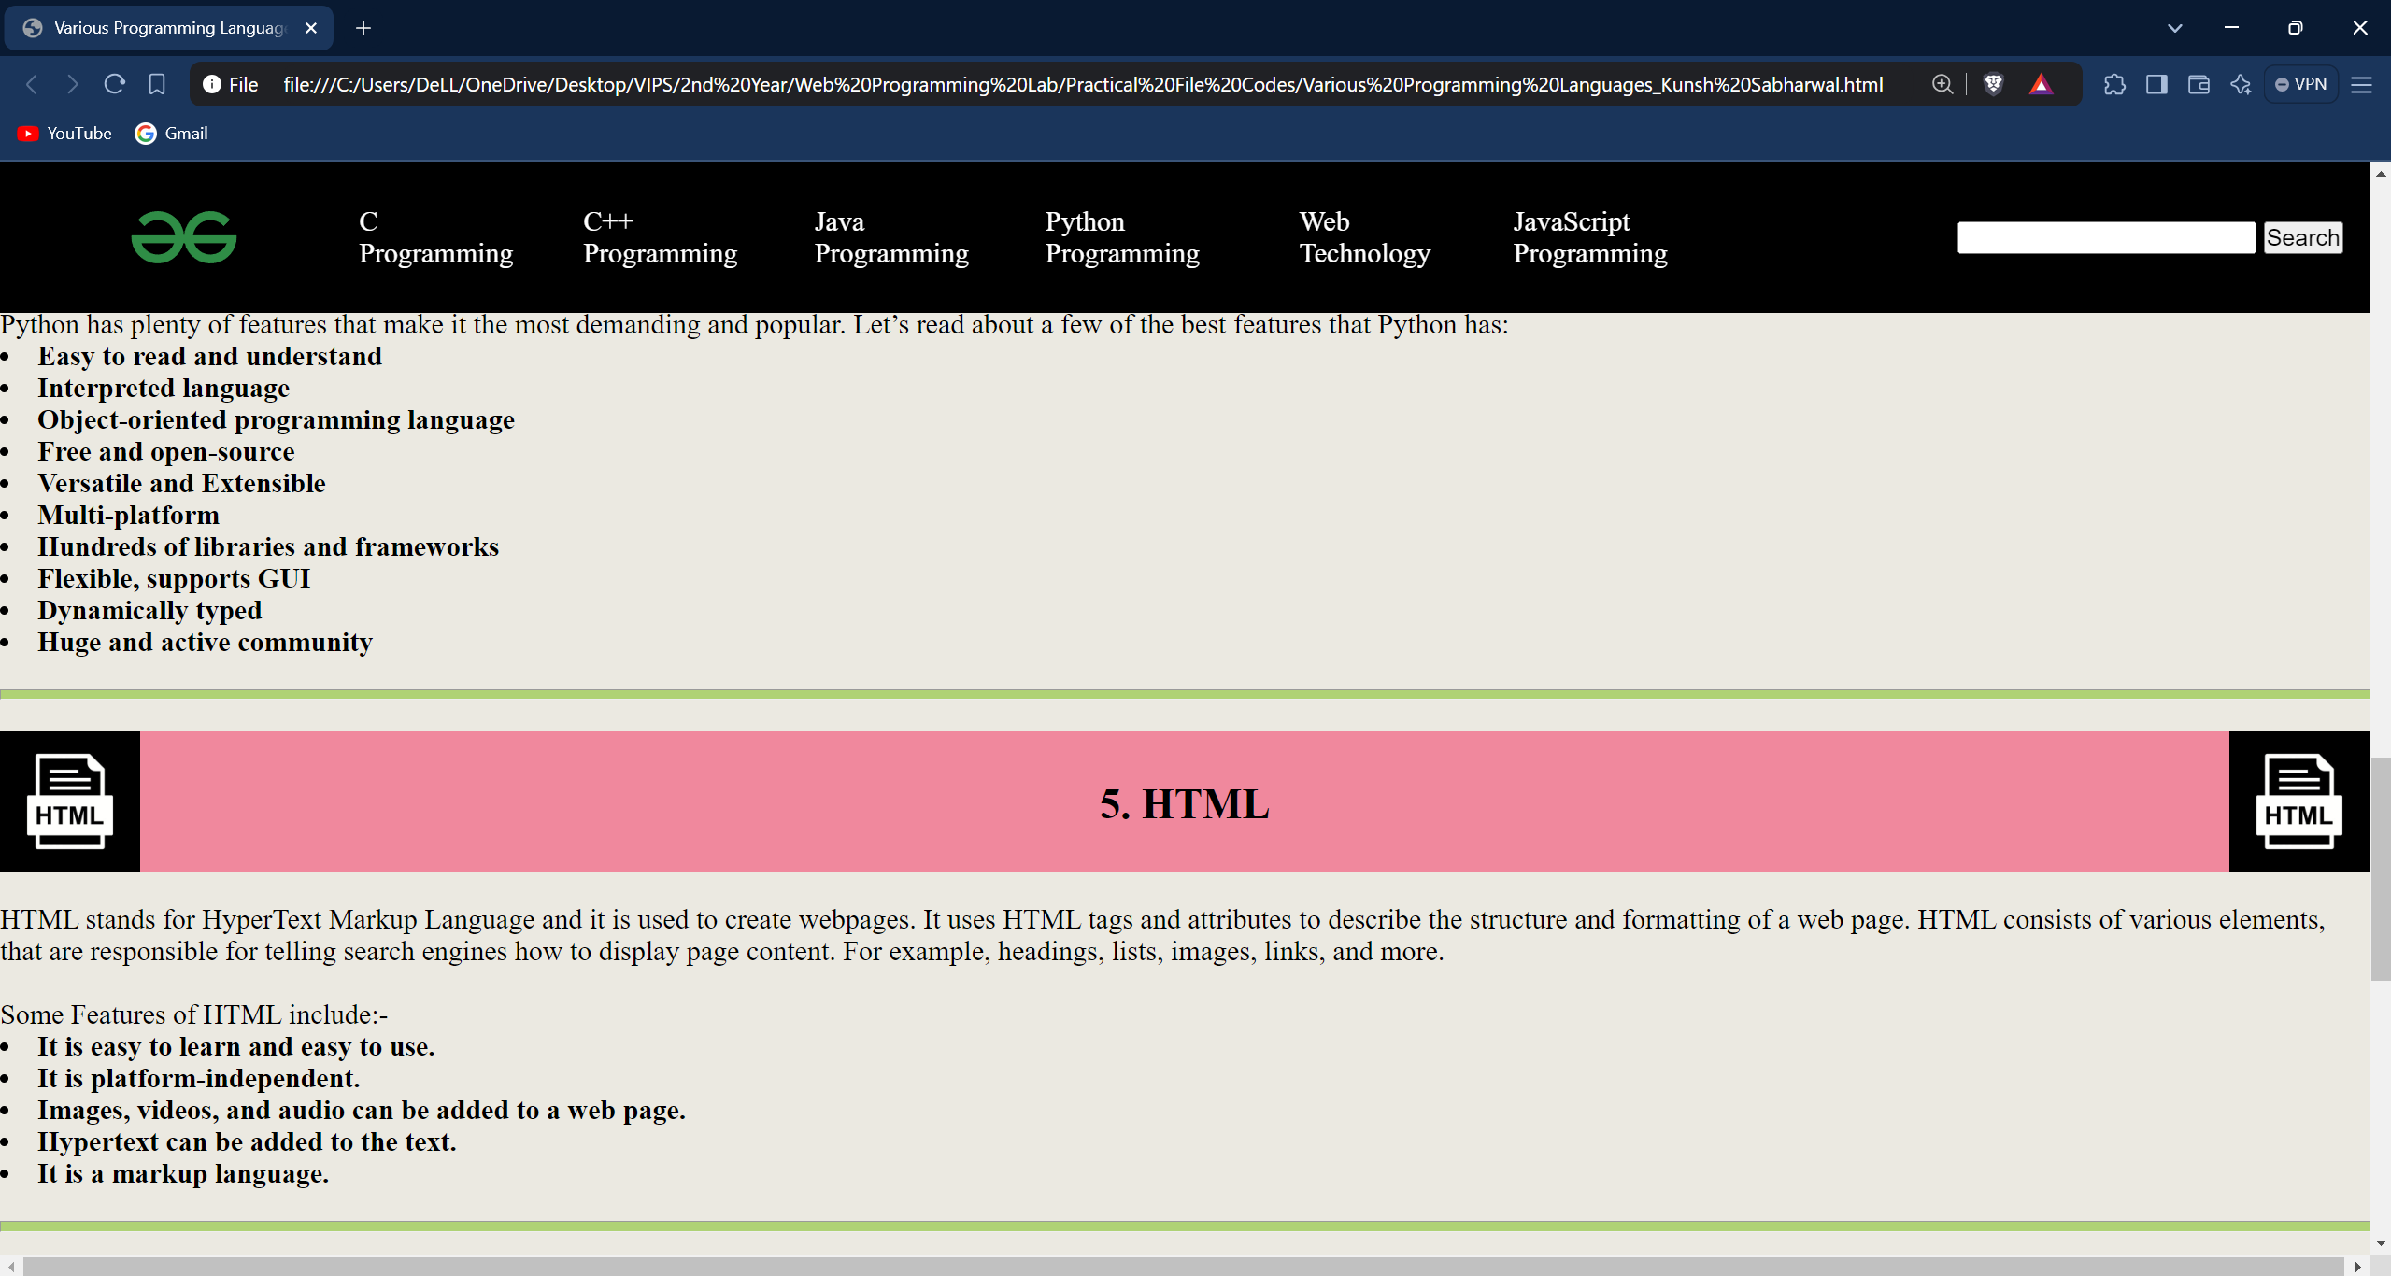

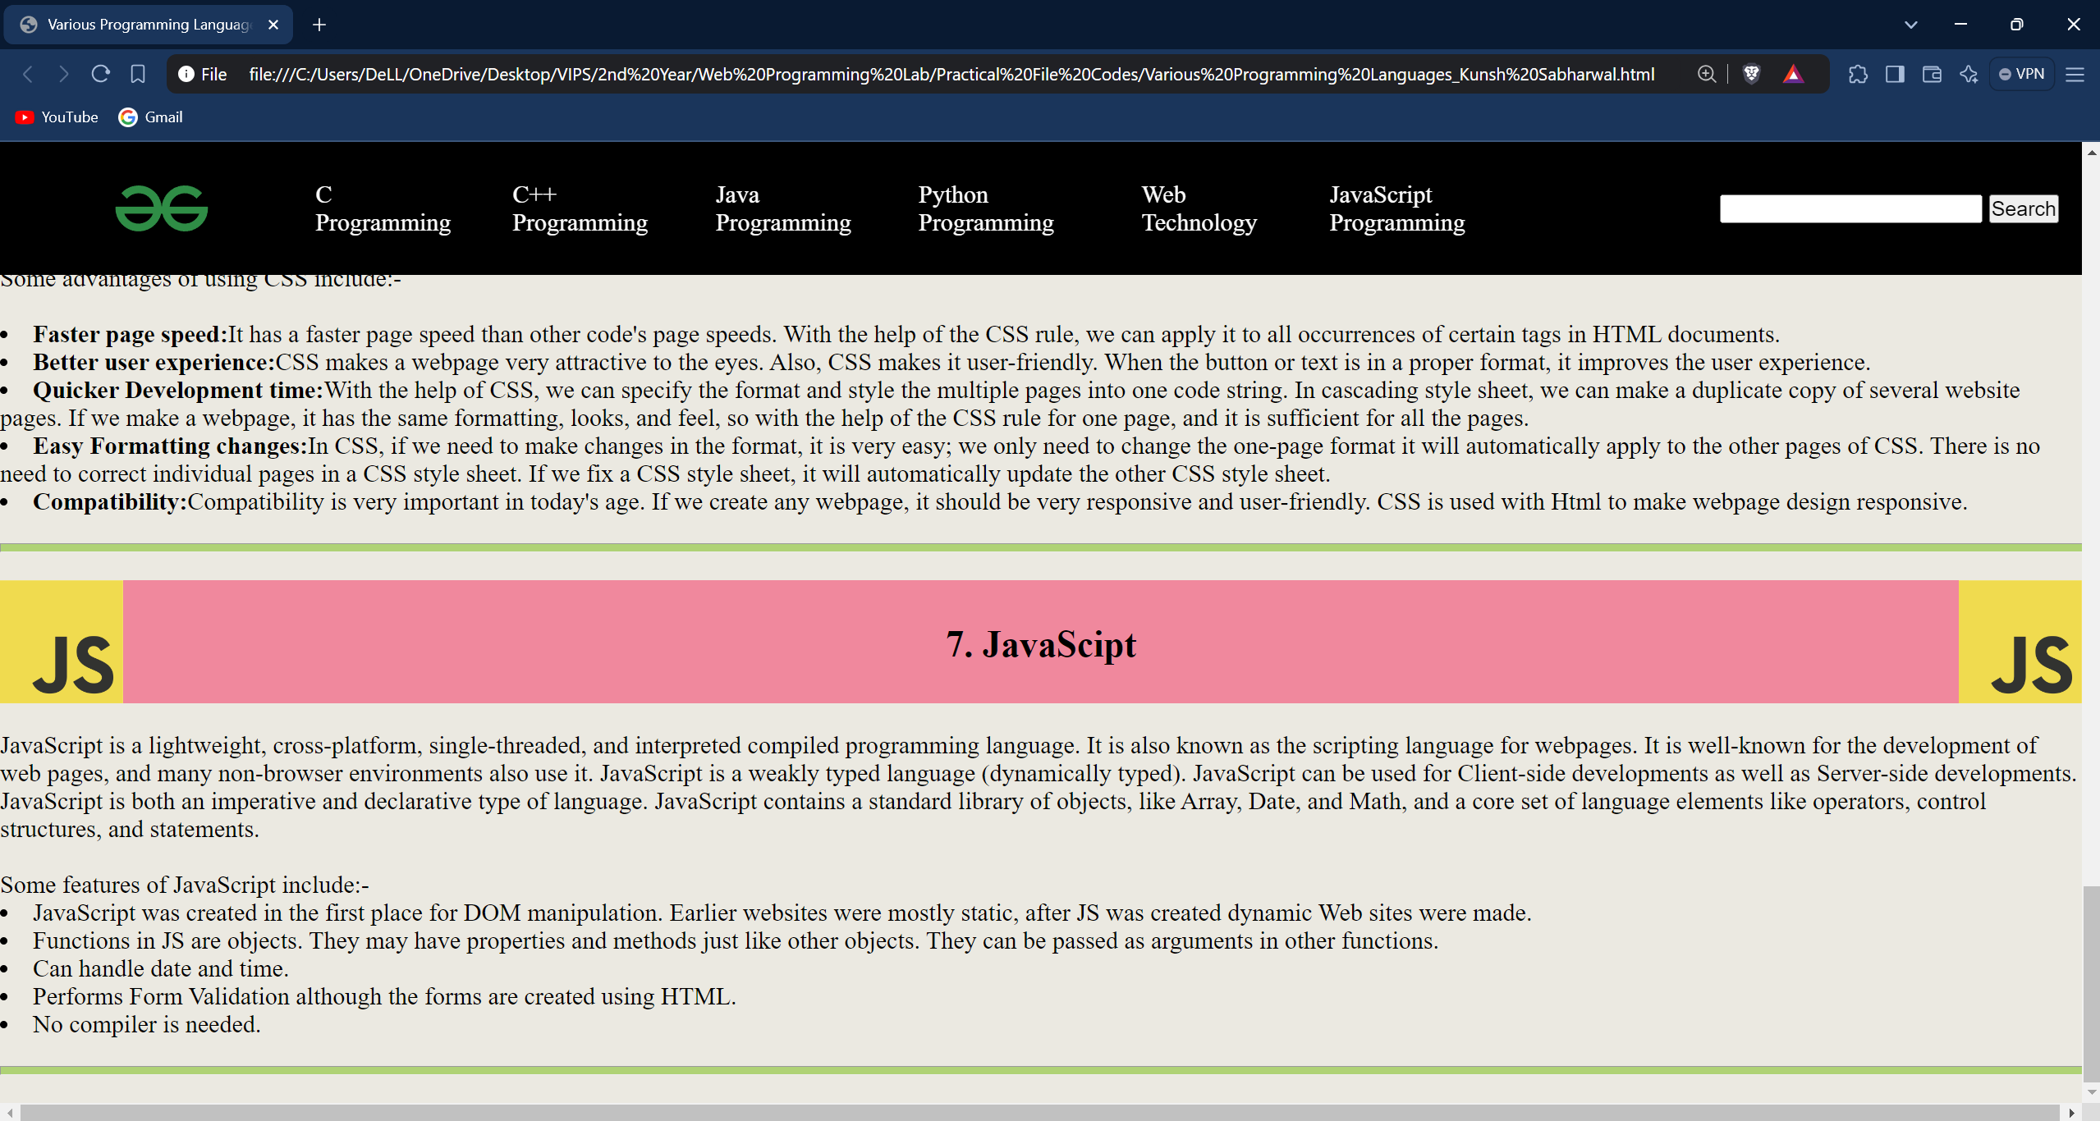

**Learning Outcome:**

**EXPERIMENT 3**

**Problem statement:** Create a webpage using JavaScript and HTML to demonstrate Simple Calculator Application.

**Theory:**

**Source Code:**

1. 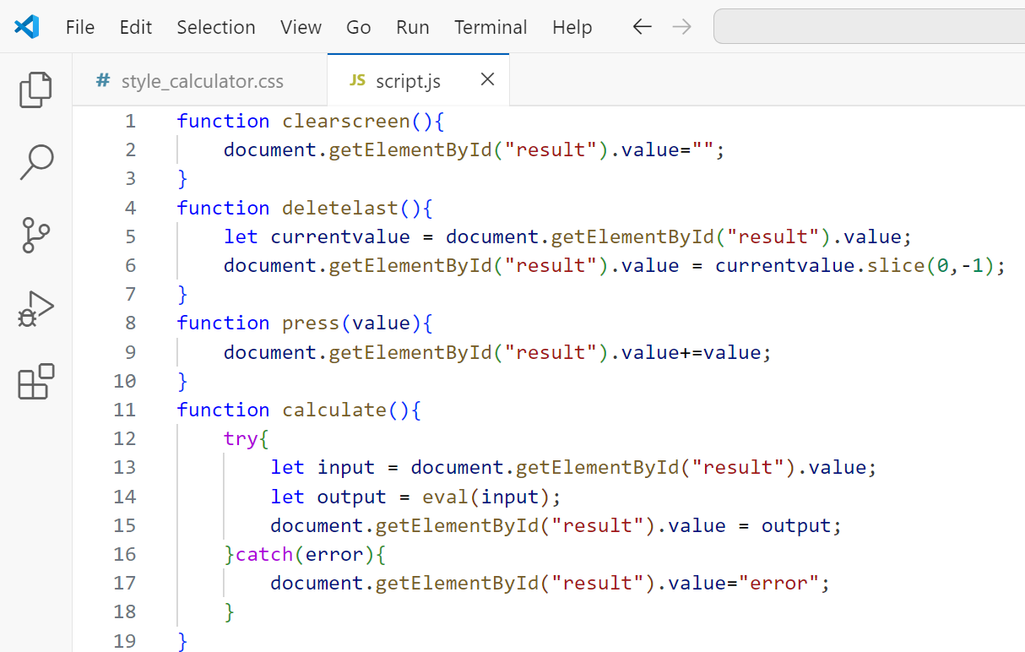**JavaScript Screenshot:**
2. **HTML screenshot:**

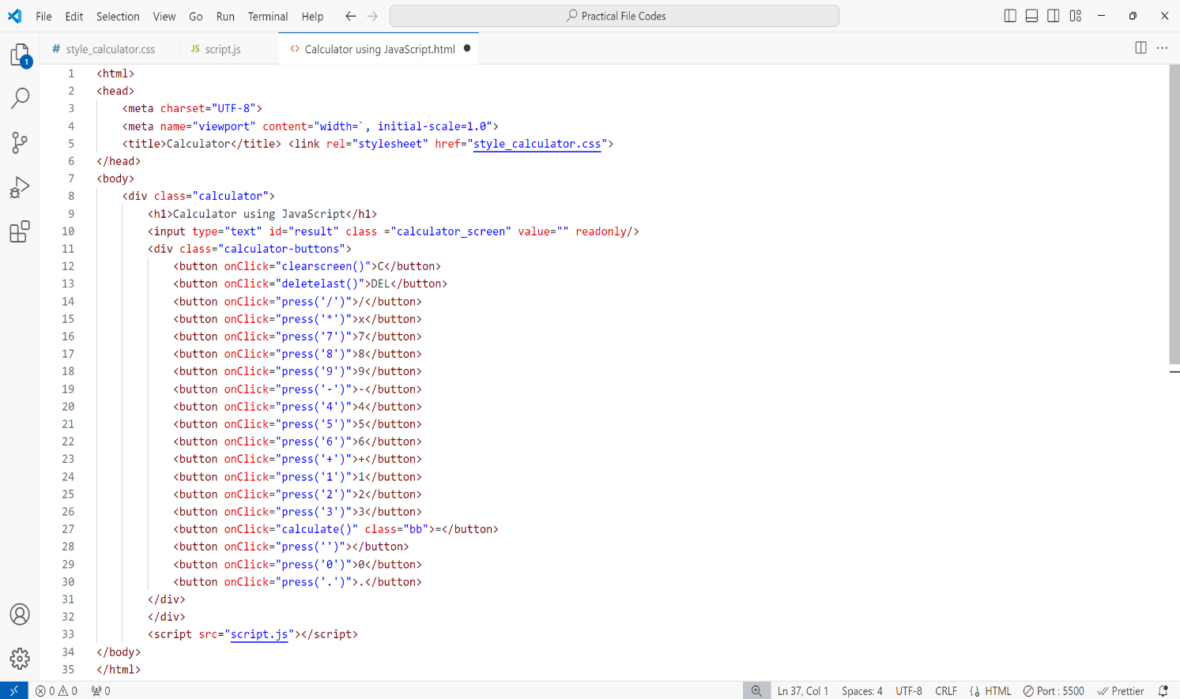

1. 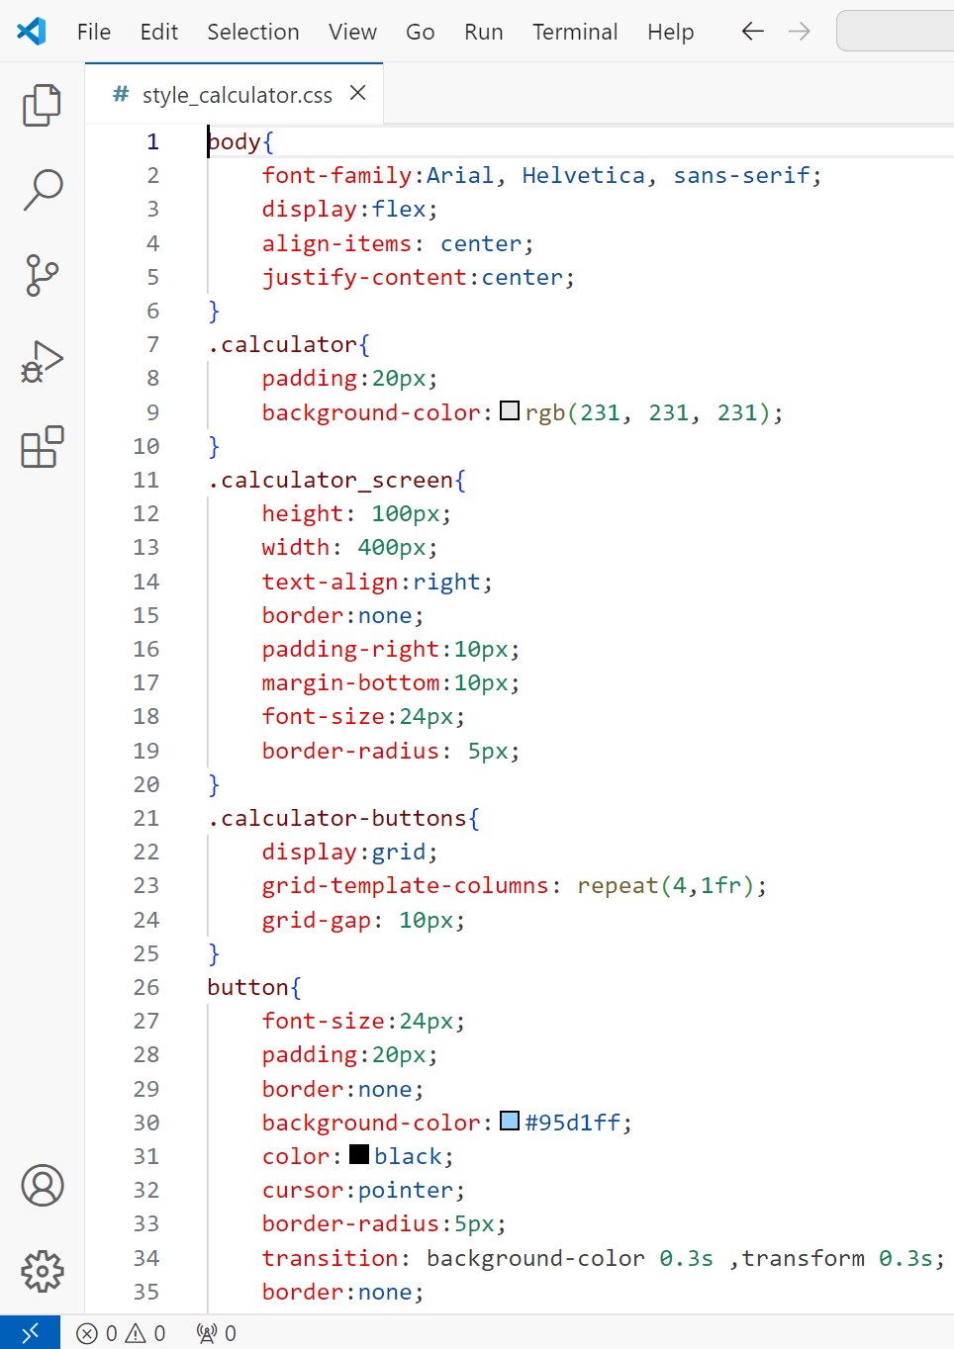**CSS Screenshot:**

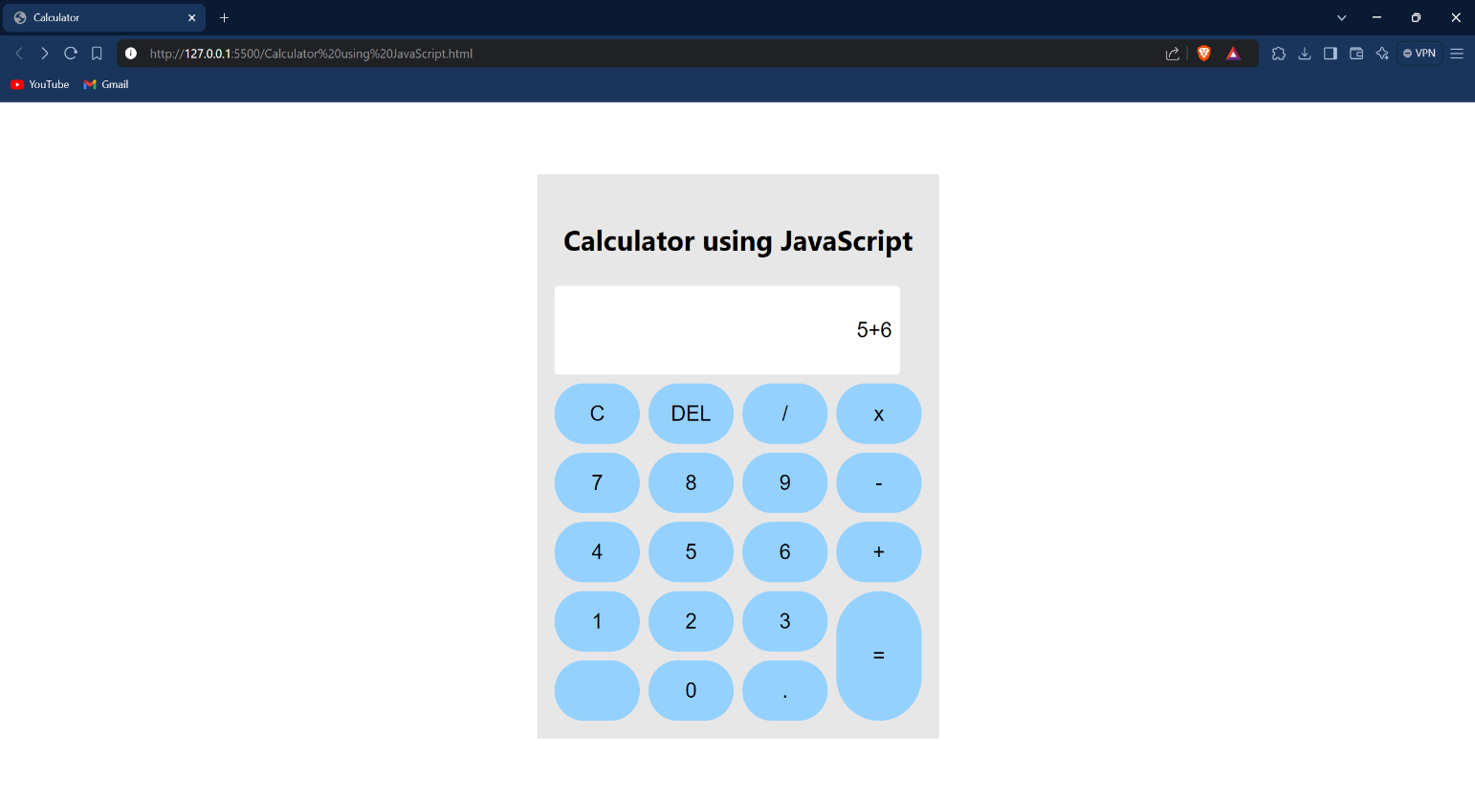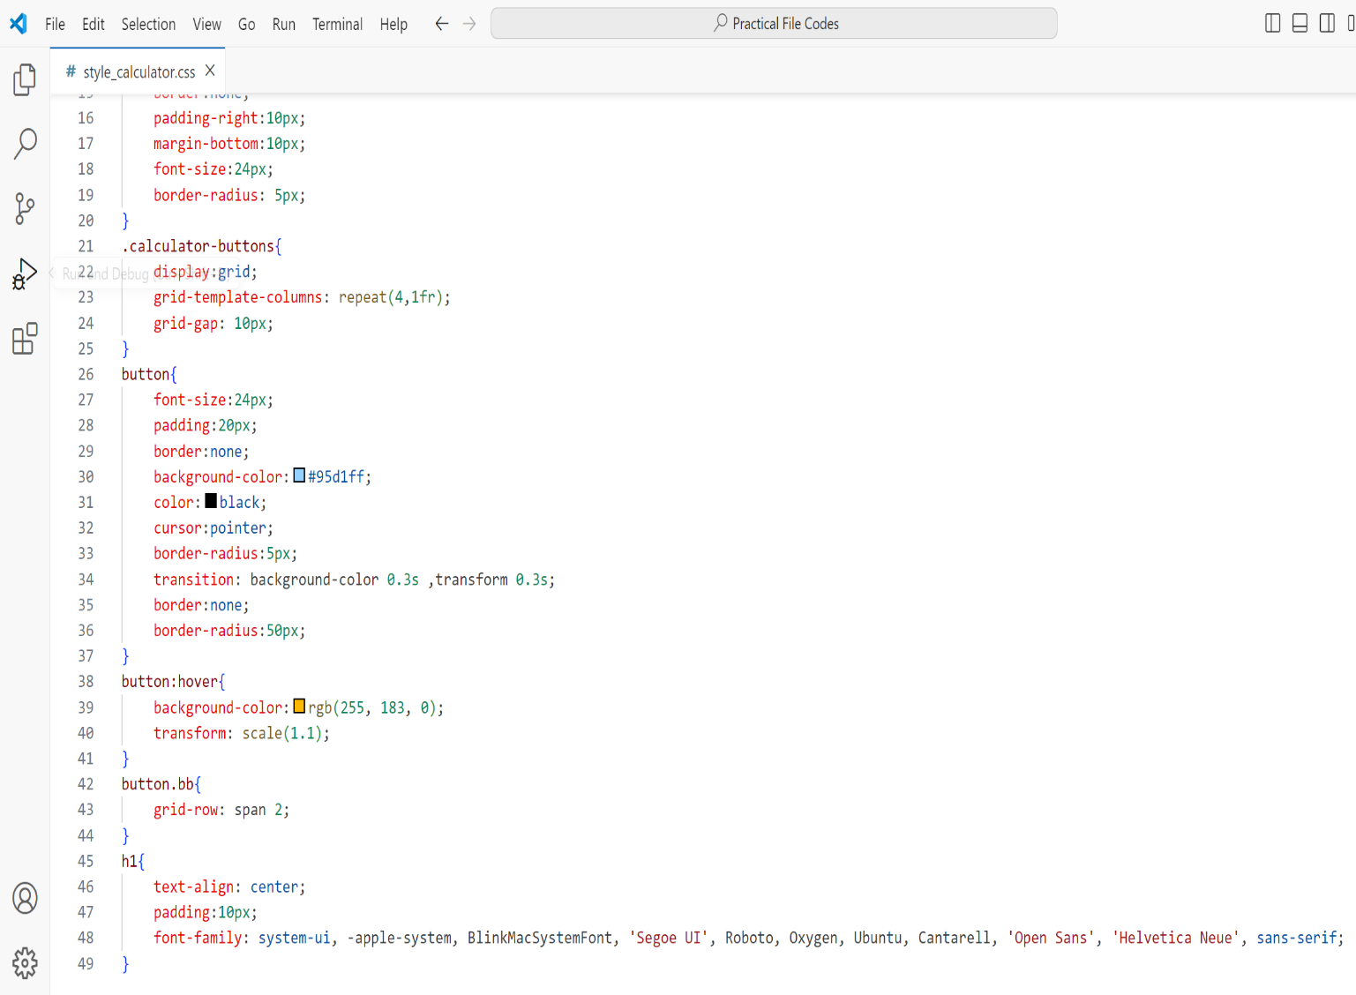**Outputs: (a) Addition**

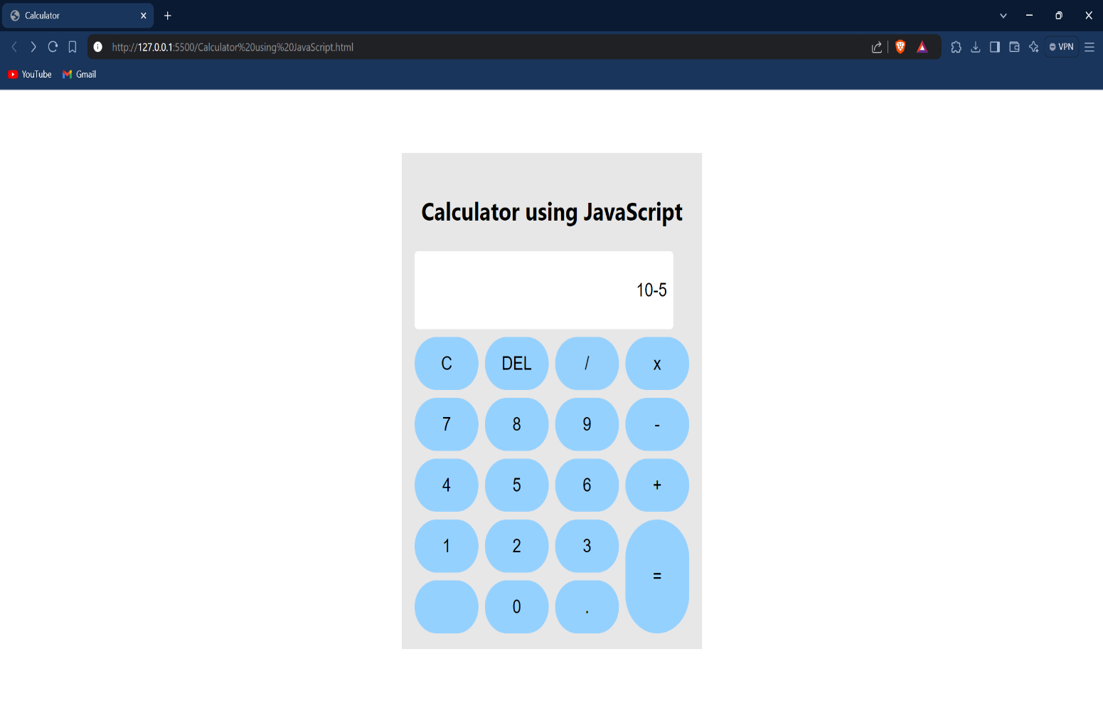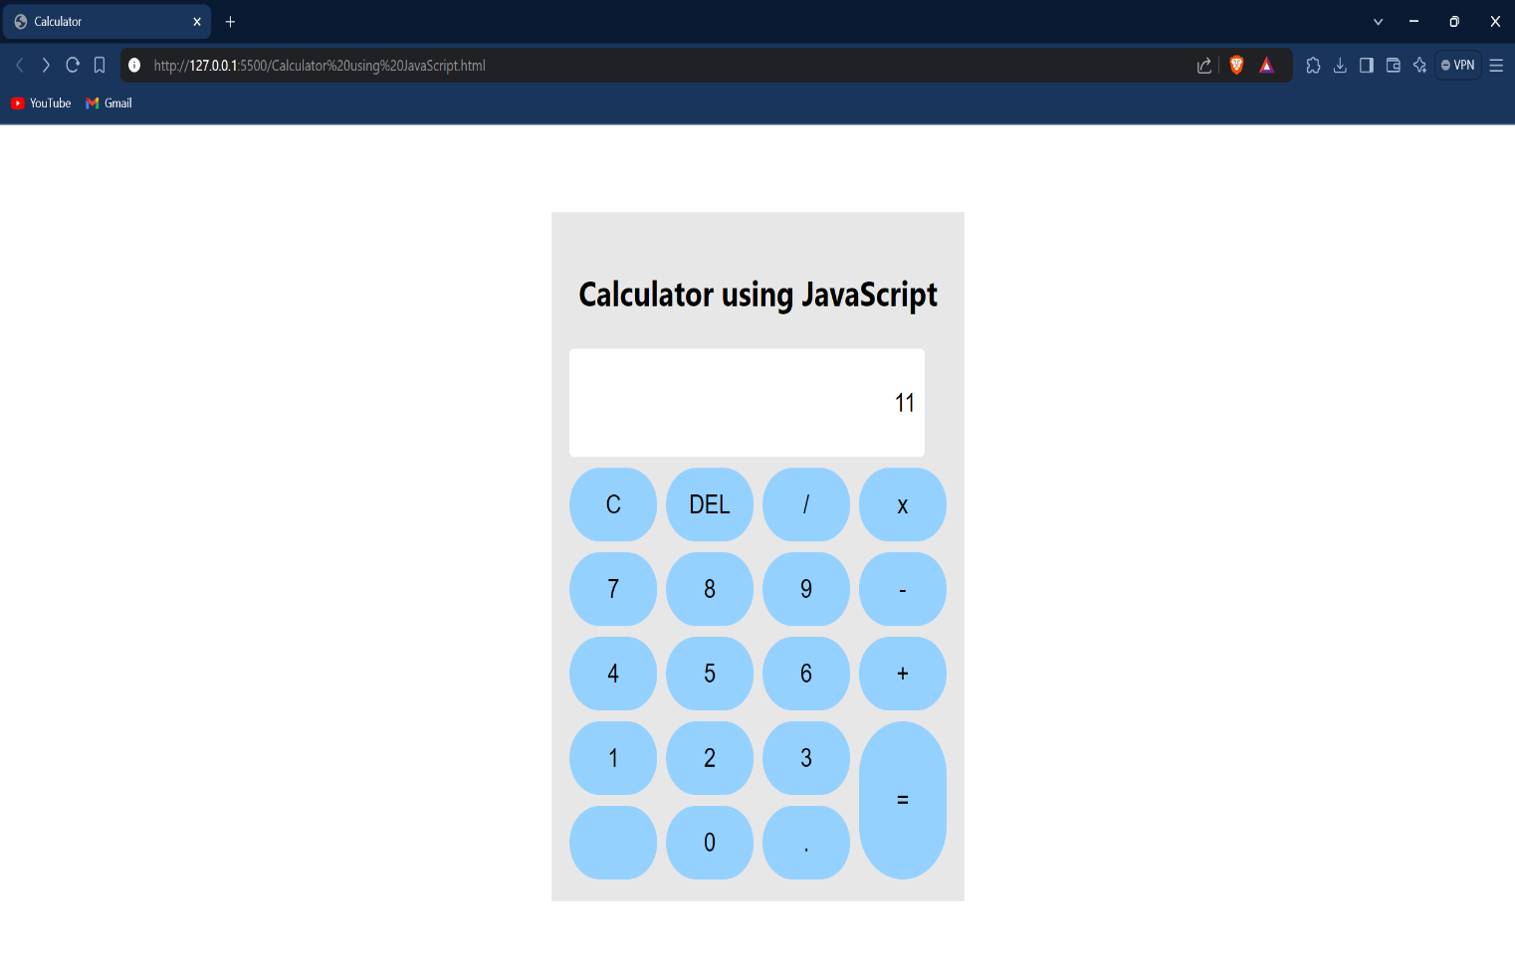**(b) Subtraction:**

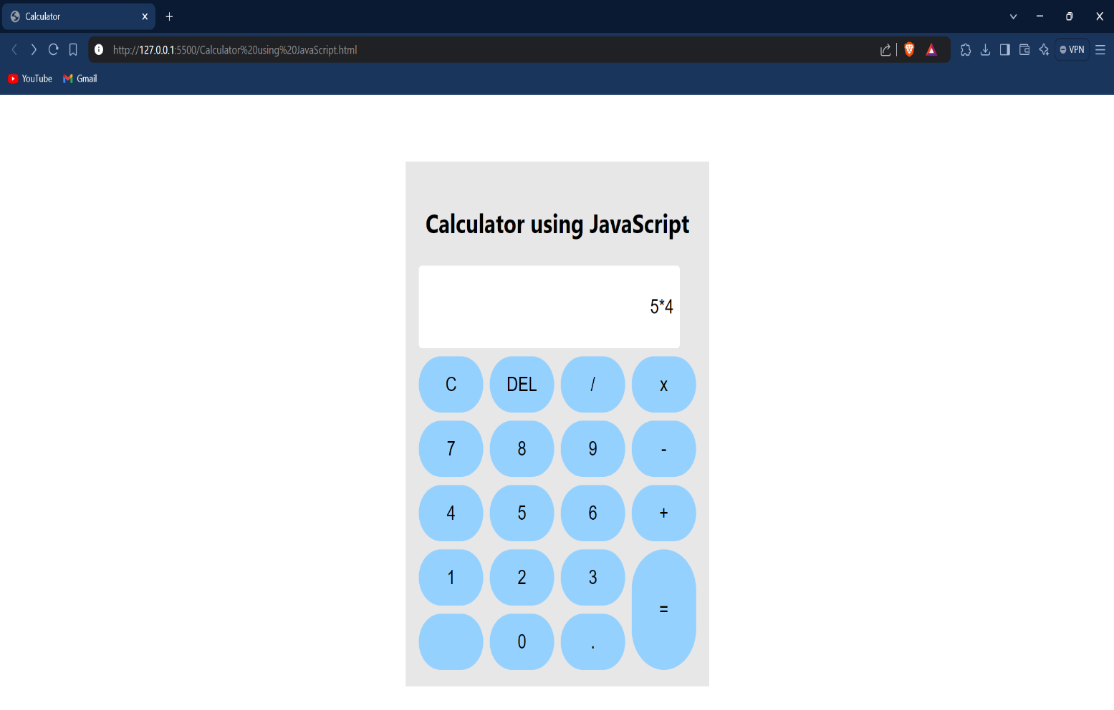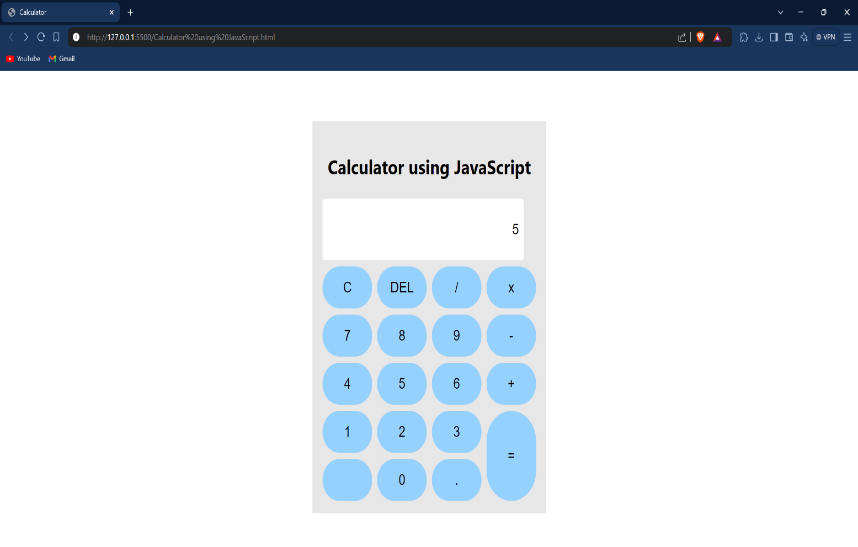**(C) Multiplication:**

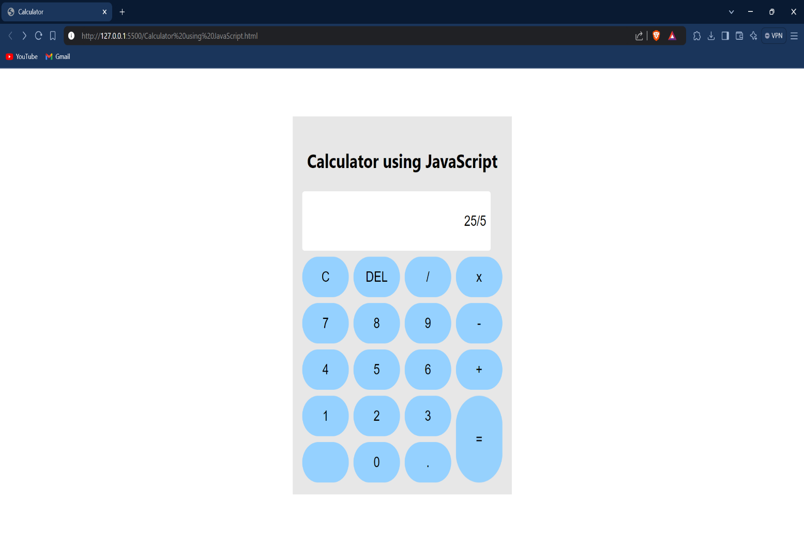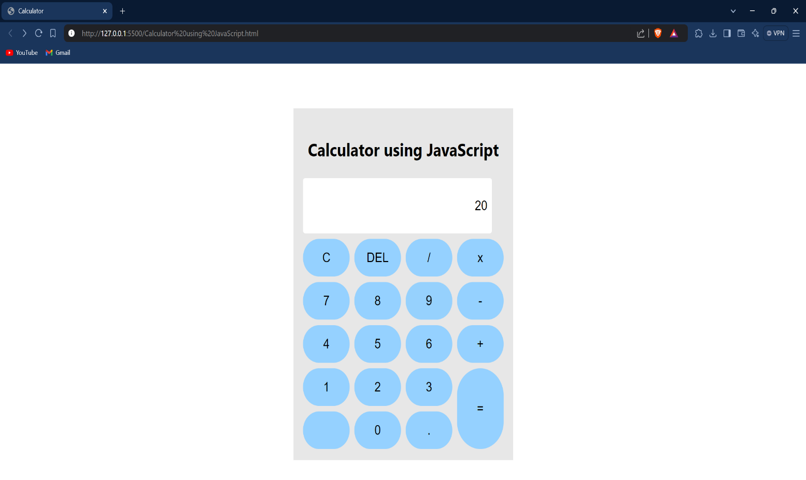**(d) Division:**

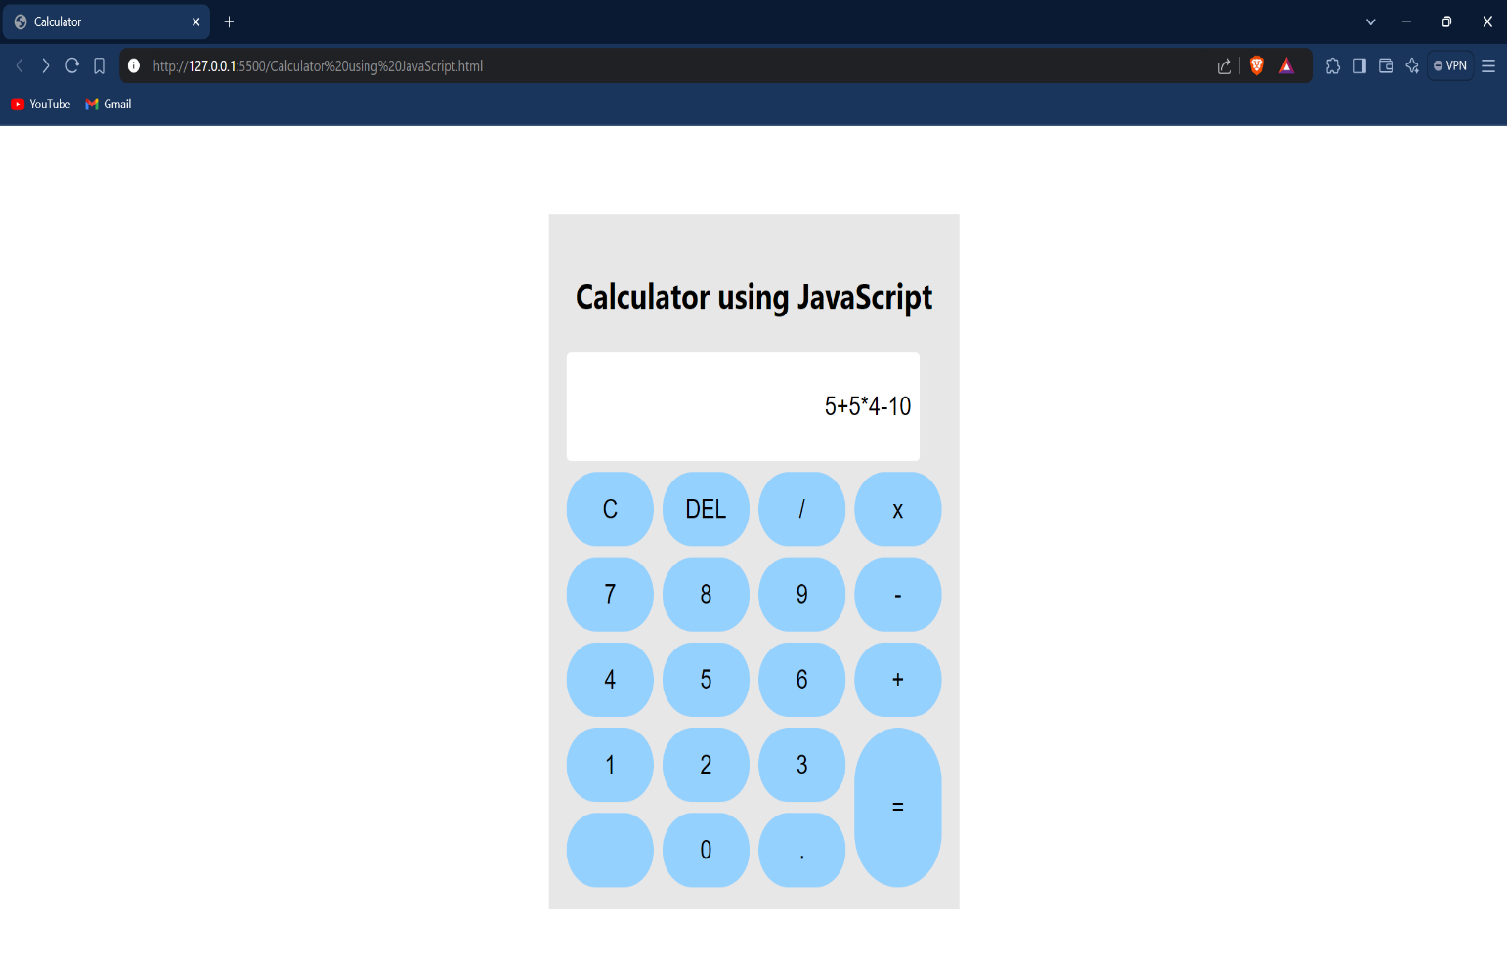**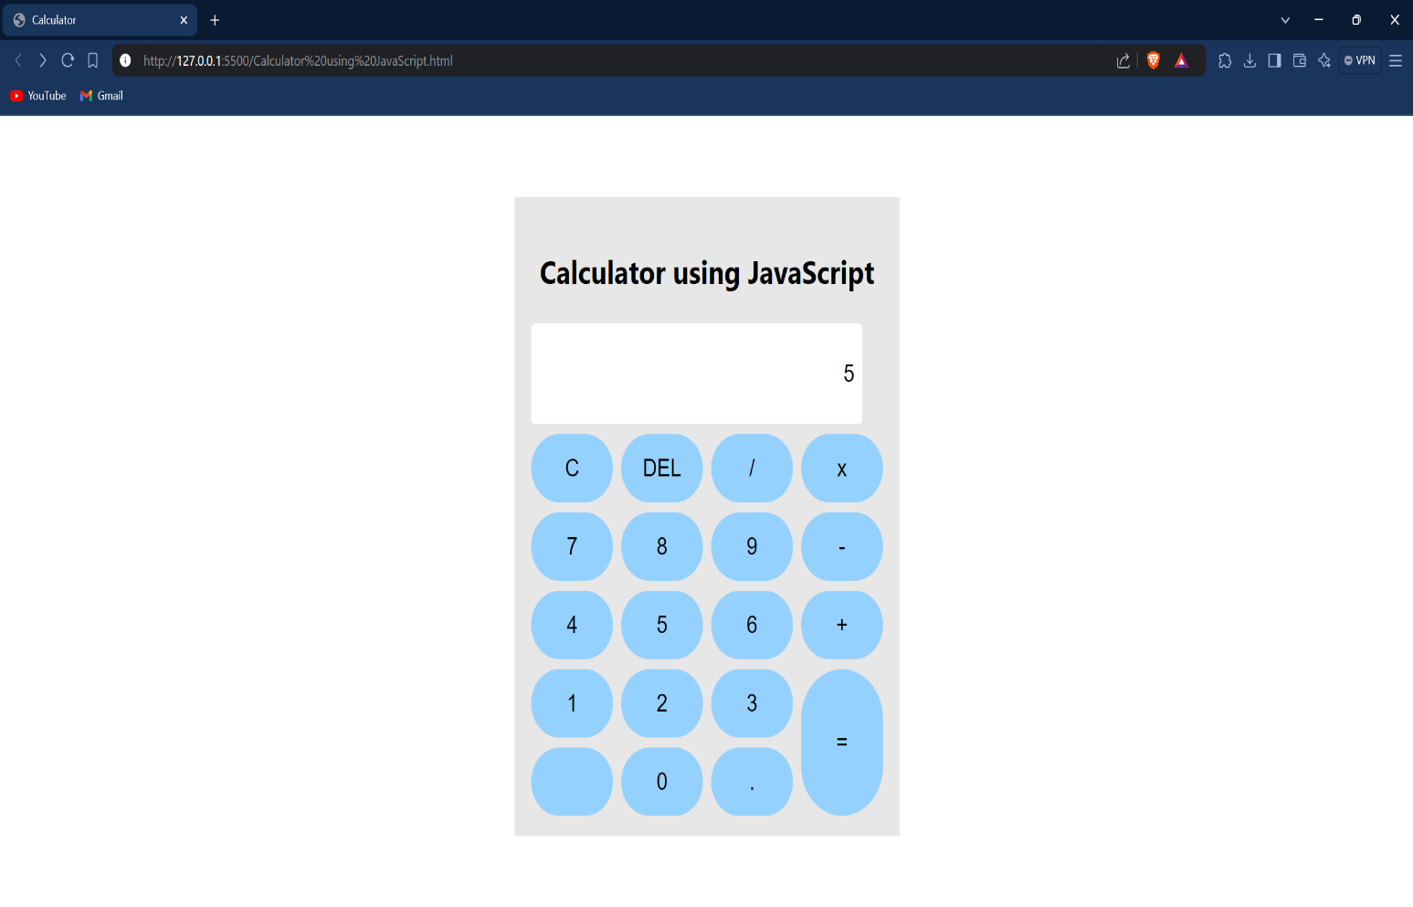(e) Multiple Operations at once:**

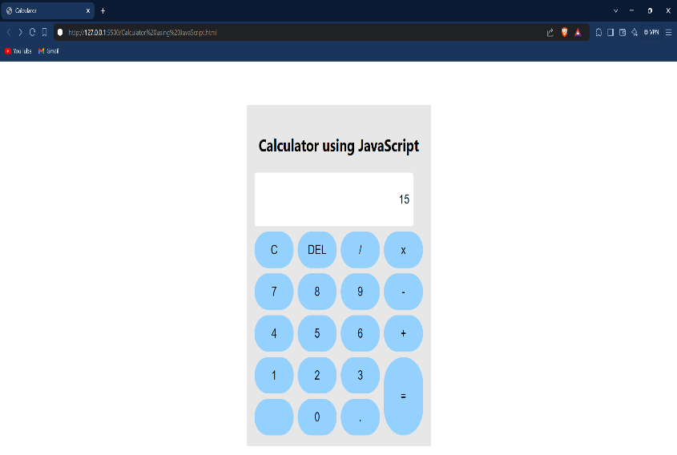**Learning Outcome:**

**EXPERIMENT 4**

**Problem statement:** Create a web page covering the basic CRUD operations (Create, Read, Update, Delete) that implements To-do/Grocery lists using JavaScript and HTML

**Theory:**

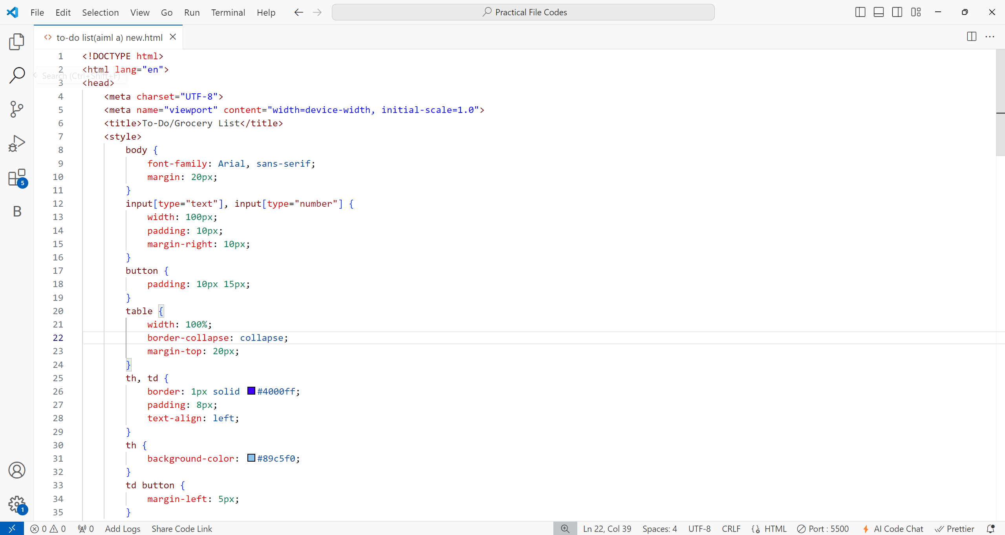**Source Code:**

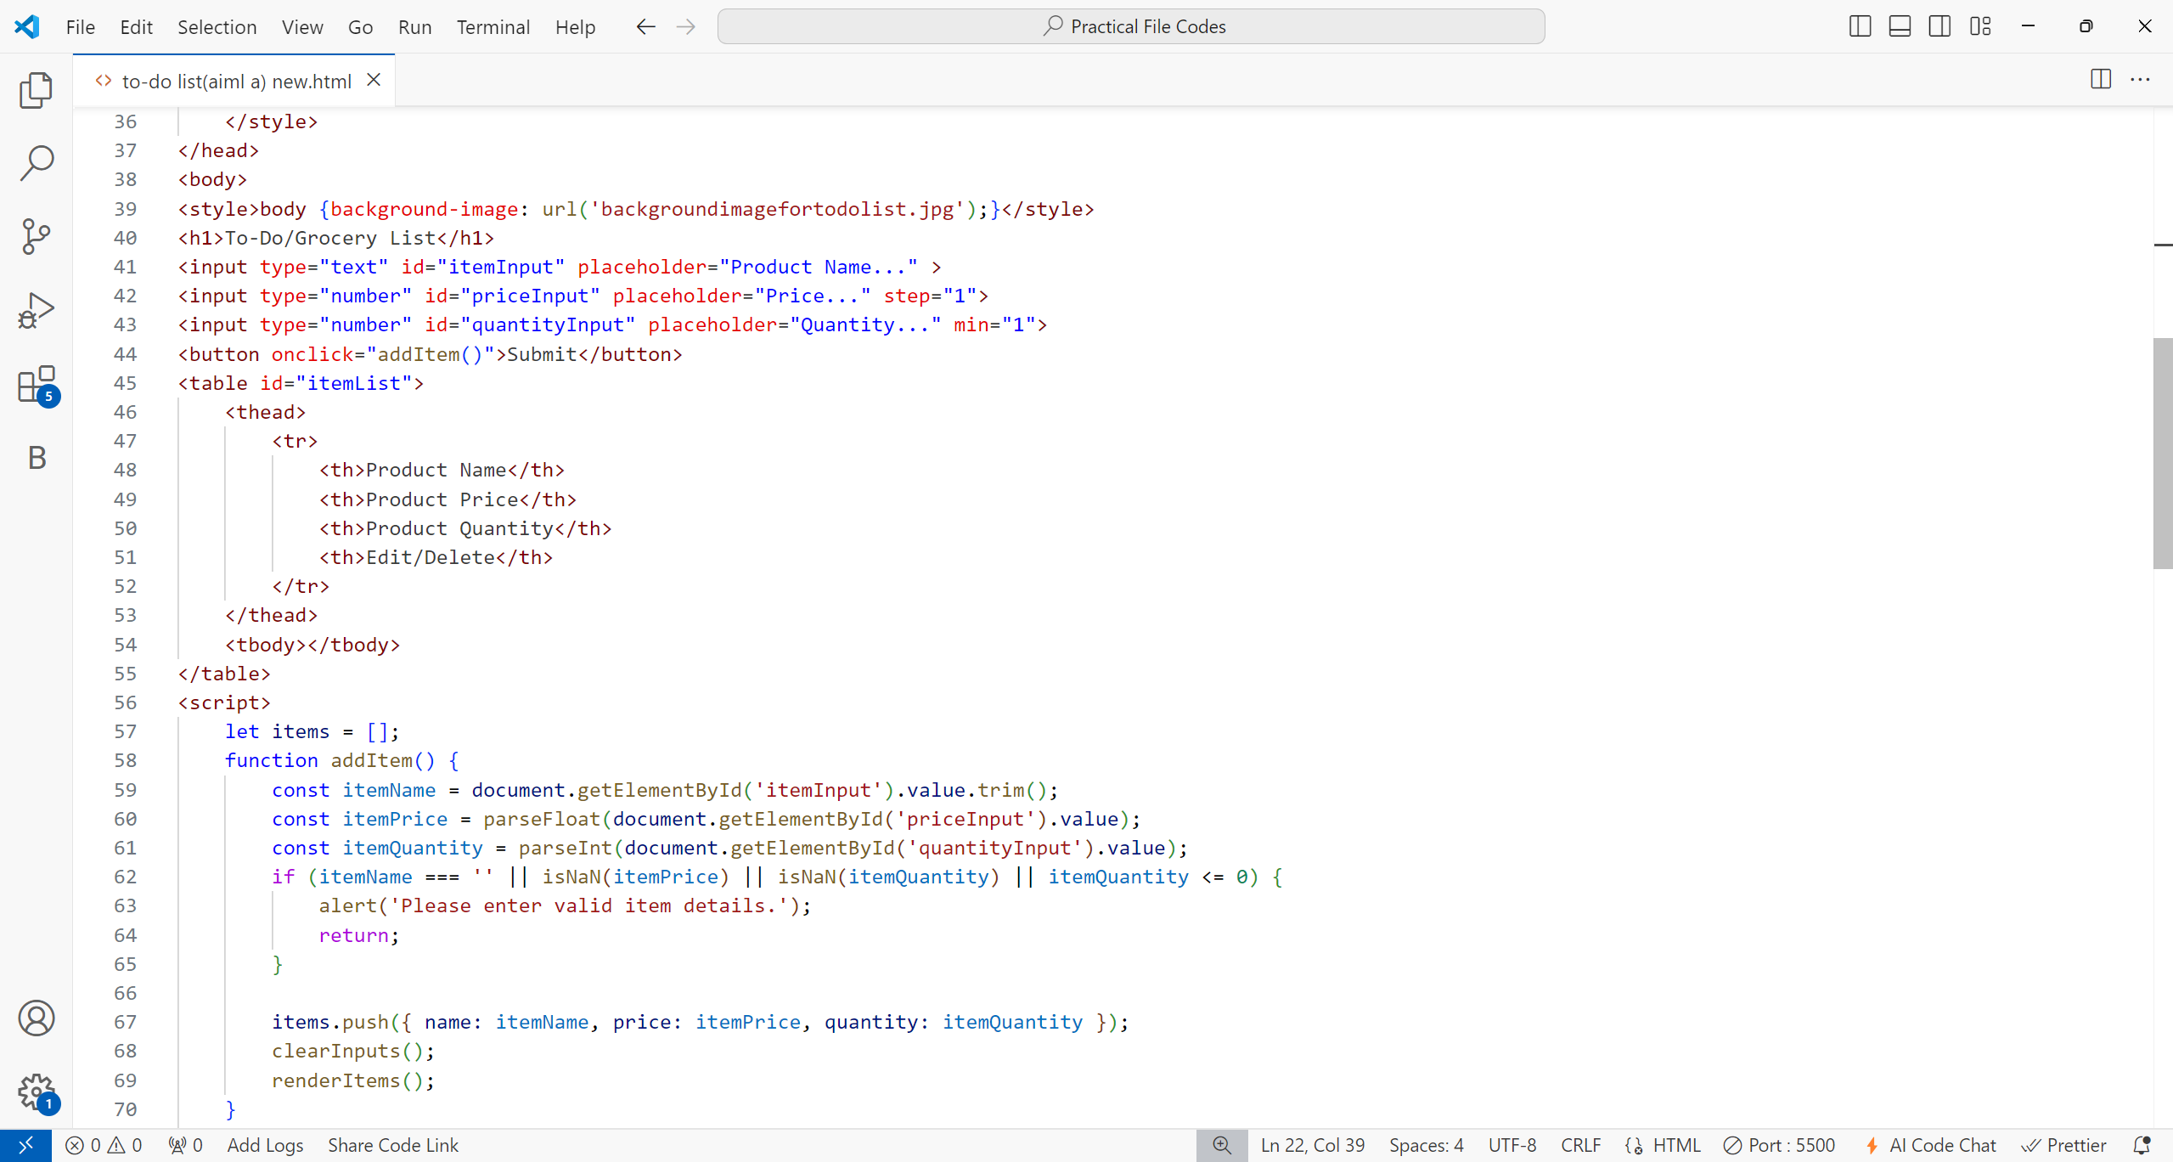

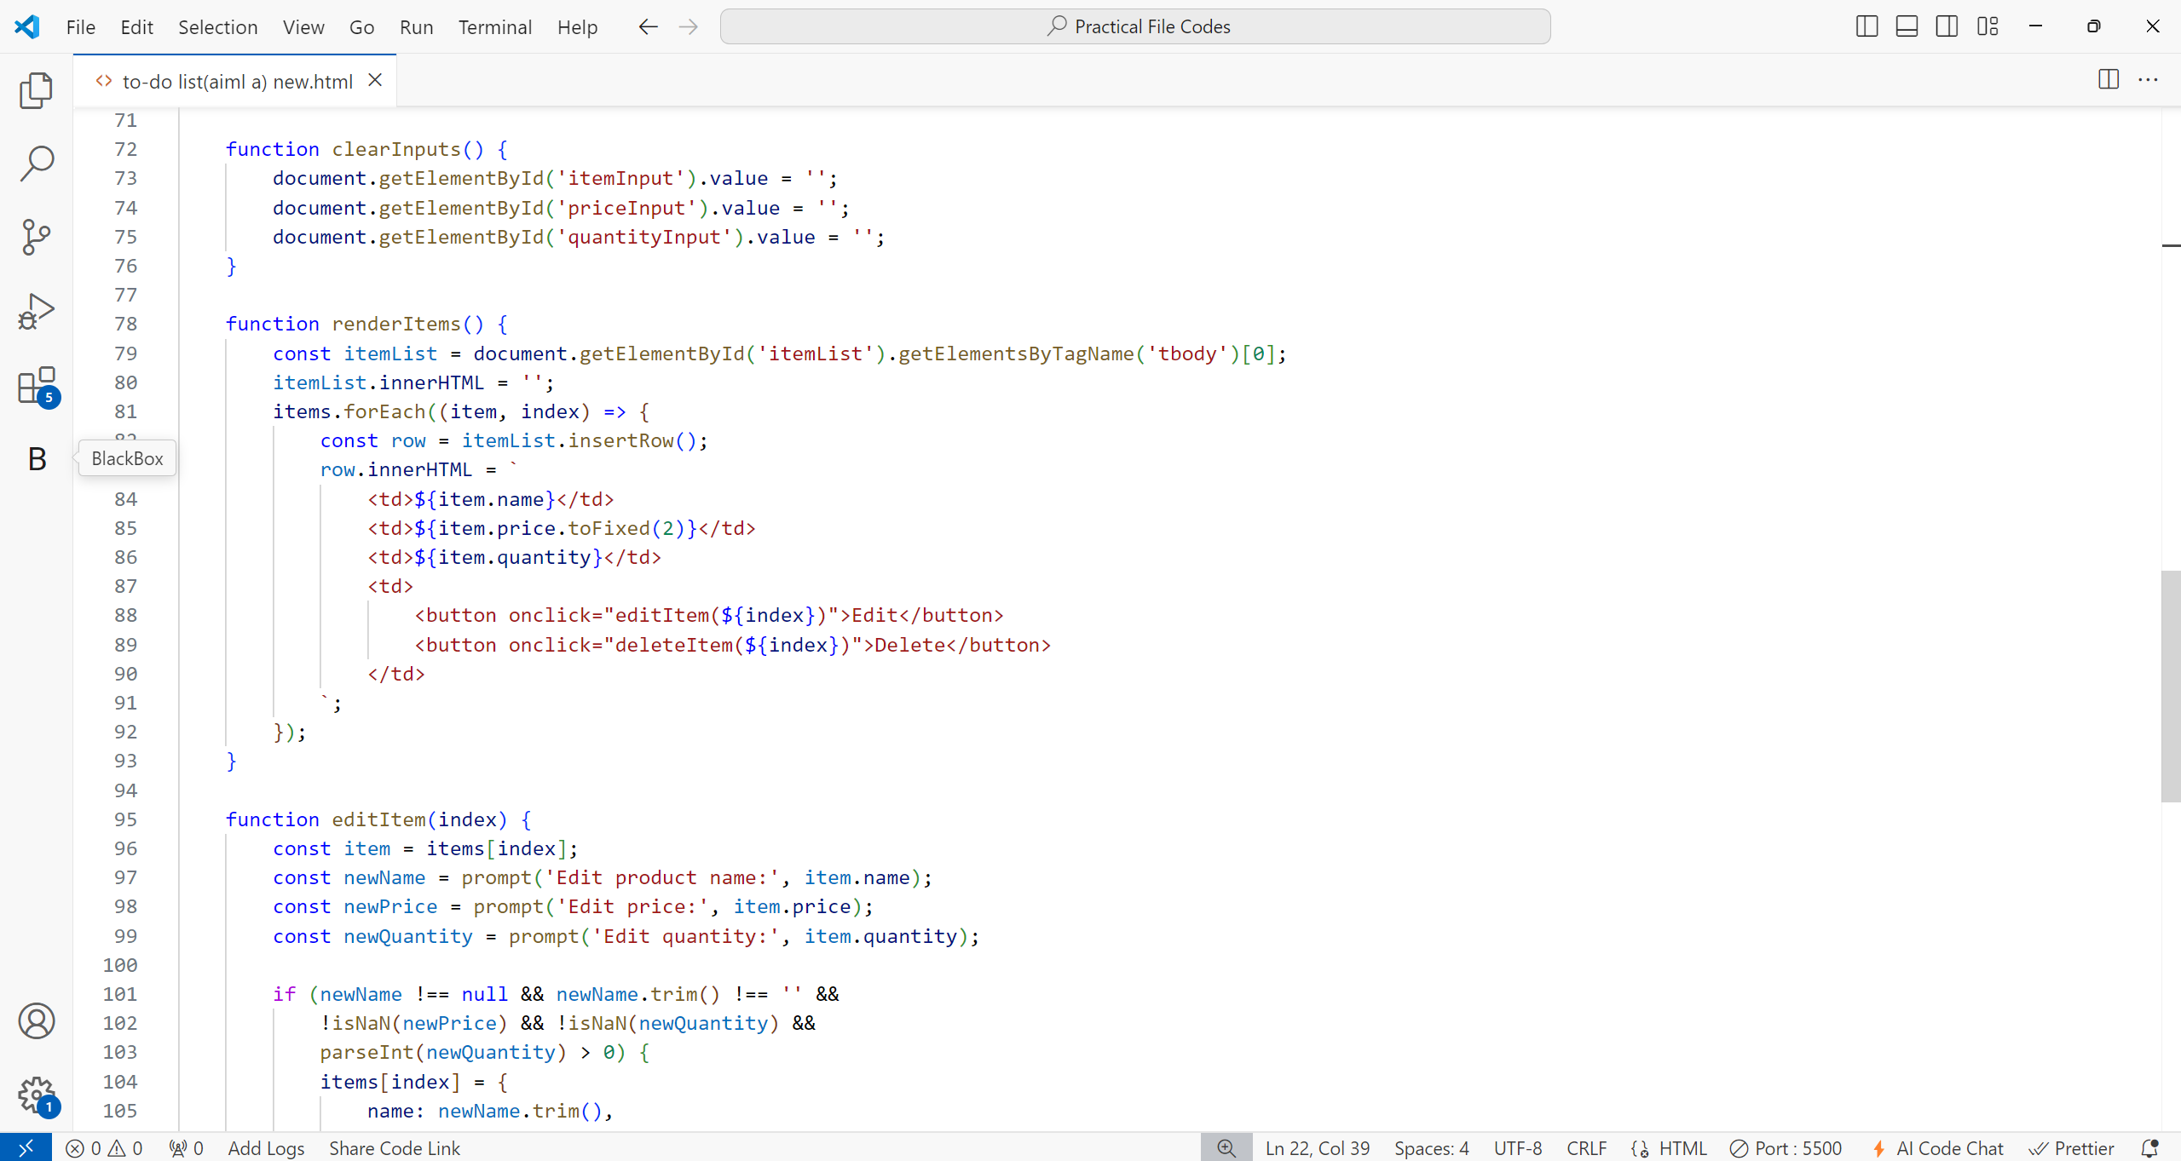

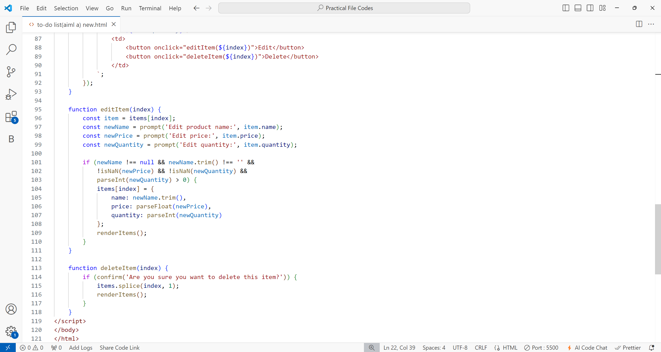

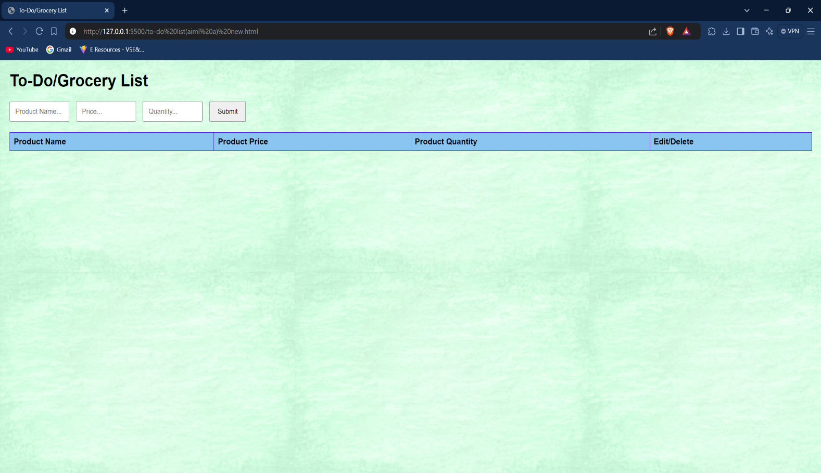**Output:**

1. 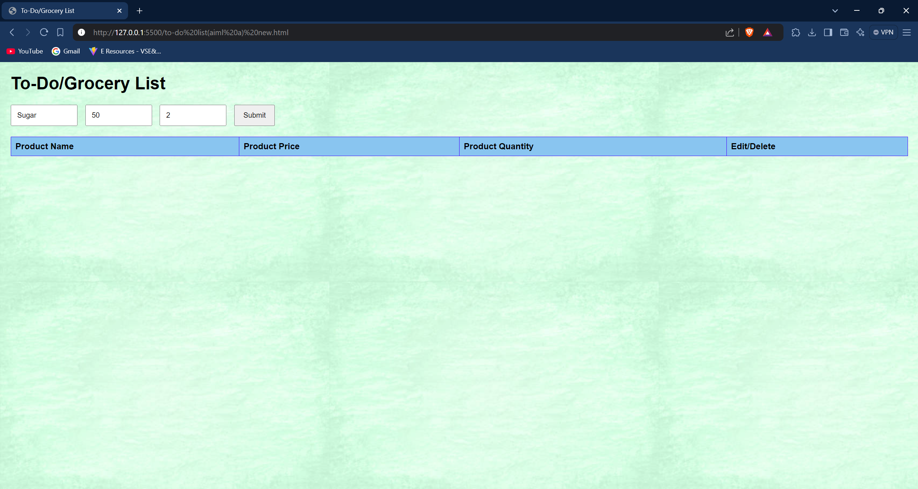**Adding elements:**

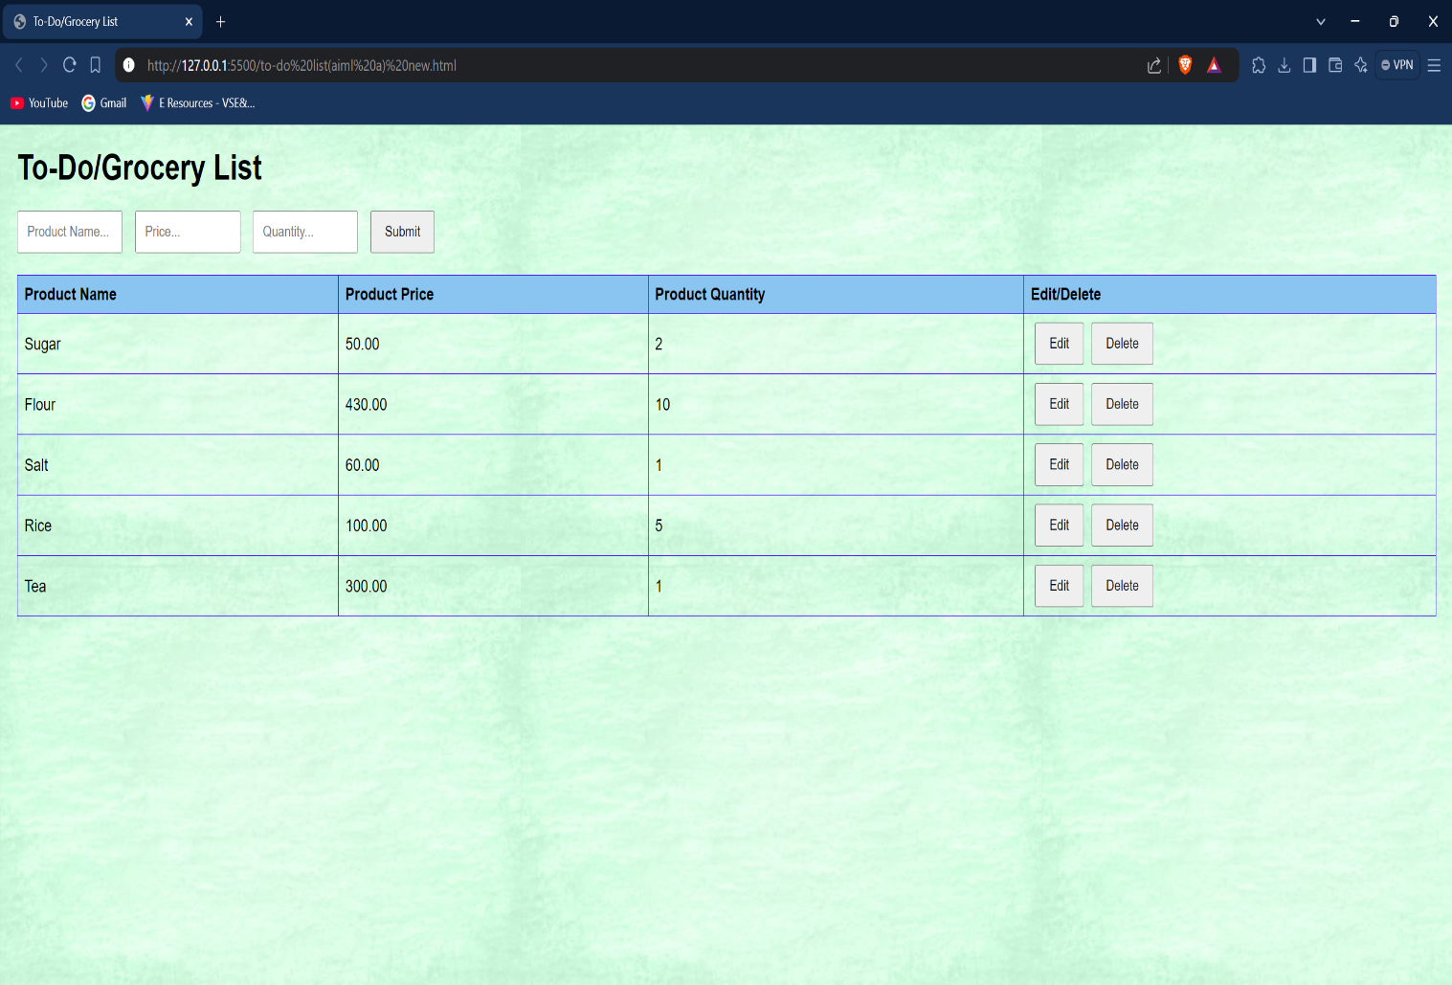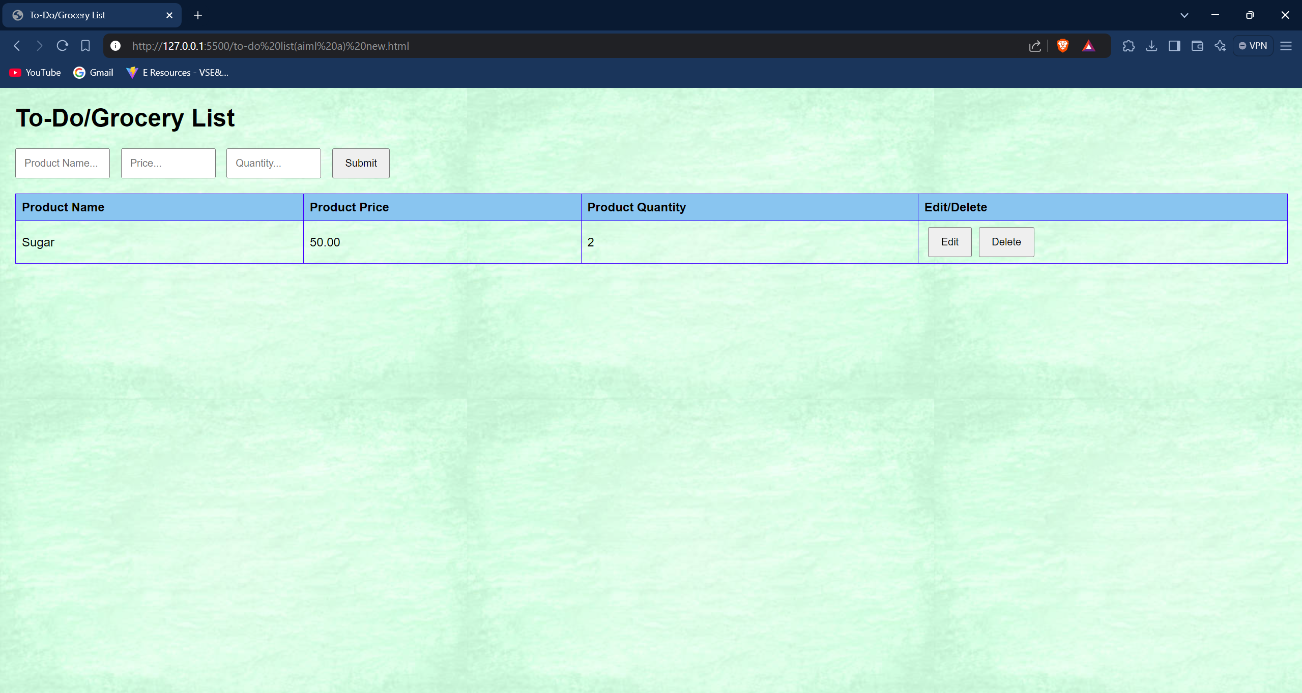

1. 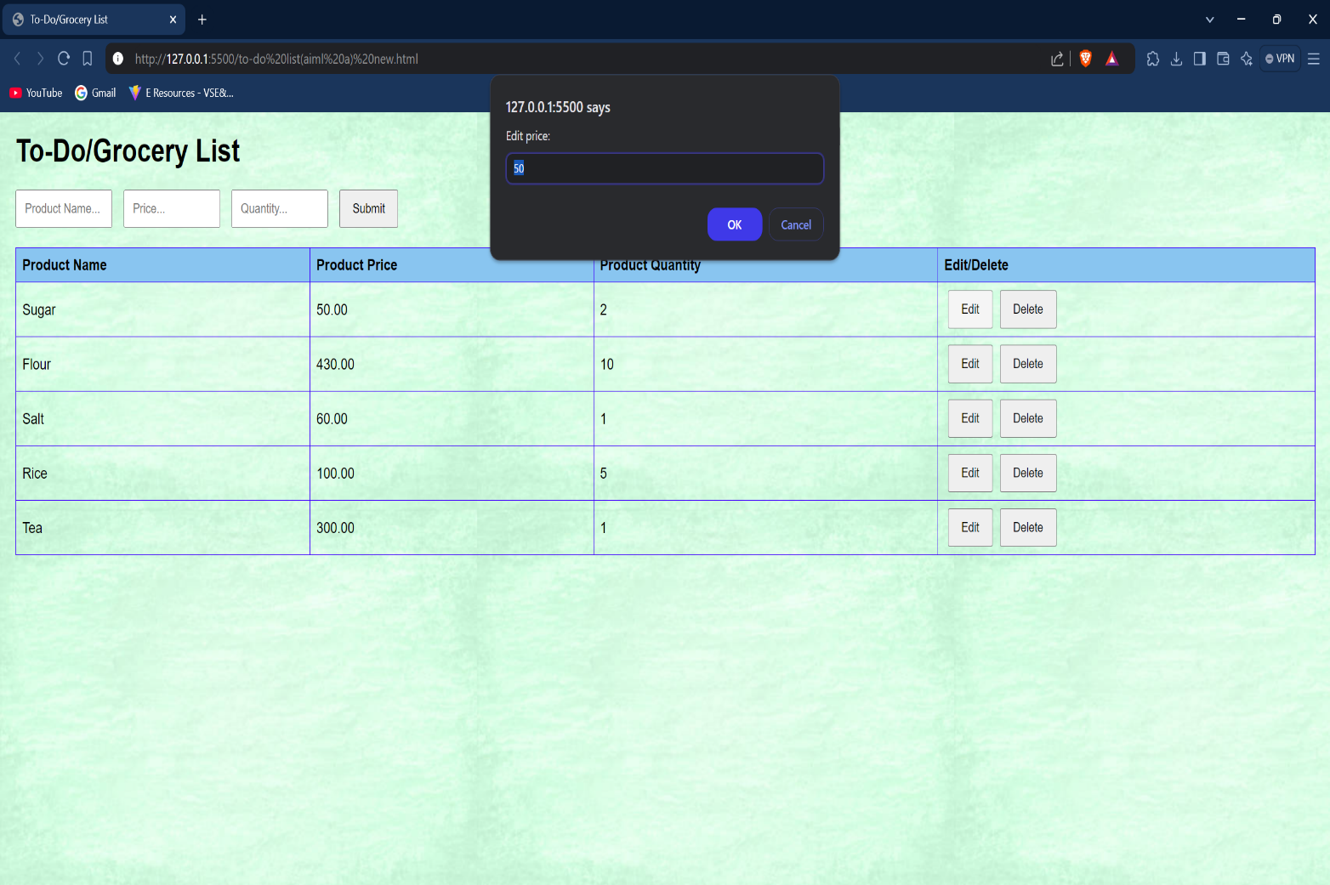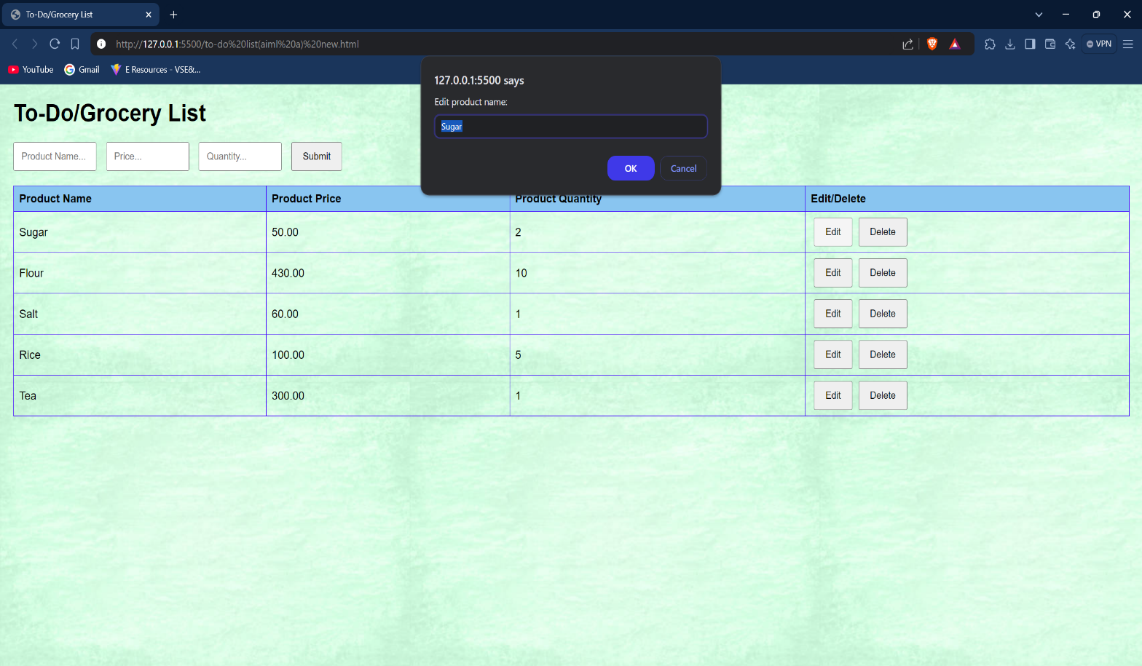**Updating an element:**

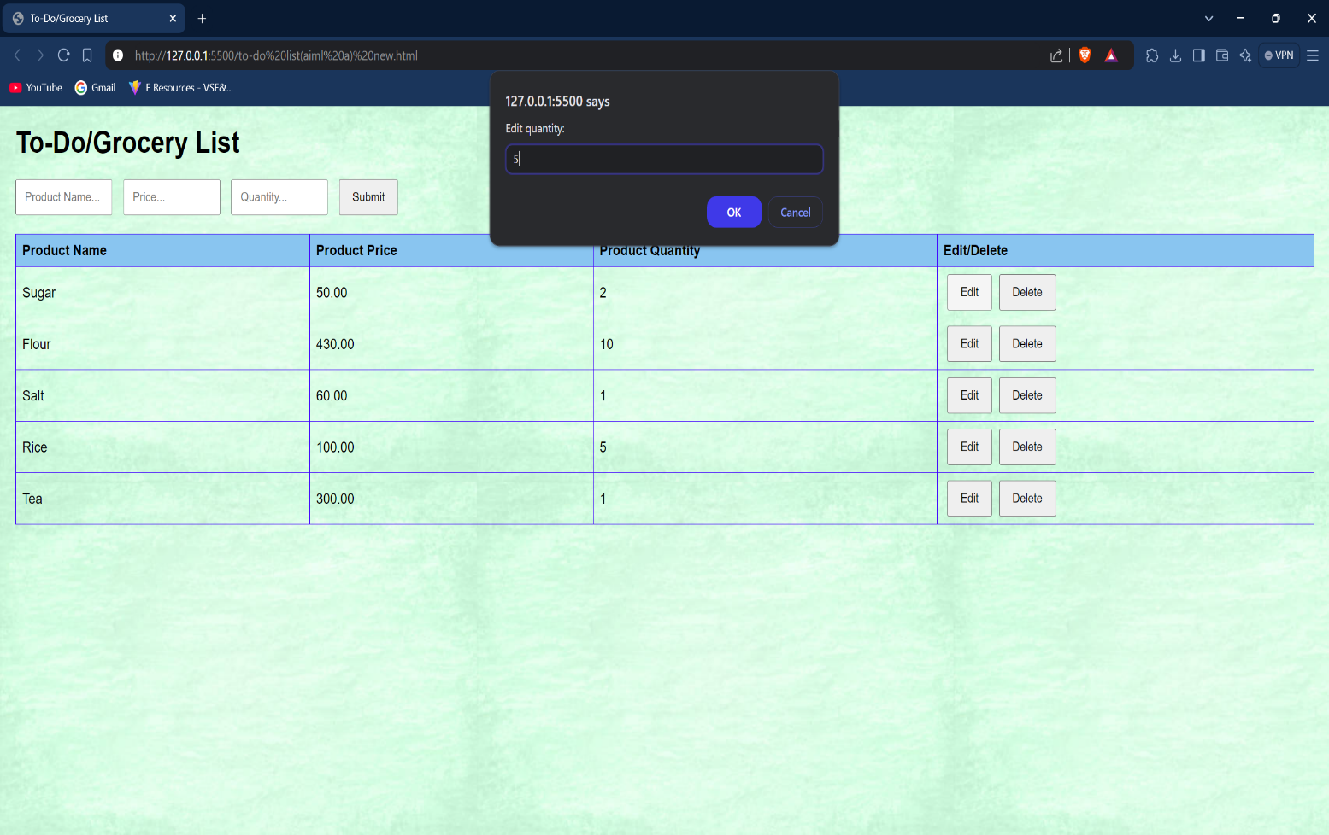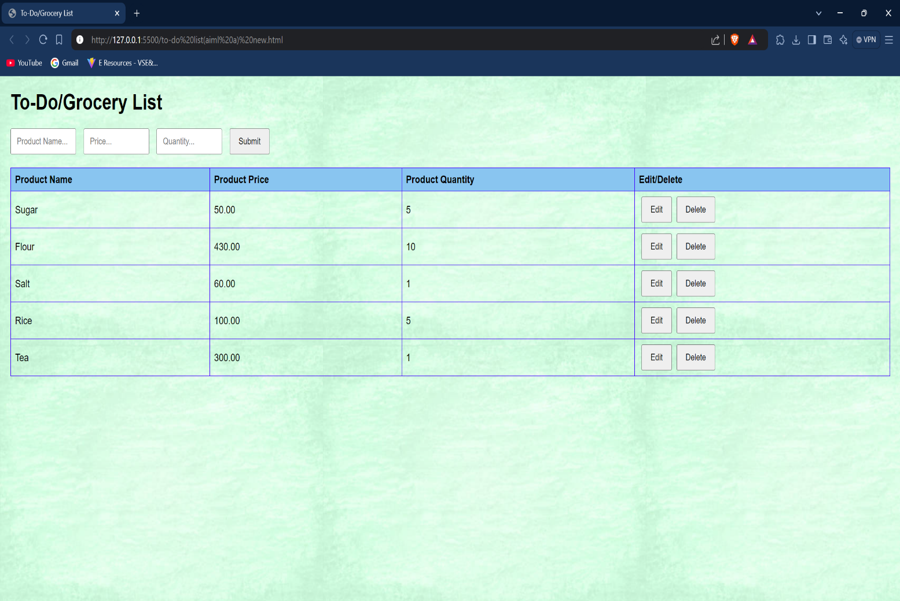

1. 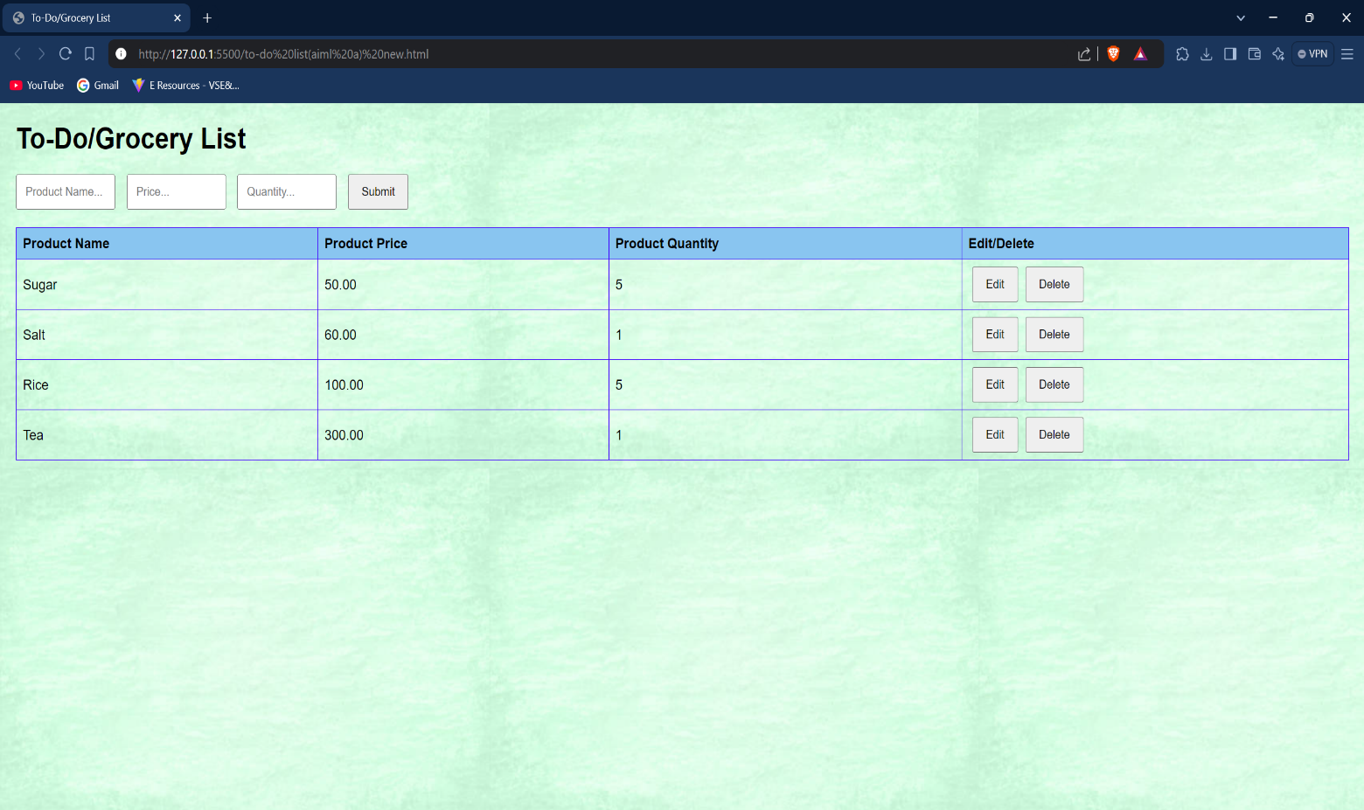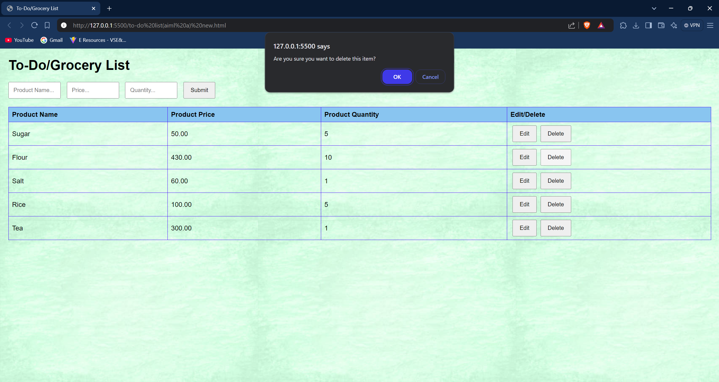**Deleting an Element:**
2. 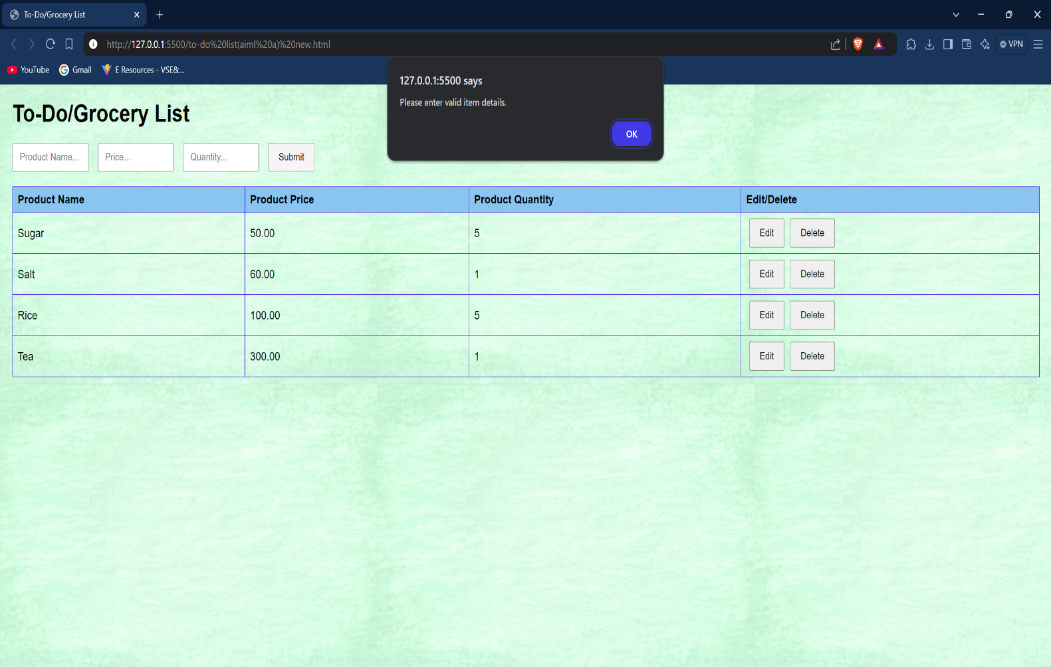**Exception Handling:**

**Learning Outcome:**

**EXPERIMENT 5**

**Problem statement:** Create a JavaScript application based on various Data Types, Statements, Keywords and Operators.

**Theory:**

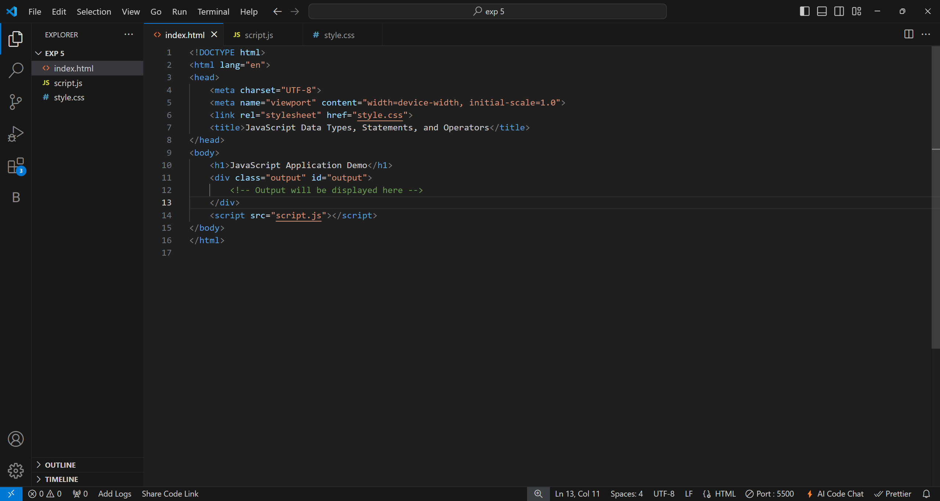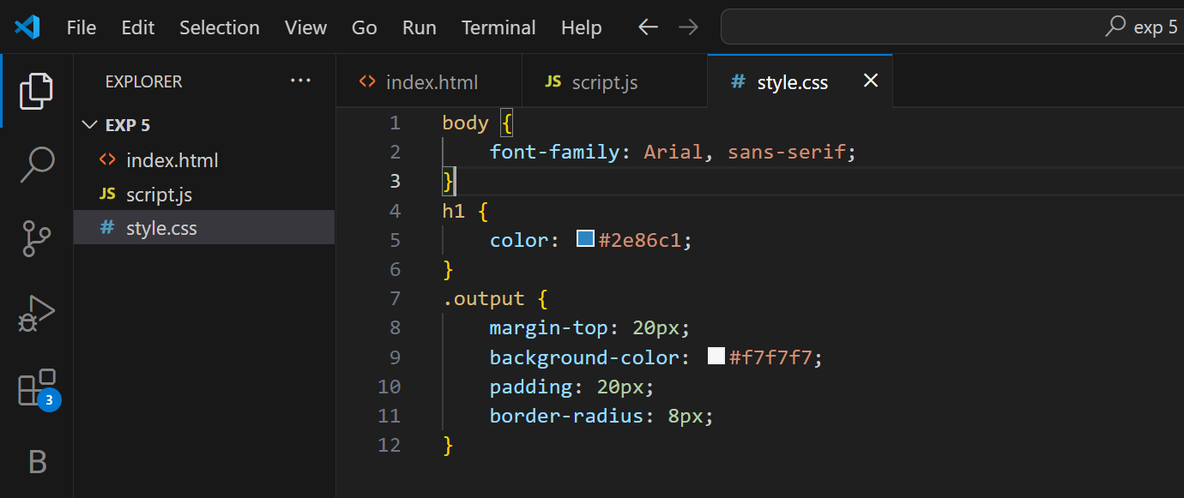**Source Code:**

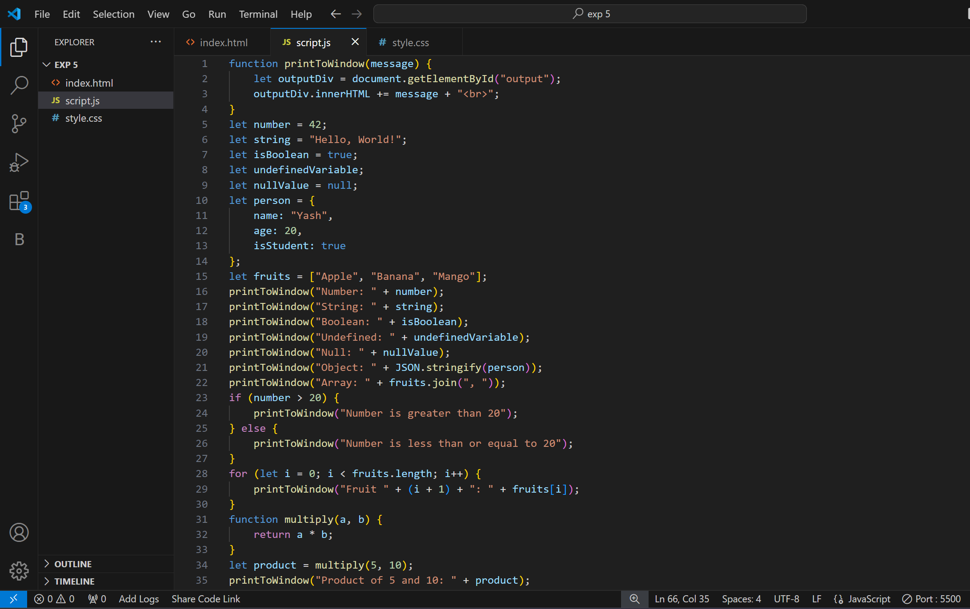

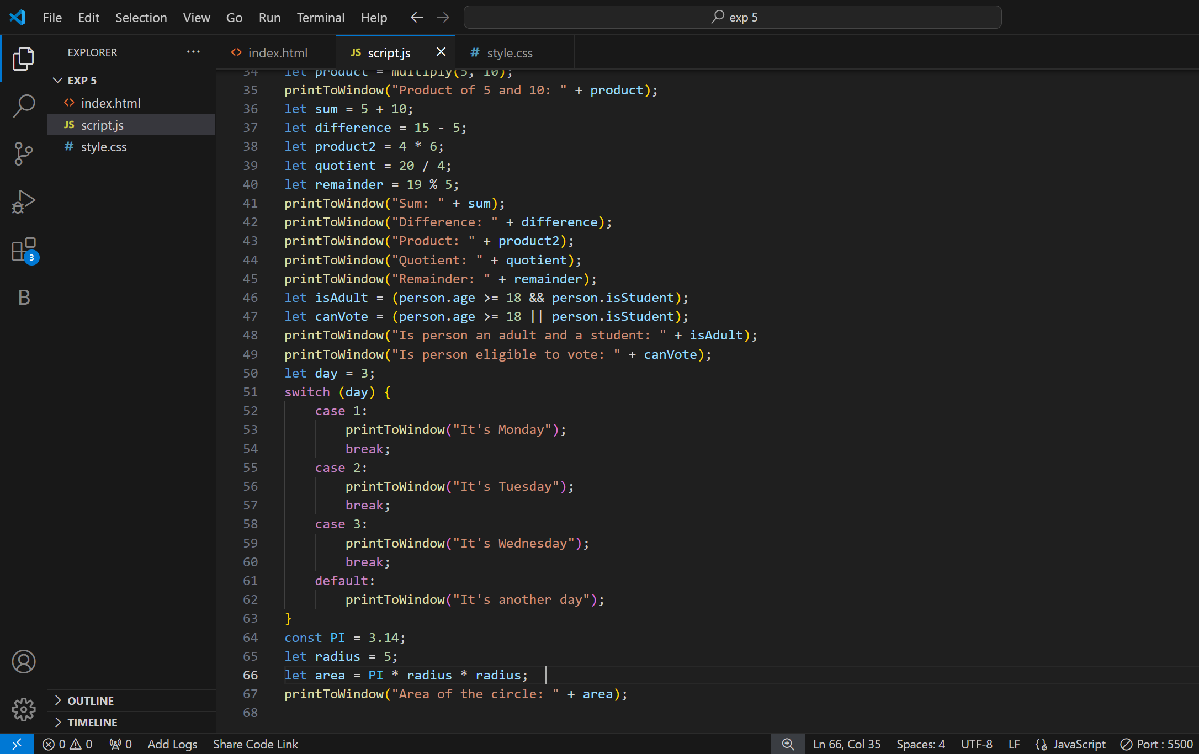

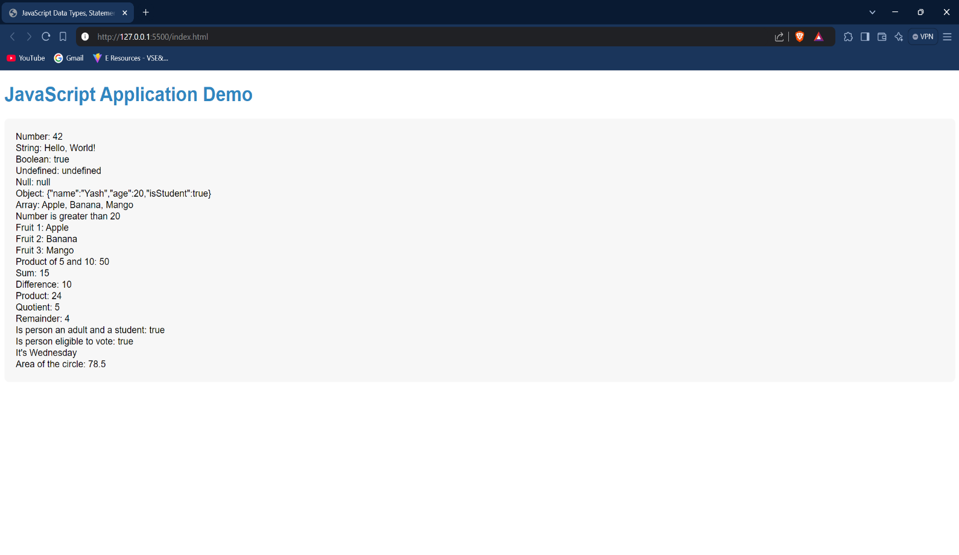**Outputs:**

**Learning Outcome:**

**EXPERIMENT 6**

**Problem statement:** Create a JavaScript application with Window Objects and Document Object.

**Theory:**

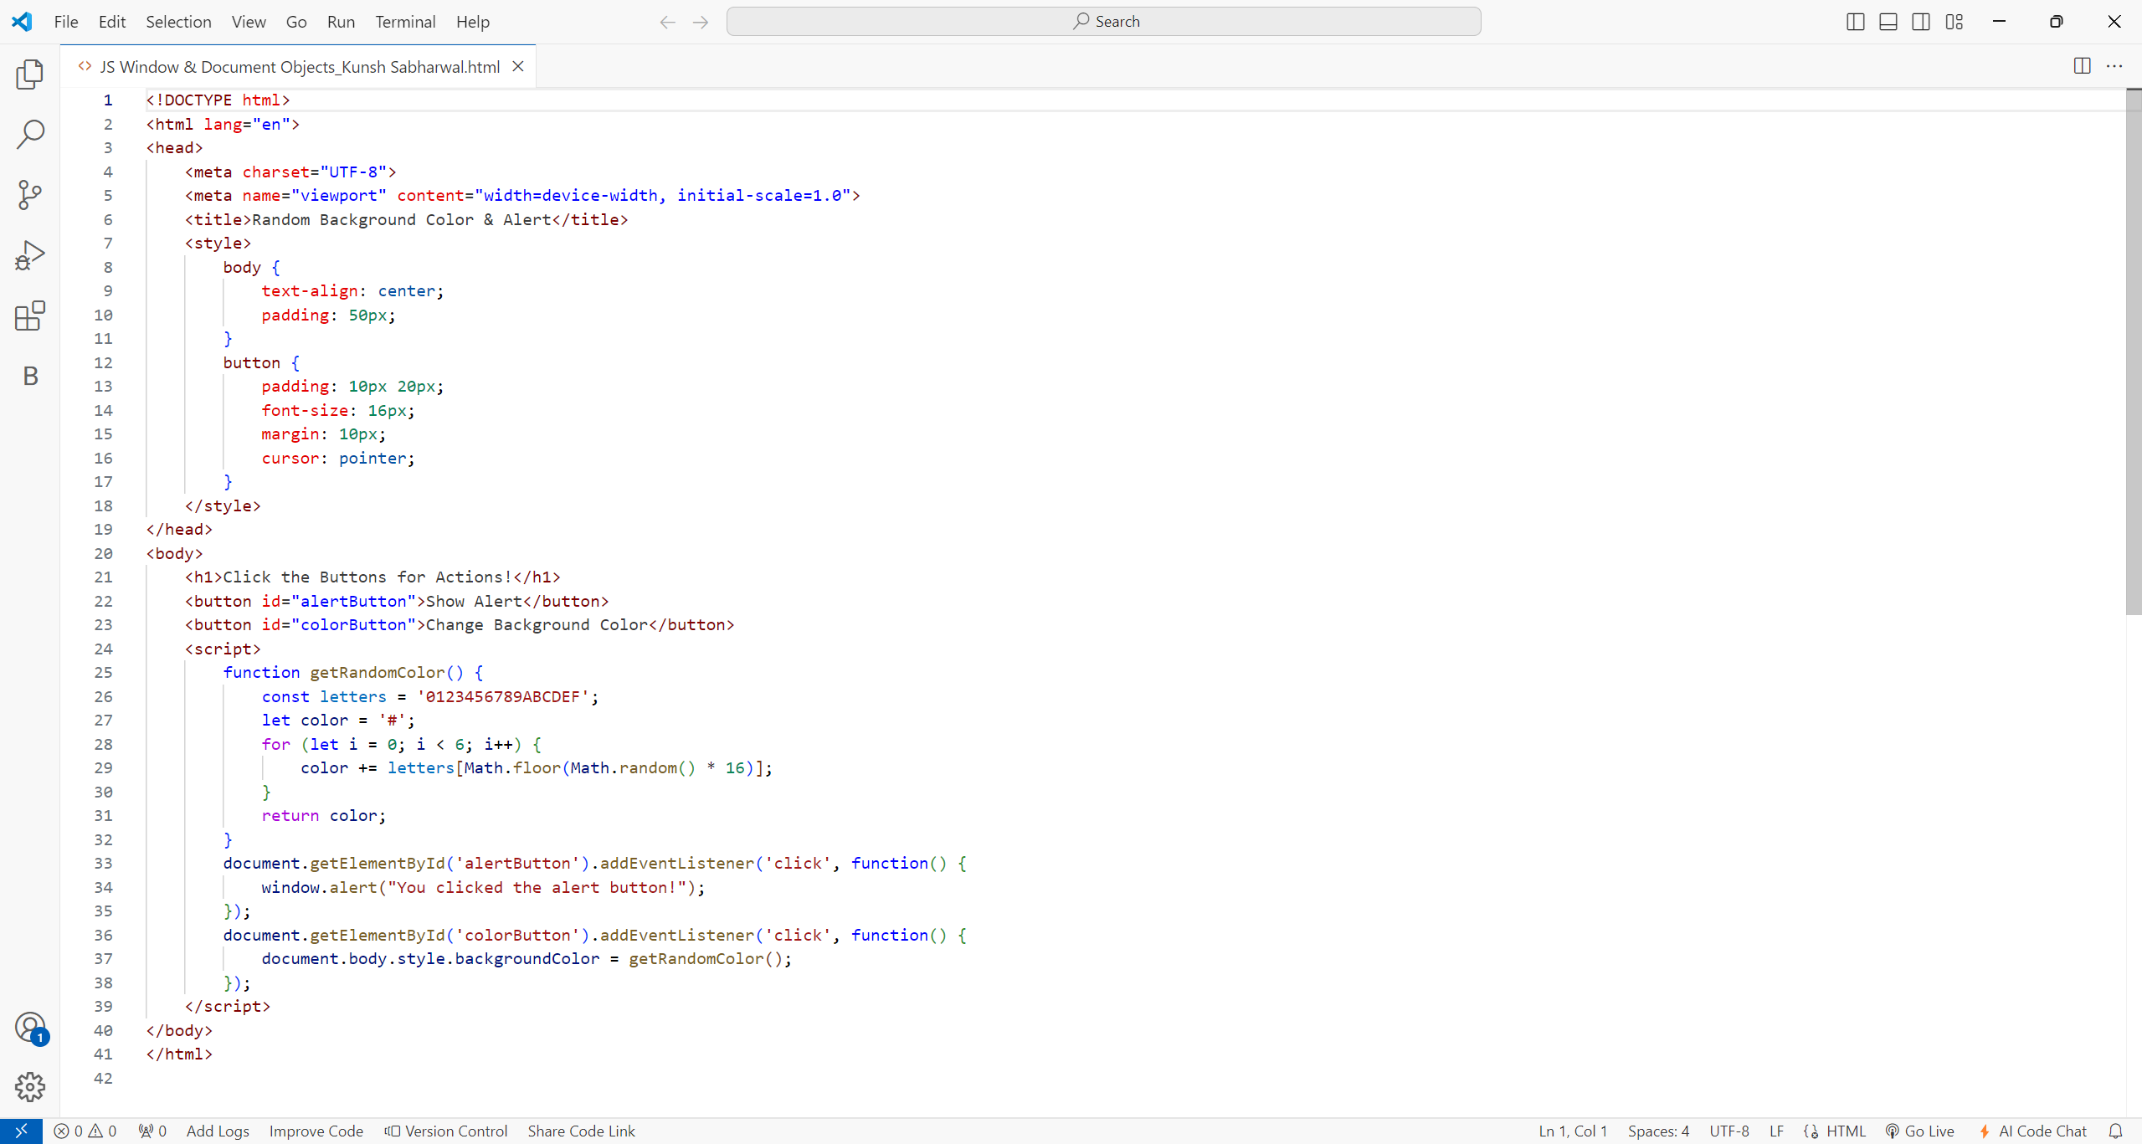**Source Code:**

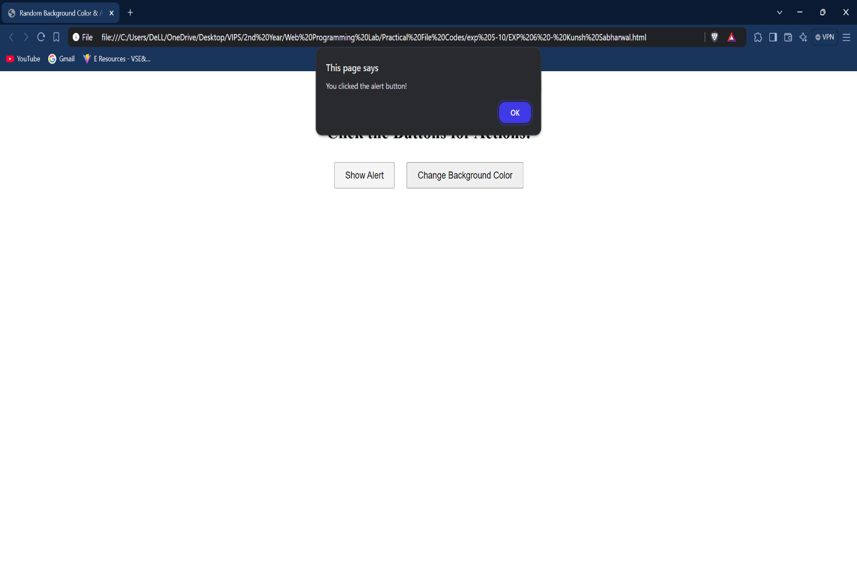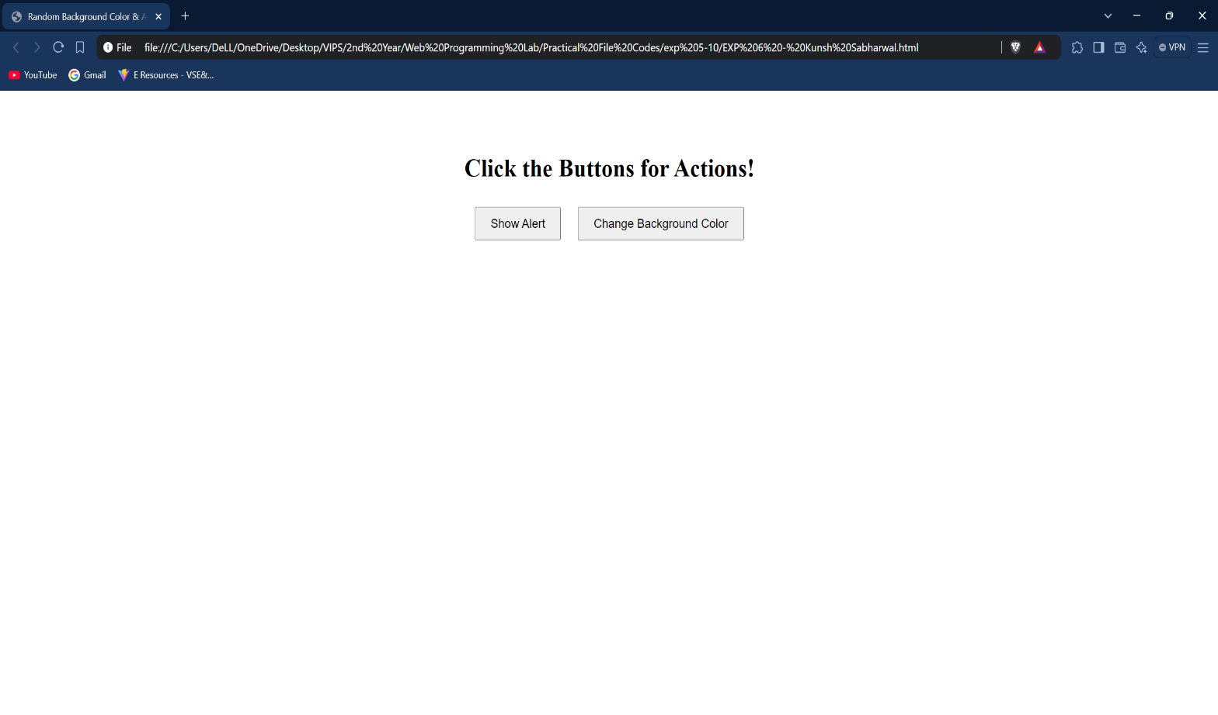**Outputs:**

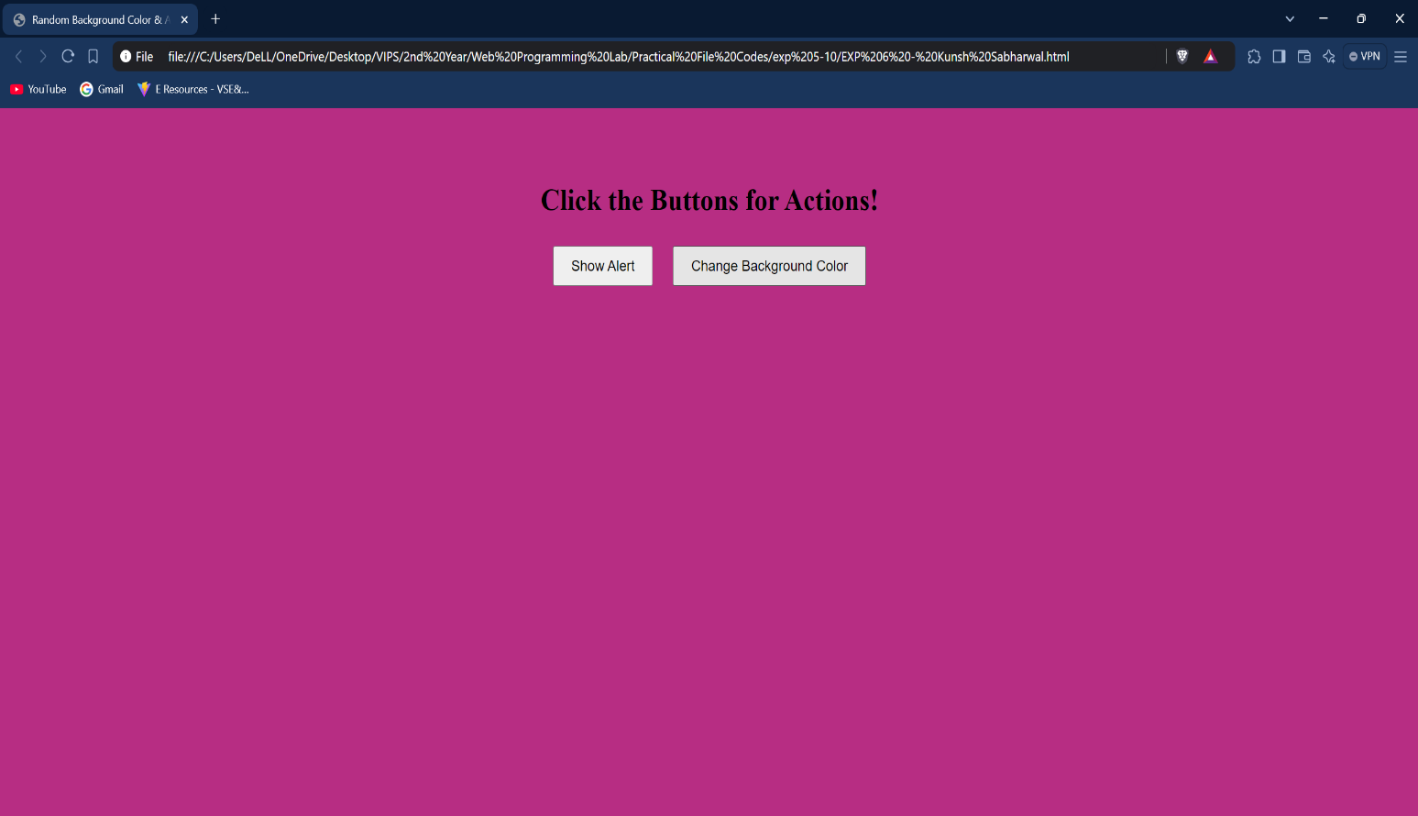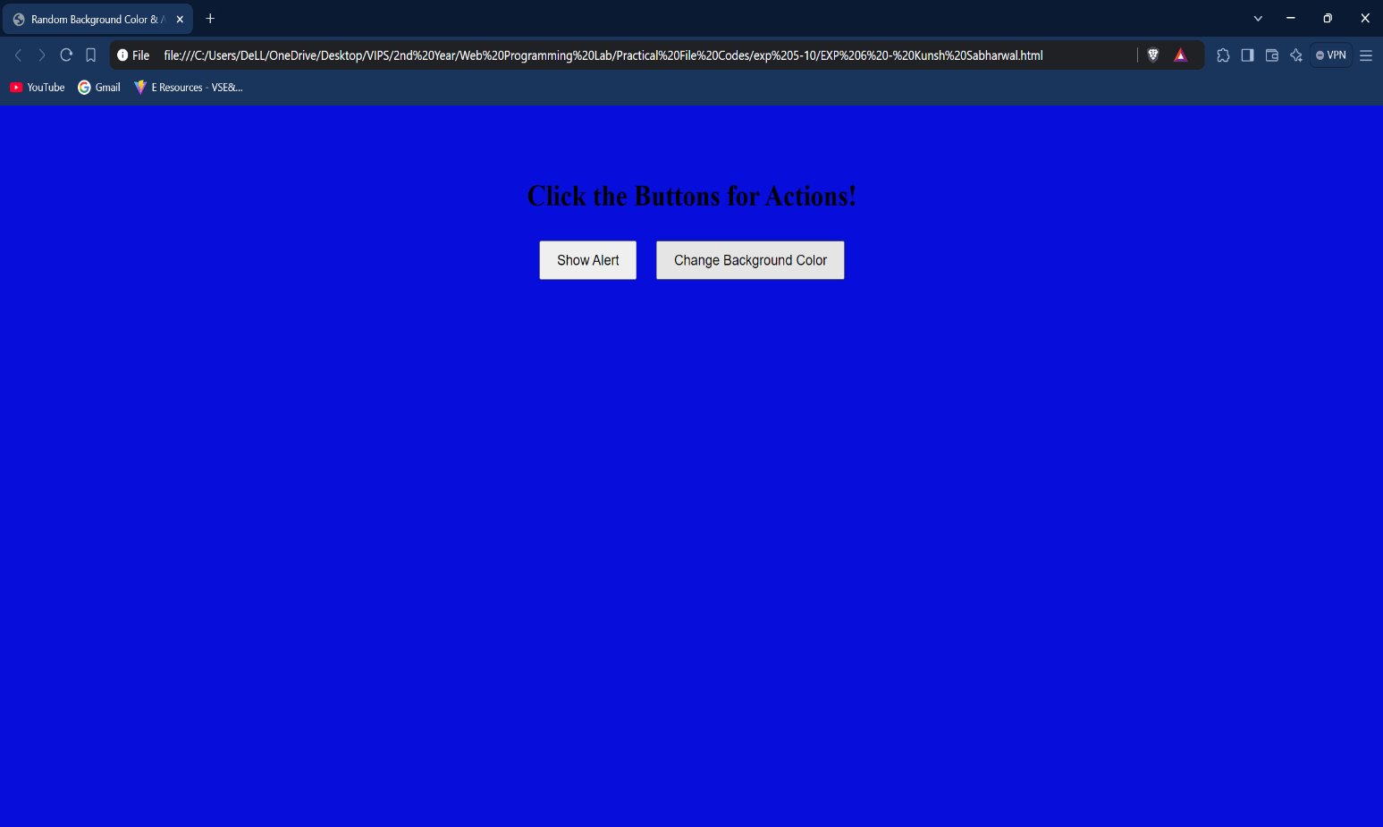**Learning Outcome:**

**EXPERIMENT 7**

**Problem statement:** Create a JavaScript application with object Creation and by adding methods of Objects.

**Theory:**

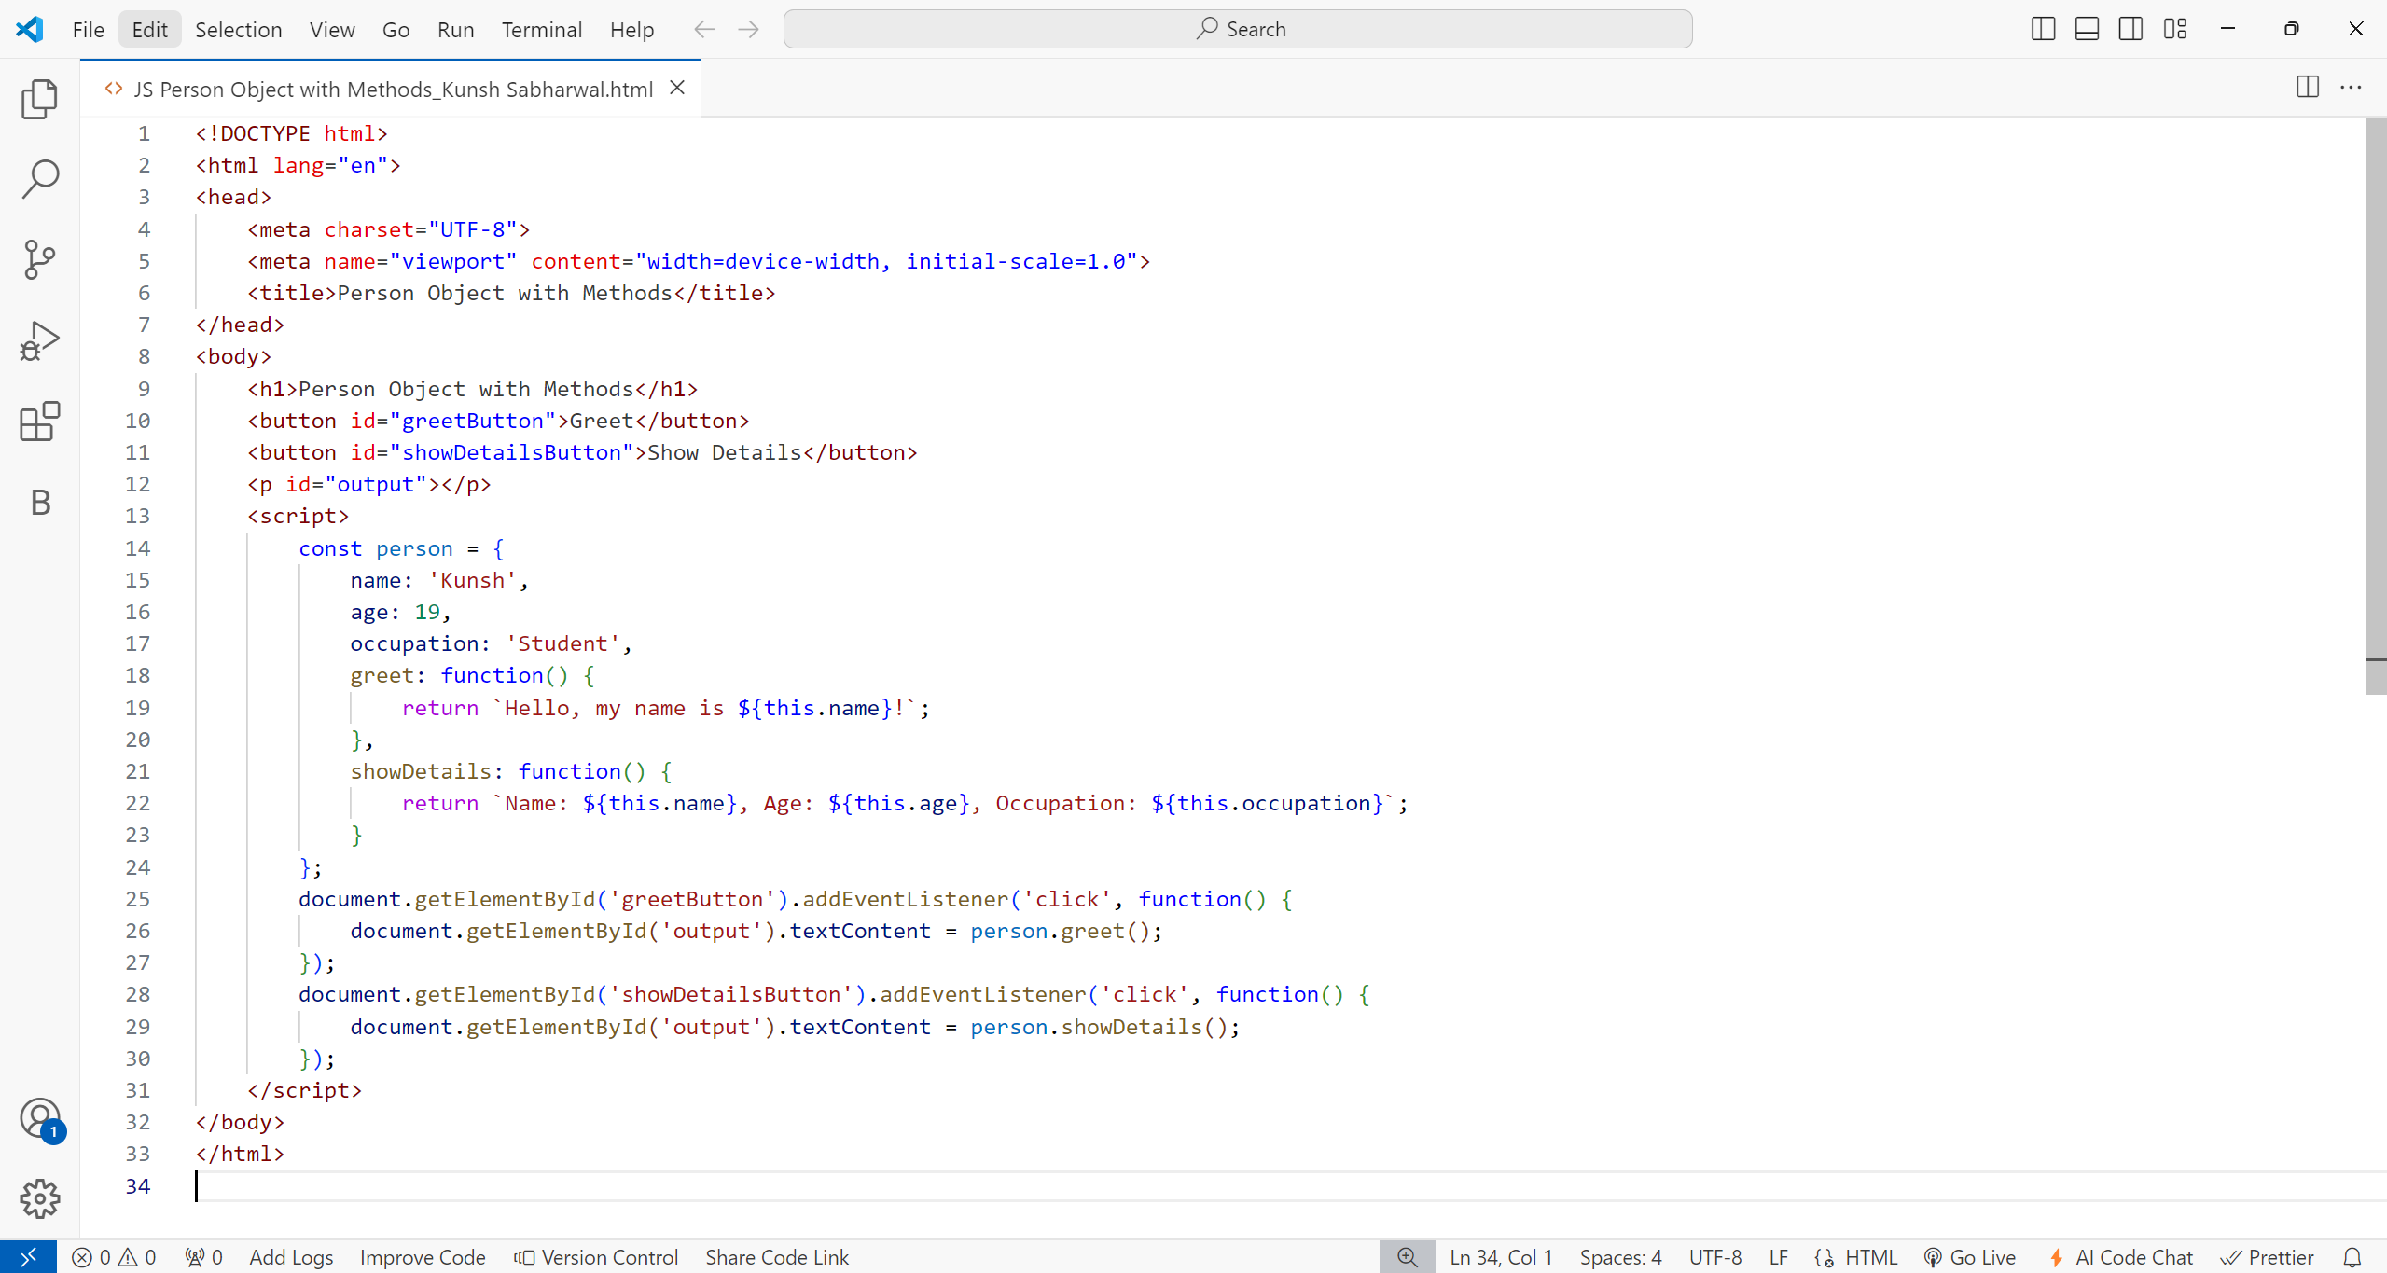**Source Code:**

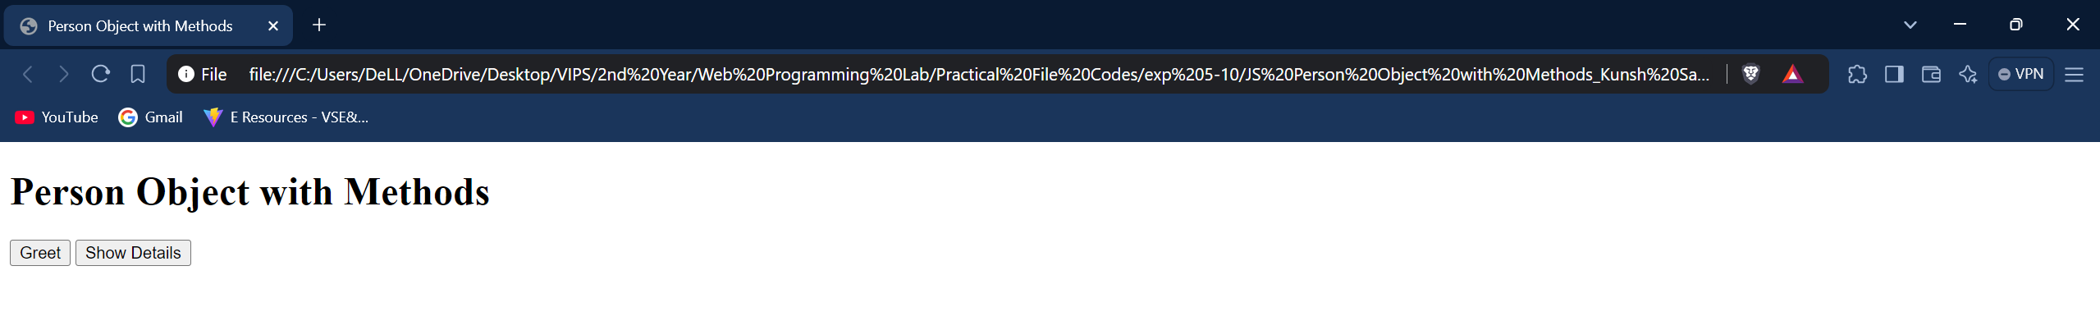**Outputs:**

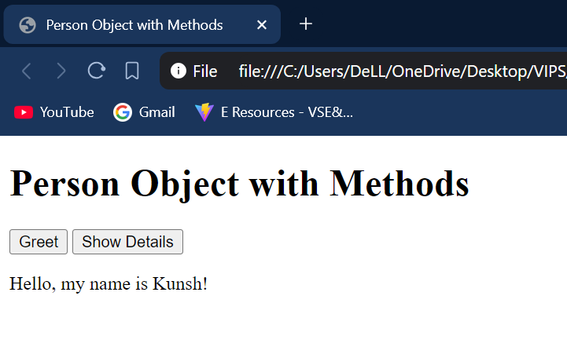

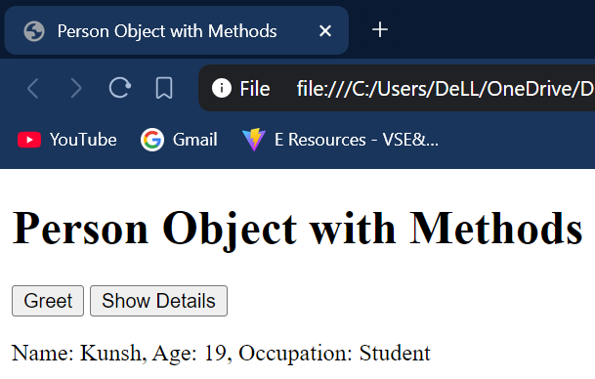

**Learning Outcome:**

**EXPERIMENT 8**

**Problem statement:** Create a JavaScript application with Loops to incorporate the concept of Iteration.

**Theory:**

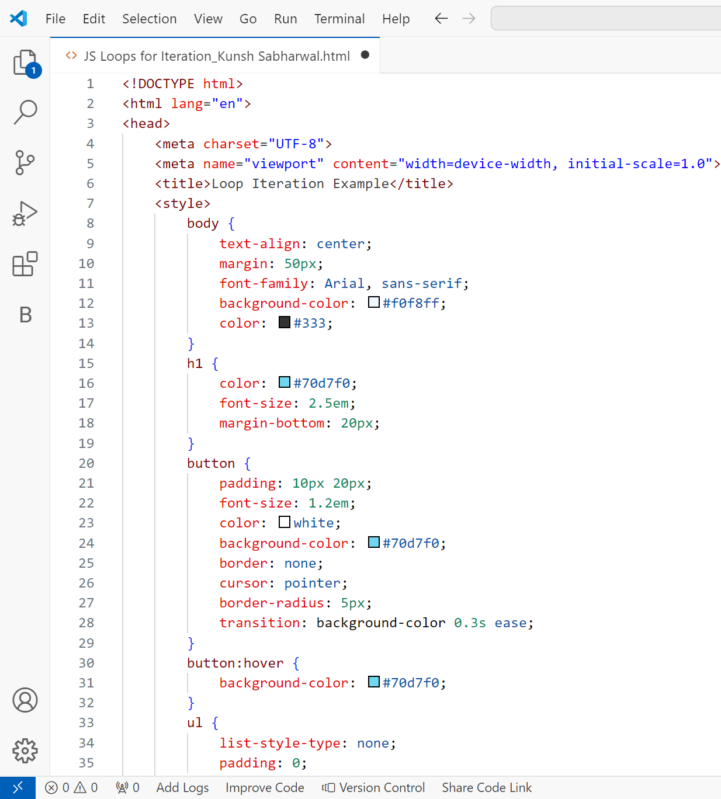**Source Code:**

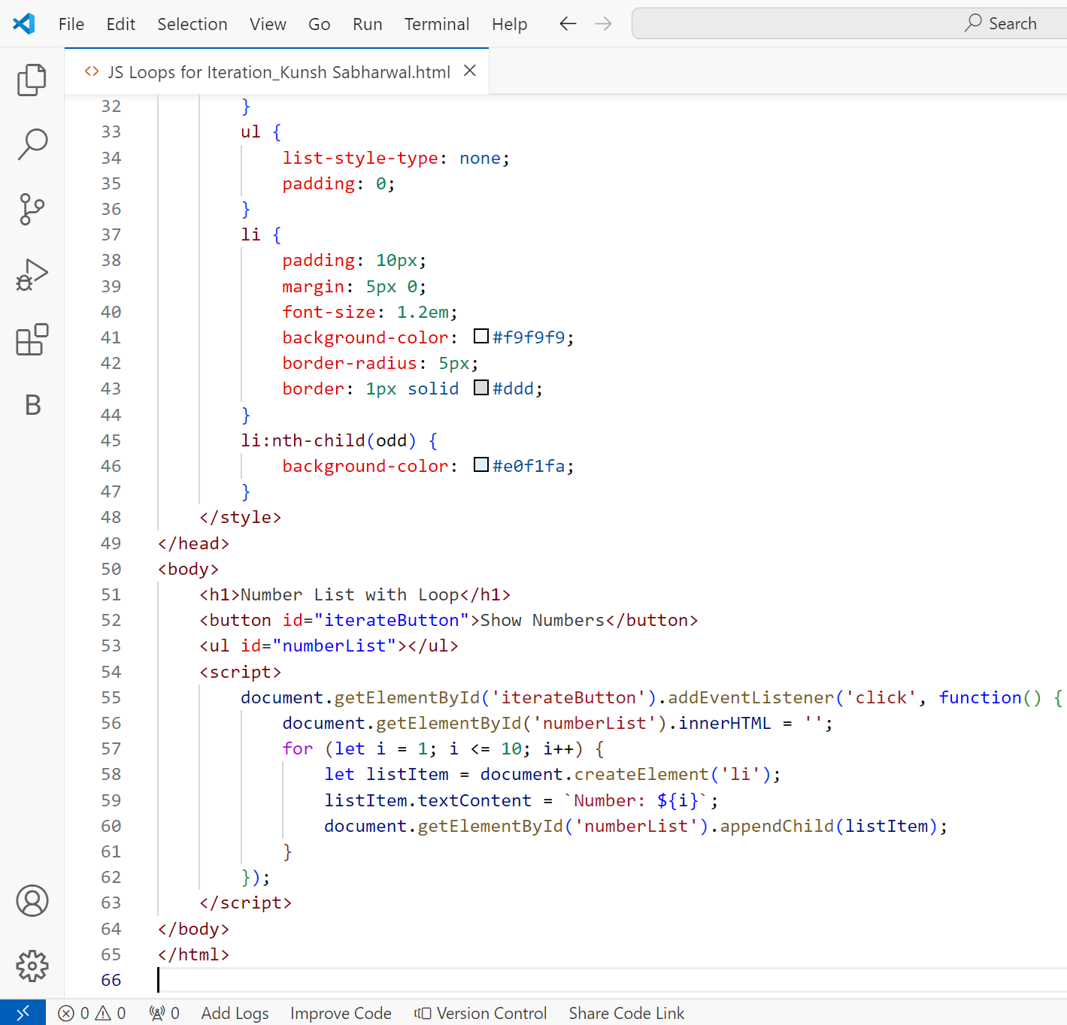

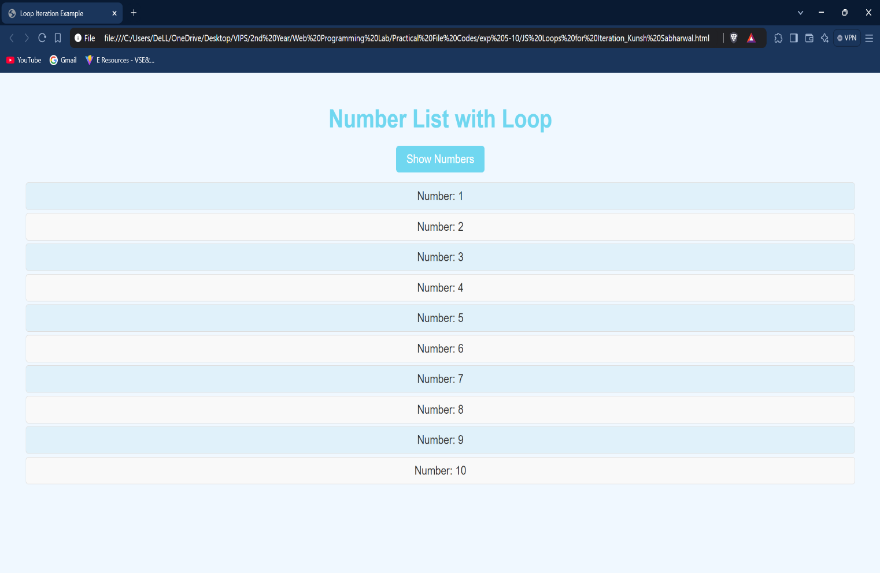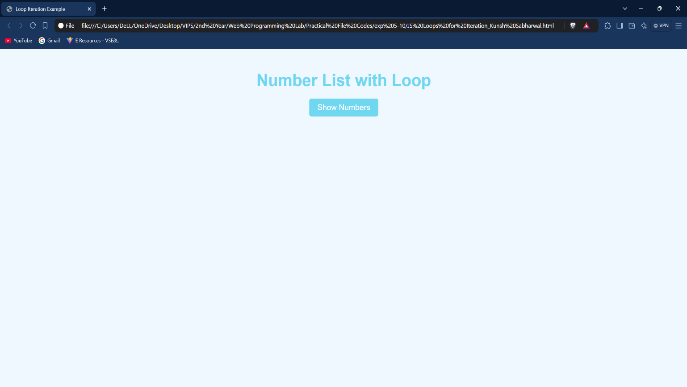**Outputs:**

**Learning Outcome:**

**EXPERIMENT 9**

**Problem statement:** Create a JavaScript application for random-number generation.

**Theory:**

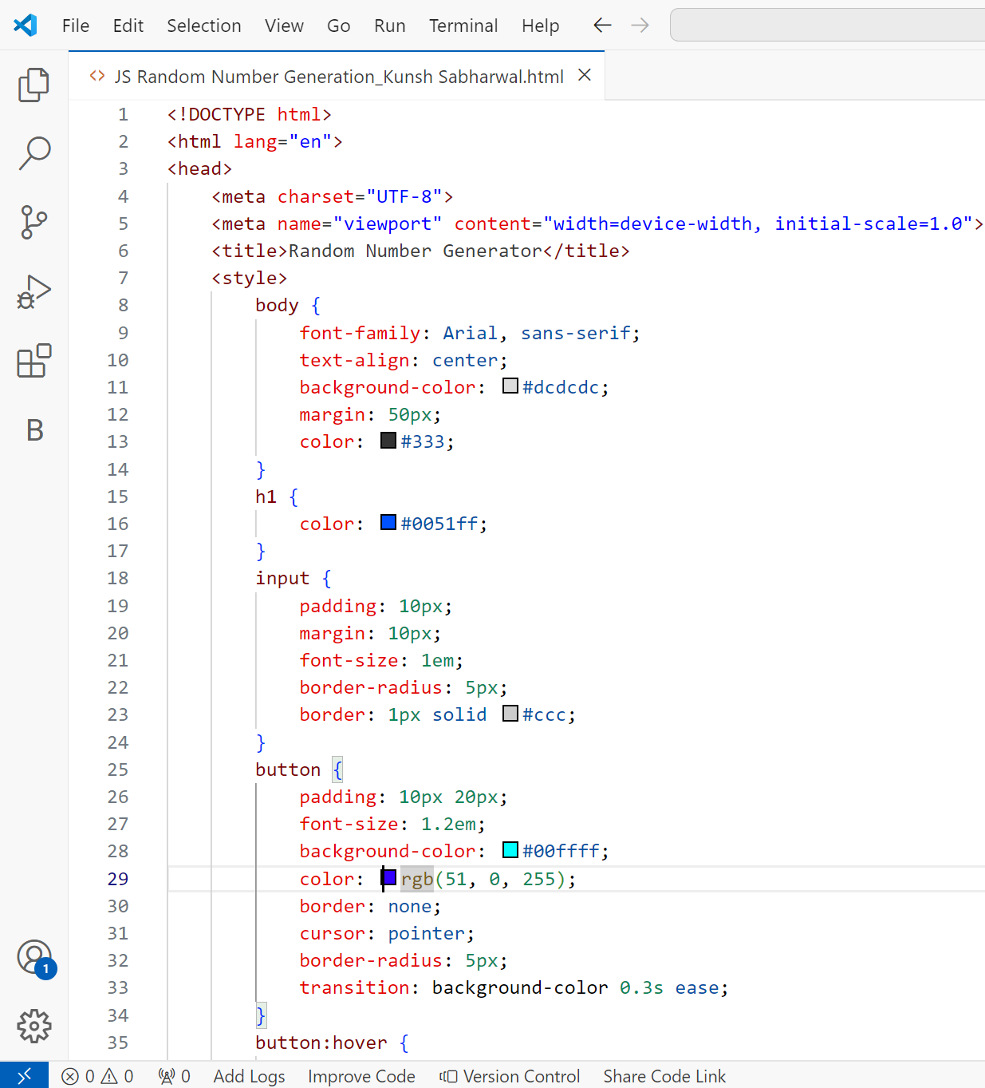**Source Code:**

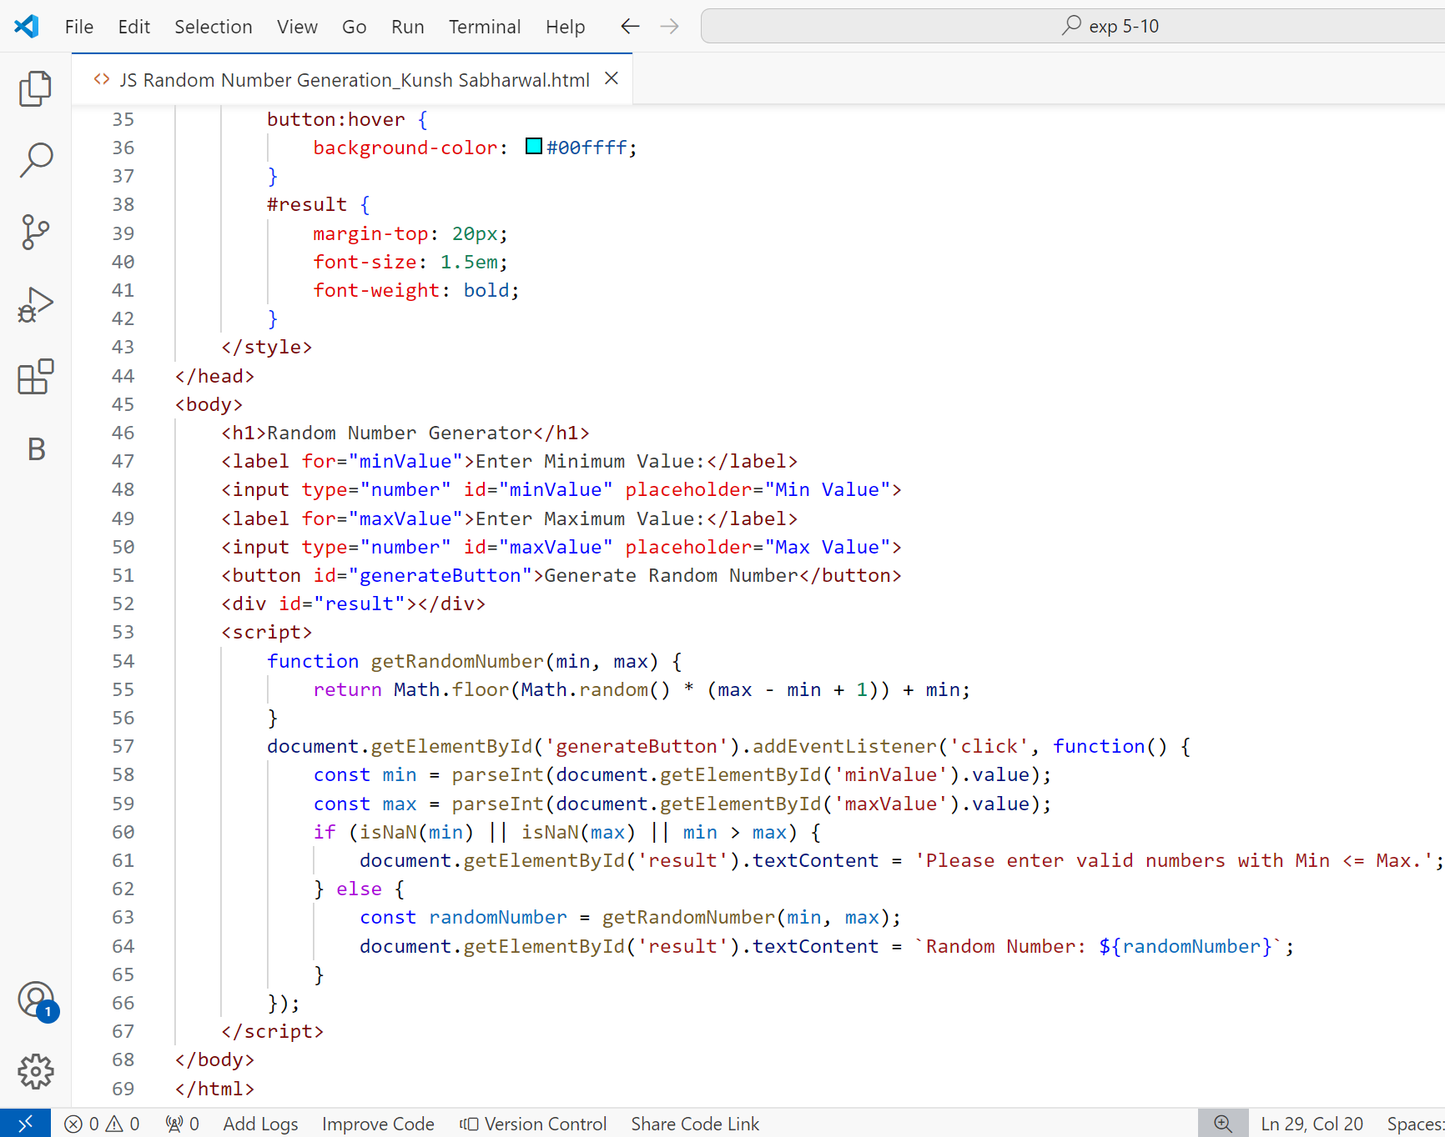

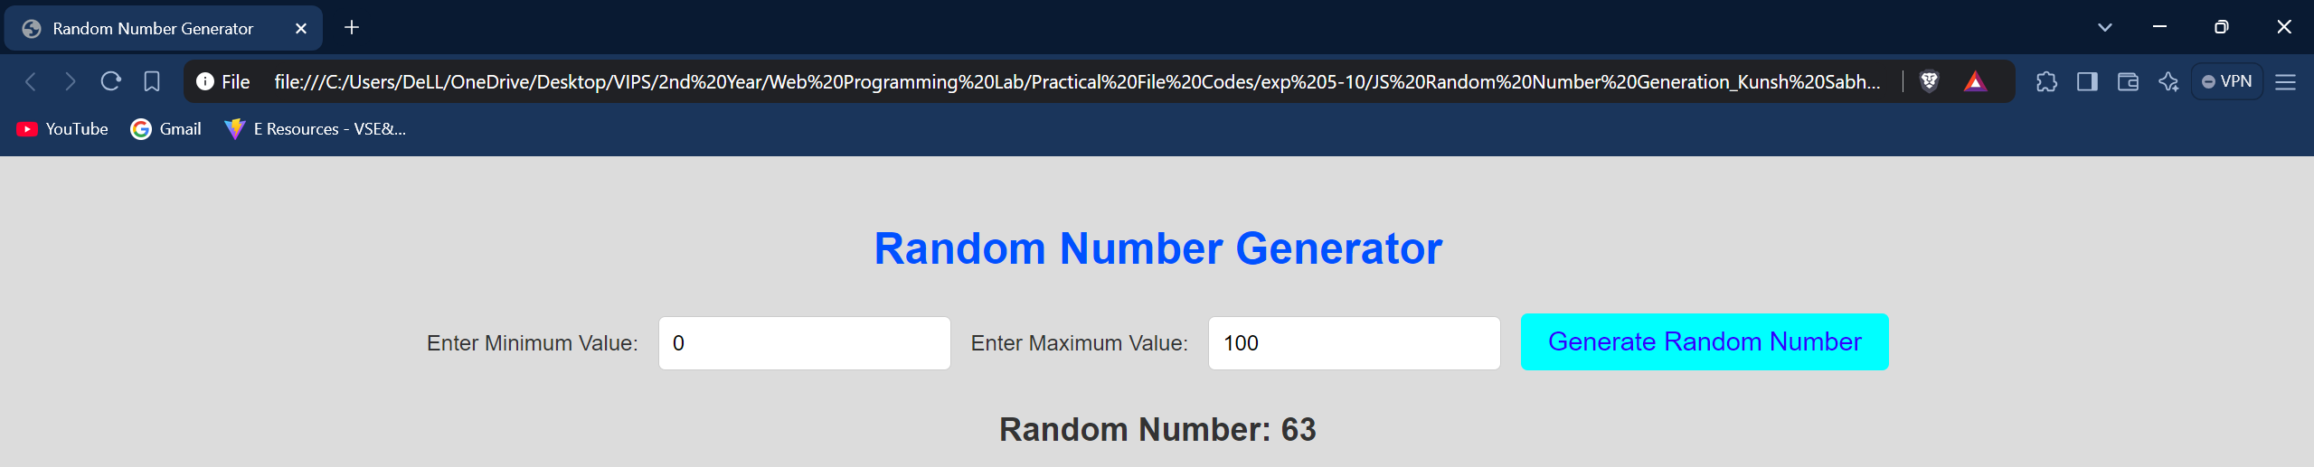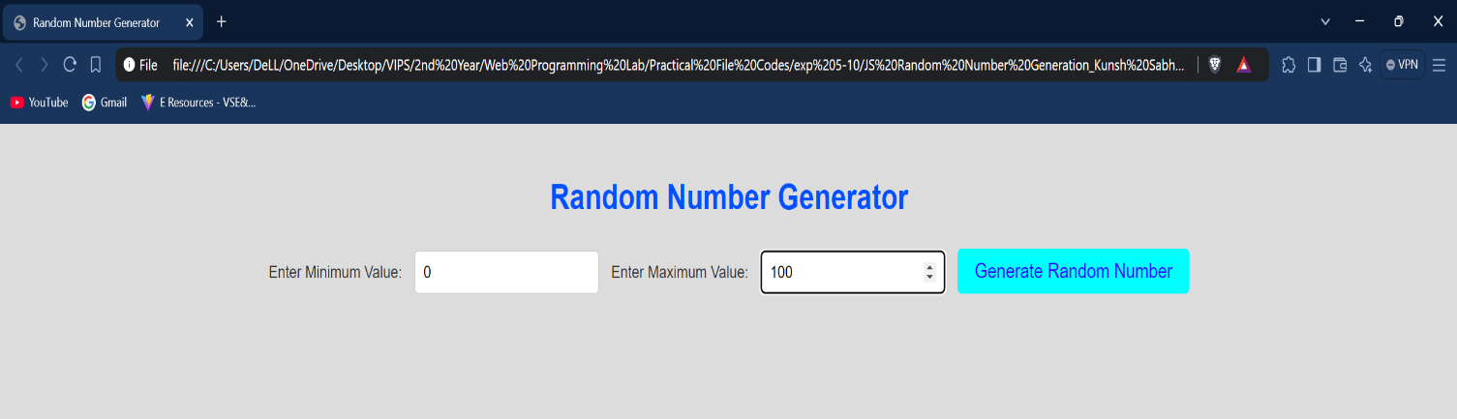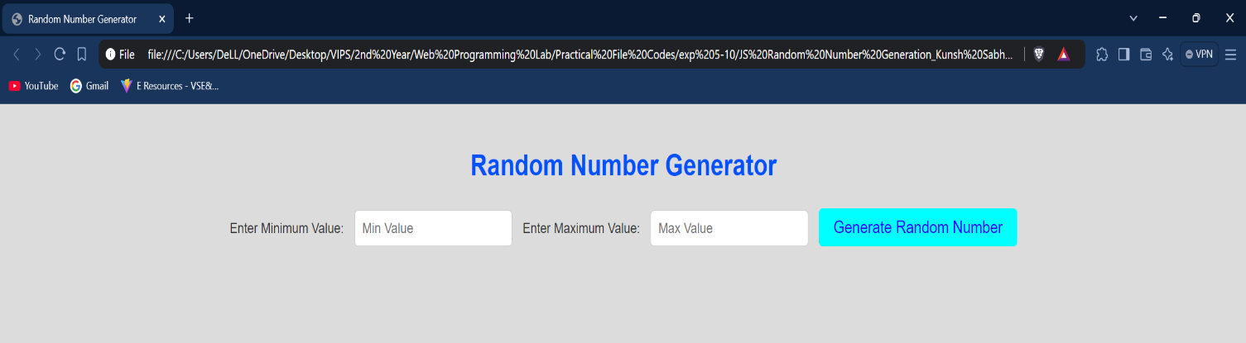**Outputs:**

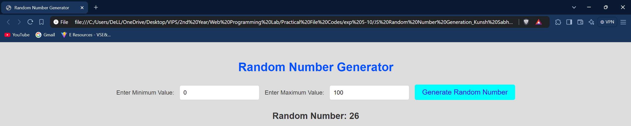**Learning Outcome:**

**EXPERIMENT 10**

**Problem statement:** Build a unit convertor application using HTML & JavaScript.

**Theory:**

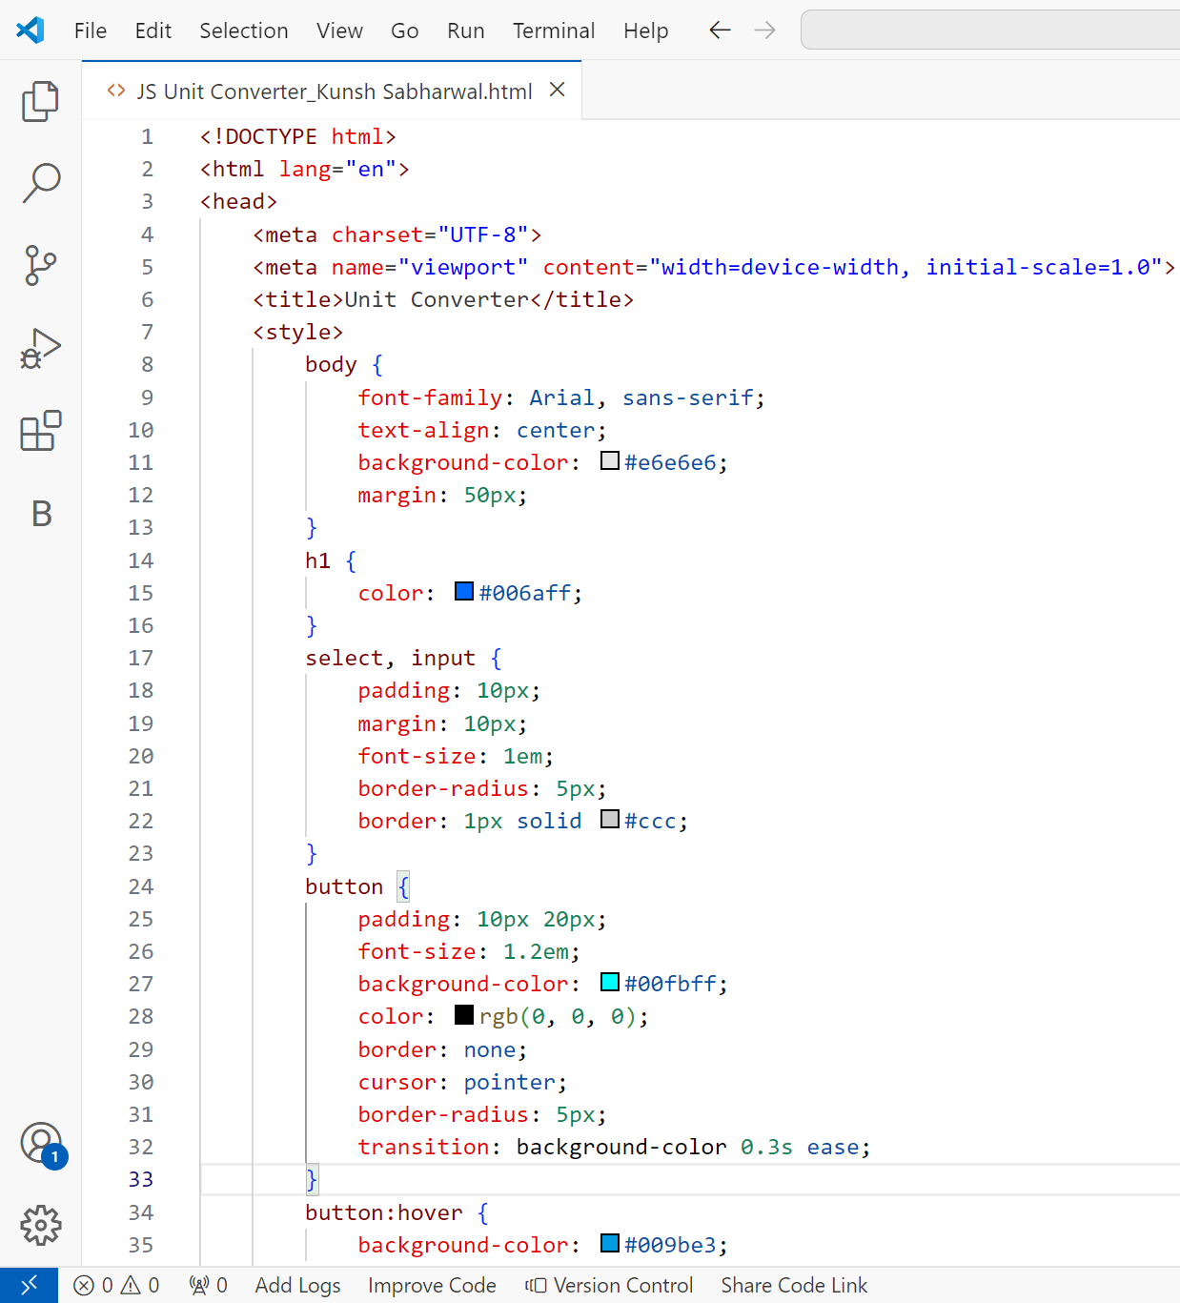**Source Code:**

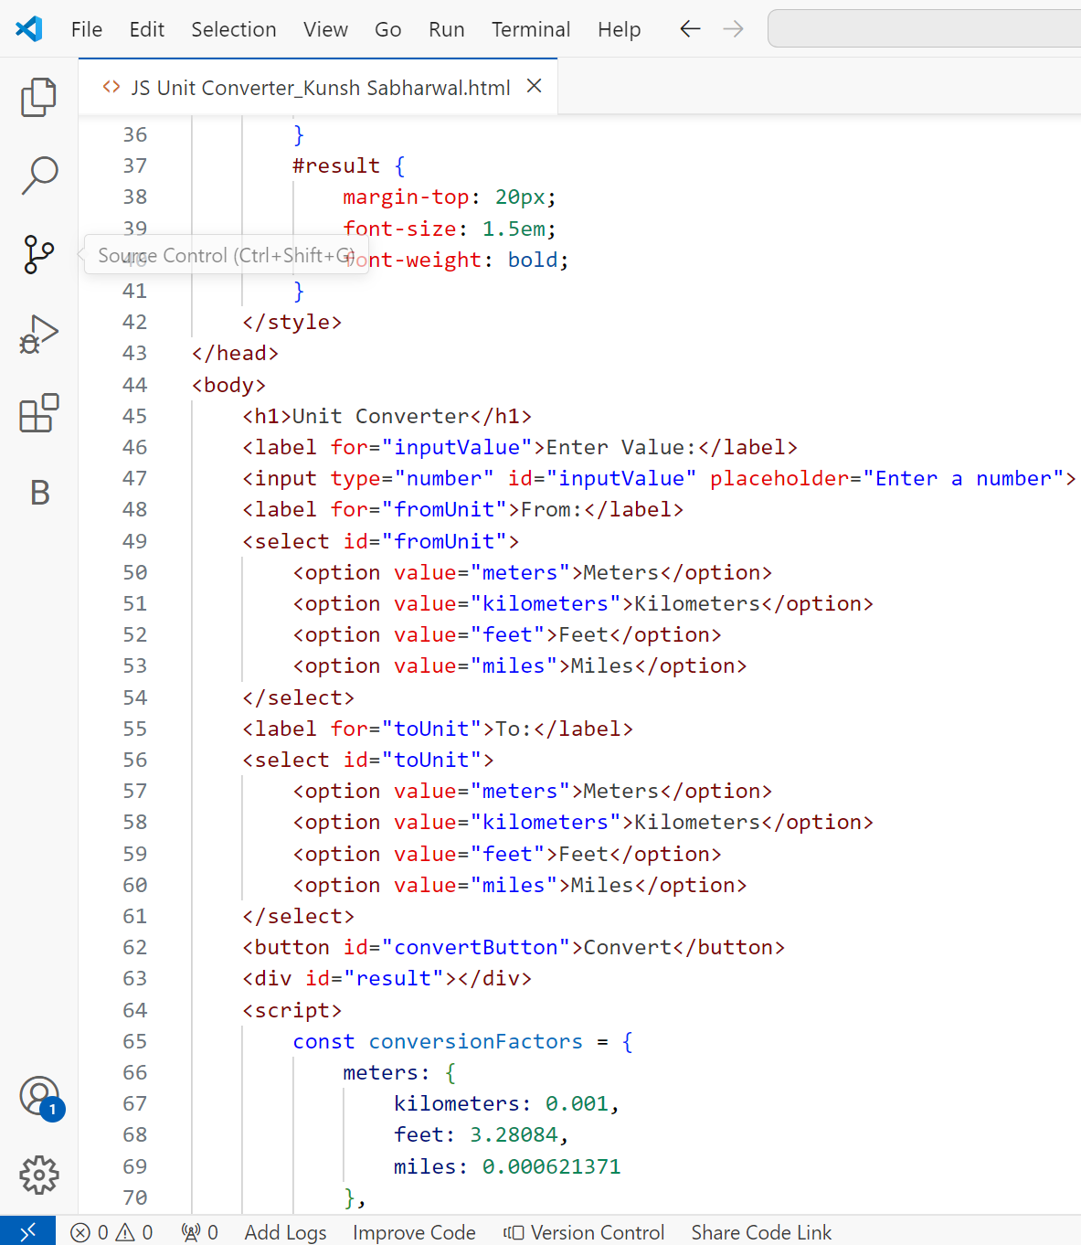

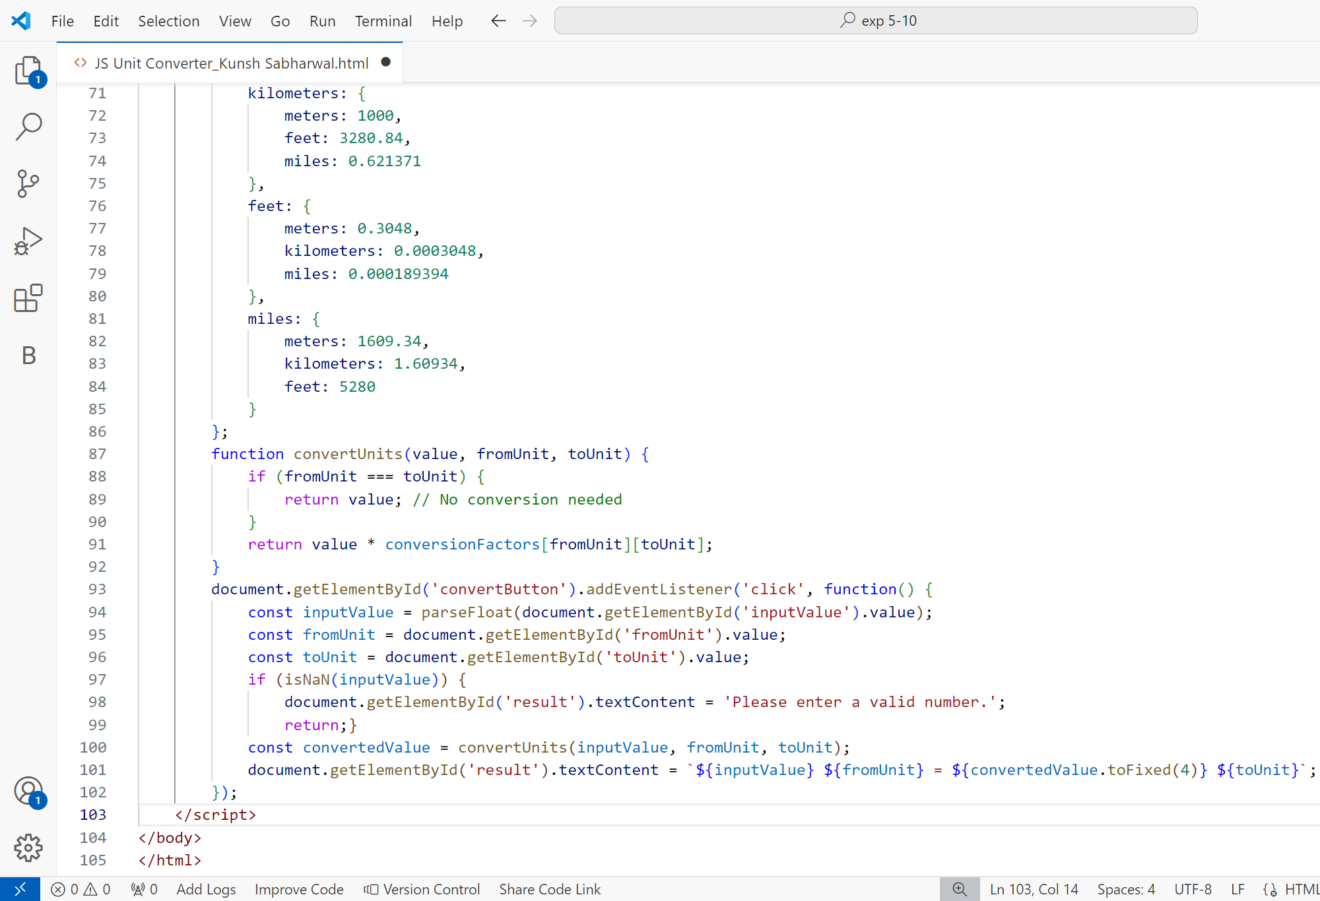

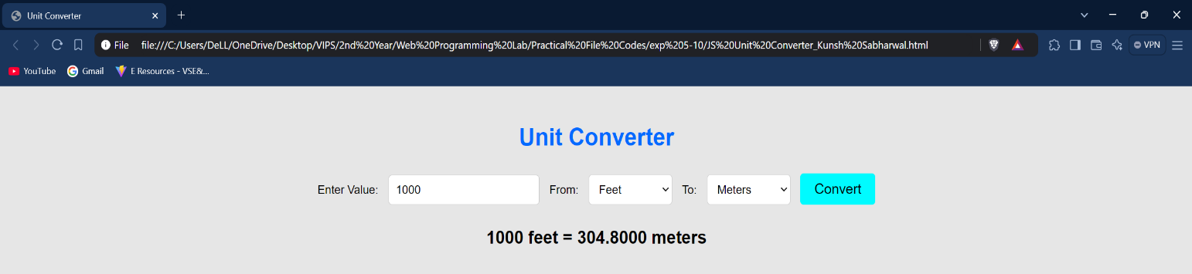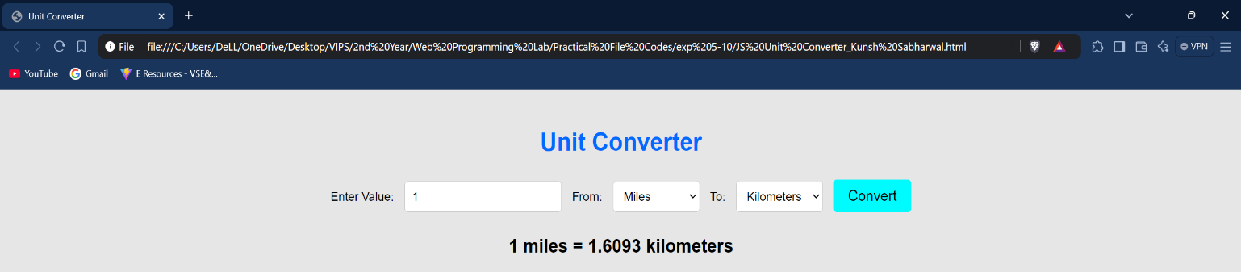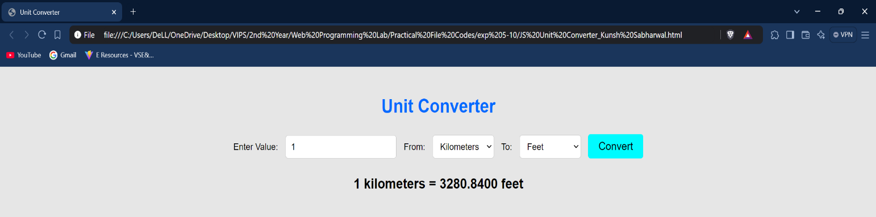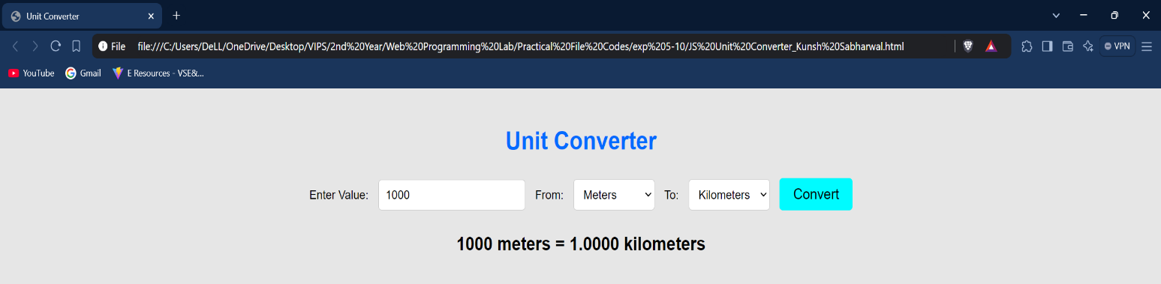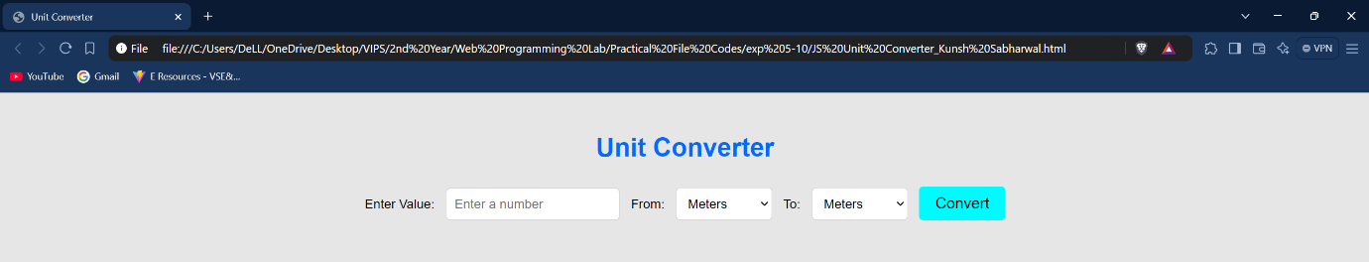**Outputs:**

**Learning Outcome:**